|  |
| --- |
| RQP – MPER Manual v6.0c  2020 |



|  |
| --- |
| N Murdoch(EA -E&B) and Tony Warn ( consultant) |

Contents

1 Introduction 8

2 Forms 9

2.1 Opening Form 9

2.2 Monte-Carlo 6.0 10

2.2.1 Intermittents 11

2.2.2 Non Parametric Data 13

2.3 Bio-available – MPER 6.0 14

2.4 Ammonia 6.0 16

2.5 Compliance 6.0 17

2.6 Warn-Brew 6.0 21

2.7 Opening form - RQP-MPER 4.5 22

2.8 Monte-Carlo 4.5 23

2.9 Bio-available (MPER) 4.5 24

2.10 Ammonia 4.5 25

2.11 Non-parametric data 4.5 26

2.12 Upper tiers 4.5 27

2.13 Intermittent discharges (simple) 4.5 28

2.14 Intermittent discharges –Spirit 4.5 29

2.15 Fish farms 4.5 30

2.16 Confidence Limit – percentile 31

2.17 Mean and standard deviation from percentile 4.5 31

2.18 Compliance 4.5 32

2.19 Binomial Compliance – Percentile 4.5 32

2.20 Parametric Compliance – Percentile 4.5 33

2.21 Confidence limits – Percentile 4.5 33

2.22 Compliance- Mean standard 4.5 34

2.23 Confidence limits – mean 4.5 34

2.24 Change in percentile – parametric 4.5 35

2.25 Change in percentile – COBRA 4.5 35

2.26 Change in Mean 4.5 36

2.27 Warn Brew 4.5 37

2.27 Opening Form - RQP Classic 2.5 38

2.28 Monte-Carlo 2.5 39

2.29 Ammonia 2.5 39

2.30 Non-Parametric 2.5 40

2.31 Upper Tiers 2.5 40

2.32 Intermittent – simple 2.5 41

2.33 Intermittent – SPIRIT 2.5 41

2.34 Fish farms 2.5 42

2.35 Percentile – from mean & SD 2.5 42

2.36 Mean & SD from percentile 2.5 43

2.37 Warn Brew 2.5 43

2.38 Phosphorus 1.0 44

2.39 SIMCAT 45

3 Test data and Comparisons 49

3.1 Test data 49

3.2 Comparisons 49

3.2.1 Monte Carlo 49

3,2,2 Bio-Available 49

3.2.3 Ammonia 50

3.2.4 Non-parametric data 51

3.2.5 Upper Tiers 52

3.2.6 Simple 52

3.2.7 Spirit 52

3.2.8 Fish Farms 52

4 Input/Output files 53

4.1 Producing Input/ Output Files 53

4.2 Example files 54

4.2.1 Word/Print files 54

4.2.2 Excel Files 60

4.3 MBL and MBE files 66

4.4 Additional files from MPER 4.5 68

5 Printing 69

6 Software 70

6.1 System Directories 70

6.2 Files 71

6.3 Installation and Running the software 75

7 Additional data 76

7.1 Bio available additional data 6.0 77

7.2 Bio available additional data 6.0 77

7.3 Ammonia additional data 6.0 78

7.4 Ammonia additional data 4.5 78

Appendix 1 MPER Guide 79

1 Summary 79

2 Sensitivity of the results to data 80

3 The correct form of standards 81

4 Calculating limits in discharges to rivers 82

5 New river quality standards for metals 84

6 Uncertainties in the calculation of bioavailable concentrations 85

7 MPER 86

8 Data for the calculations 86

9 The calculations 88

10 An example for copper 89

11 Where discharges cause failure of the new river standards 92

12 Comparisons with the old standards for copper 93

13 Uncertainties in the calculations for copper 94

14 Sensitivity to data of the results for copper 95

15 Allowed deterioration 97

Appendix 2 RQP Guide 101

1 Permits 101

1.1 Introduction 101

1.2 Concepts 101

1.2.1 Emission 101

1.2.2 Receiving Waters 101

1.2.3 Mixing Zone 102

1.2.4 Emission Control 102

1.2.5 Standards 102

1.2.6 Mass Balance 102

1.2.7 Simple Mass Balance Calculation 103

1.2.8 Combined Distribution Method 103

1.2.9 Warn Brew Method 104

1.2.9 MONTE-CARLO Method 104

1.2.10 Warn Brew Method 104

2 Monte Carlo Software 105

2.1 Introduction 105

2.2 Monte-Carlo Software 107

3 Other MONTE-CARLO Options 110

3.1 Applications 110

3.2 Ammonia Standards 110

3.3 Non-Parametric Distributions 111

3.4 Monte-Carlo simulation for Upper Tiers 111

3.5 Intermittent discharges (Simple Method) 111

3.6 Intermittent Discharges (SPIRIT) 111

3.7 Fish Farms 111

4 Compliance 112

4.1 Introduction 112

4.2 Standards and Permits 112

4.2.1 Pass/ Fail Standards 112

4.2.2 Statistical Standards 112

4.2.3 Relationship between Pass/Fail and Statistical Standards. 113

5 Compliance Software 114

5.1 Introduction 114

114

5.2 Binomial Compliance for any Percentile 115

5.3 Parametric Method for any Percentile 115

5.4 Compliance with Mean Standard 115

5.5 Confidence Limits for any Percentile 115

5.6 Confidence Limits for Mean Values 115

5.7 Change in any Percentile (Parametric) 116

5.8 Change in any Percentile (Parametric) 116

5.9 Change in Mean 116

Appendix 2.A Environmental Standards 117

Appendix 2.B STATISTICS 120

Introduction 120

Concepts 120

Samples and Populations 120

Summary Statistics 120

Confidence 121

Percentiles 121

Distributions 121

Hypotheses Testing 122

Correlations 122

Appendix C System files 123

# Introduction

This manual describes the updated River Quality Planning system (version 6.0).

The manual is intended to:

* provide a description of the software for users and for software support
* provide a description of ideas and concepts behind the software.

The updates are:

* Intermittents and non-parametric input data options added
* Improved facilities for entering additional data and setting correlations. Defaults assigned
* Inclusion of SIMCAT157 and 148 within the system.
* Rewriting some of the software in VB.NET

The following applications are included in this update:

* Mass balance calculations:
  + Monte-Carlo (6.0,4,4,2.5)
  + Bio-availability (MPER) (6.0,4.5)
  + Ammonia (6.0,4,4,2.5)
  + Non-parametric inputs (4.5,2.5)
  + Upper Tiers (4.5,2.5)
  + Intermittents (Simple) (4.5,2.5)
  + Intermittents (Spirit) (4.5,2.5)
  + Fish Farms (4.5,2.5)
* SIMCAT (15.7,14.8)
* Compliance utilities (6.0,4.5)
* Phosphorus (OECD calculations)

The numbers in brackets indicate version numbers. For now previous versions are included for operational/business reasons; specifically so that we check previous calculations if necessary, and to minimise disruption to users. For new calculations, the latest version number should be used.

Sections 2 to 6 describe the software and its use.

Appendix 1 describes the principles behind the bio-available calculations and, similarly, Appendix 2 describes the mass balance and compliance principles.

# 2 Forms

Below, the forms displayed by the system are presented.

You can go through them to learn how to use the system. The outputs displayed in the forms may also be used for test purposes.

## 2.1 Opening Form



Comments:

* Monte-Carlo, Bio-available, Ammonia and Compliance are versions 6.0.
* They are written in VB Net.
* Previous RQP-MPER is version 4.5.
* Classic RQP is version 2.5

## 2.2 Monte-Carlo 6.0



Comments

* Enter test data by typing “157” in the discharge name box.
* Input /output may be saved as Excel /WORD document. (Input may also be saved as Note or ‘Out’ documents.)
* For a no deterioration, for a percentile, or MAC, do a forward calculation and compare the upstream percentile with the downstream percentile.
* You can change the percentile (in the ‘corresponding percentile’ input box) from say, 90th to 95th (see below)



### 2.2.1 Intermittents

To include an intermittent, click on ‘’ on the bottom left of the form:



This will bring up the form below, for you to populate:



Once populate, repeat the calculation:



You can also look at the results for the intermittent (via option on the right of the screen):



Hence



:

Points to note:

* Do not close the intermittent input data from after you have entered the data.
* Close the intermittent results form after you have looked at it.

### 2.2.2 Non Parametric Data

To enter non-parametric data click on ‘’ on the bottom left of the form.

This will bring up the selection form:



Select the option you want and then navigate to the appropriate file.



## 2.3 Bio-available – MPER 6.0



Comments

* Enter test data by typing
  + 15c (for copper)
  + 15l (for lead)
  + 15m (for manganese)
  + 15n (for nickel)
  + 15z (for zinc)
  + Into the discharge name box
* Takes a little while to run
* If sensitivity is included, calculations take longer. Screen may go blank.
* Input /output may be saved as Excel /WORD document. (Input may also be saved as Note or ‘Out’ documents.).

## 2.4 Ammonia 6.0



Comments

* Enter test data by typing “156” in the discharge name box.
* Input /output may be saved as Excel /WORD document. (Input may also be saved as Note or ‘Out’ documents.)

## 2.5 Compliance 6.0



Mean

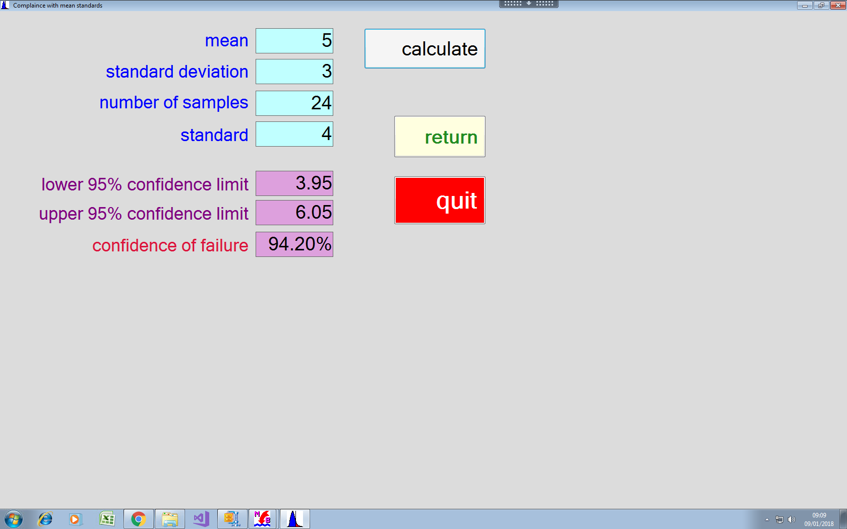

Percentile



Percentile – failed samples



Confidence limits – mean



Confidence limits – percentile



Change in mean



Change in Percentile



Change – percentile – failed samples



## 2.6 Warn-Brew 6.0

*Discontinued*

## 2.7 Opening form - RQP-MPER 4.5



Comments

* RQP version 4.5
* Written in VB6

## 2.8 Monte-Carlo 4.5

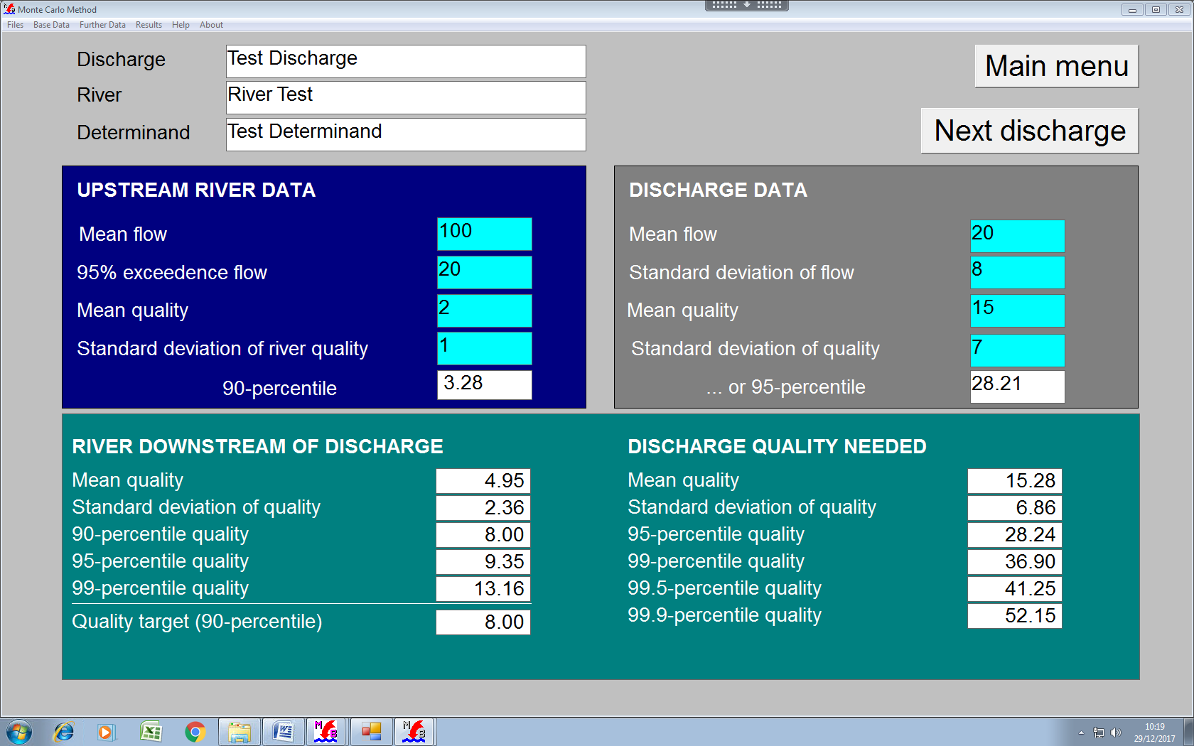

Comments

* Enter test data by typing “156” in the discharge name box.
* Input data may be saved and then read from file (*.mbl)
* Hardcopy available via Print option in Files drop down.

## 2.9 Bio-available (MPER) 4.5

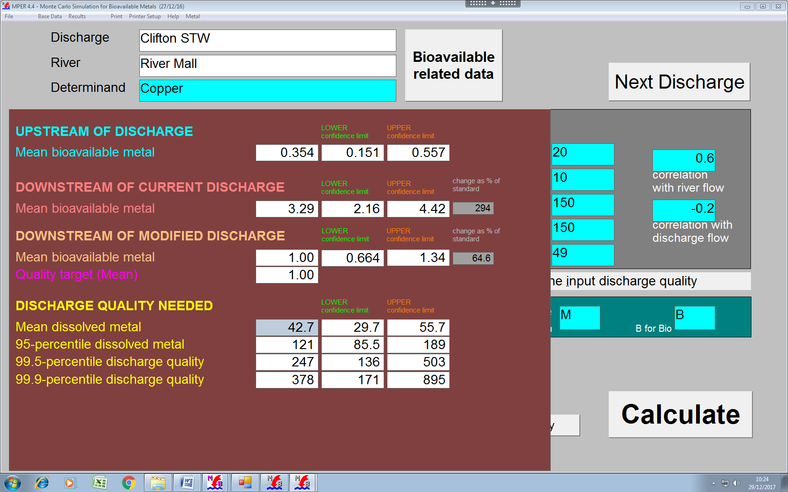

Comments

* Type 15c,15l,15m,15n,15z into discharge name box to enter test data
* Opens an output window (DOS) when running ... see below.
* Input data may be saved and read from file (*.mpe)
* Hardcopy available via Print option in Files drop down.

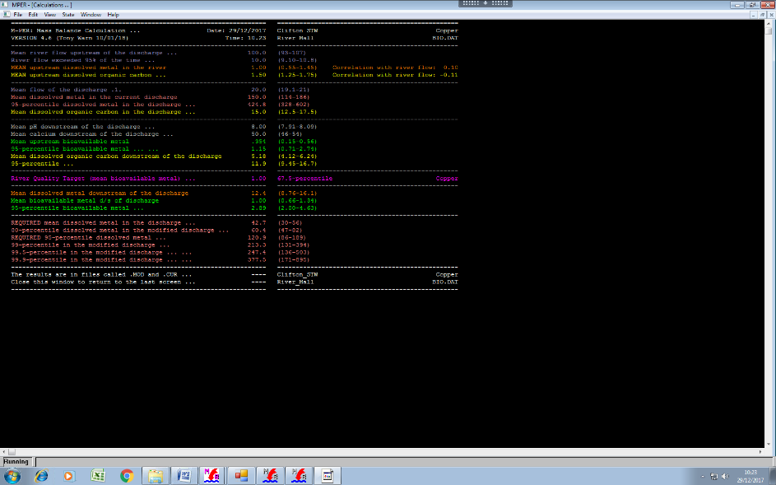

## 2.10 Ammonia 4.5

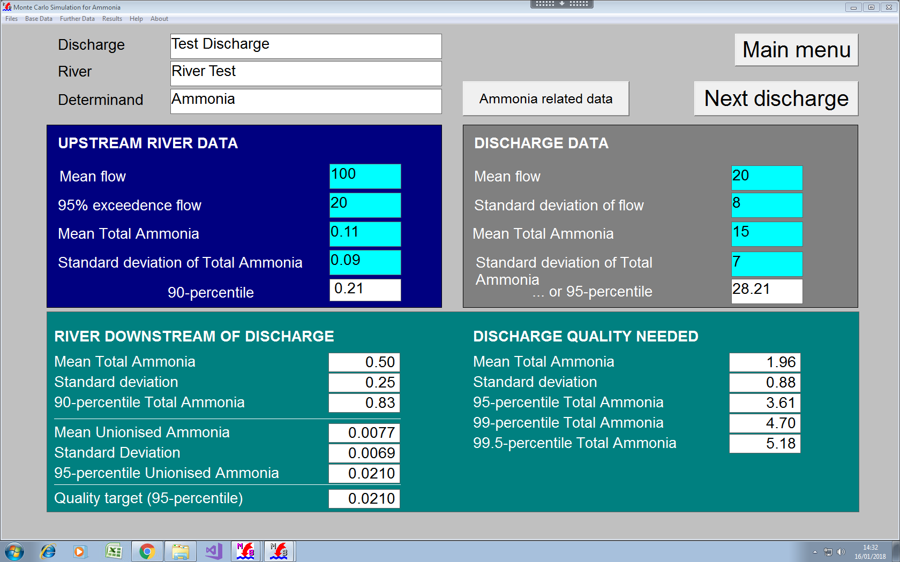

Comments

* Enter test data by typing “156” in the discharge name box.
* Input data may be saved and then read from file (*.mbl)
* Hardcopy available via Print option in Files drop down.

## 2.11 Non-parametric data 4.5

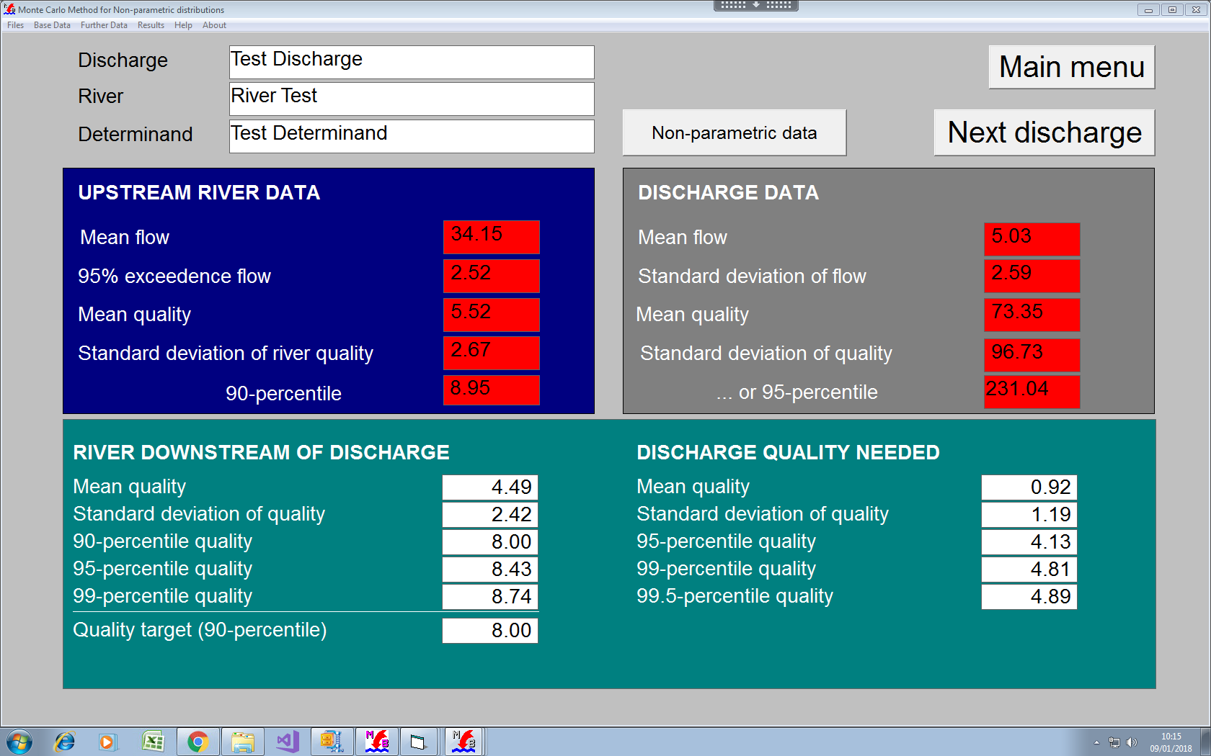

Comments

* Non parametric data are entered from a previously prepared text file.
* Format is
  + No of points
  + Value
  + Space separated

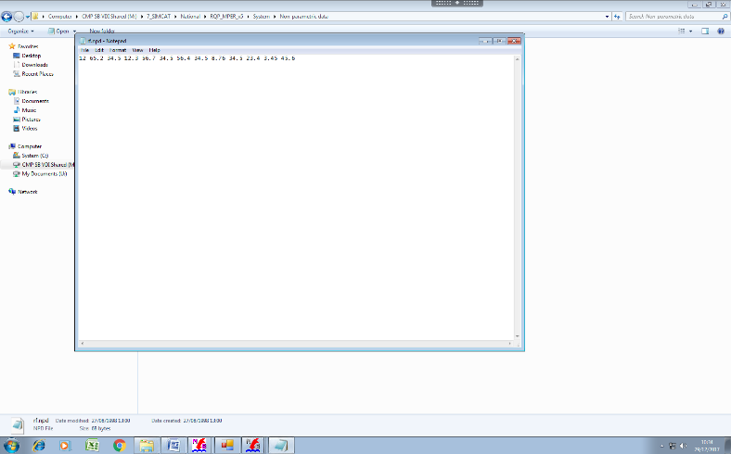

## 2.12 Upper tiers 4.5

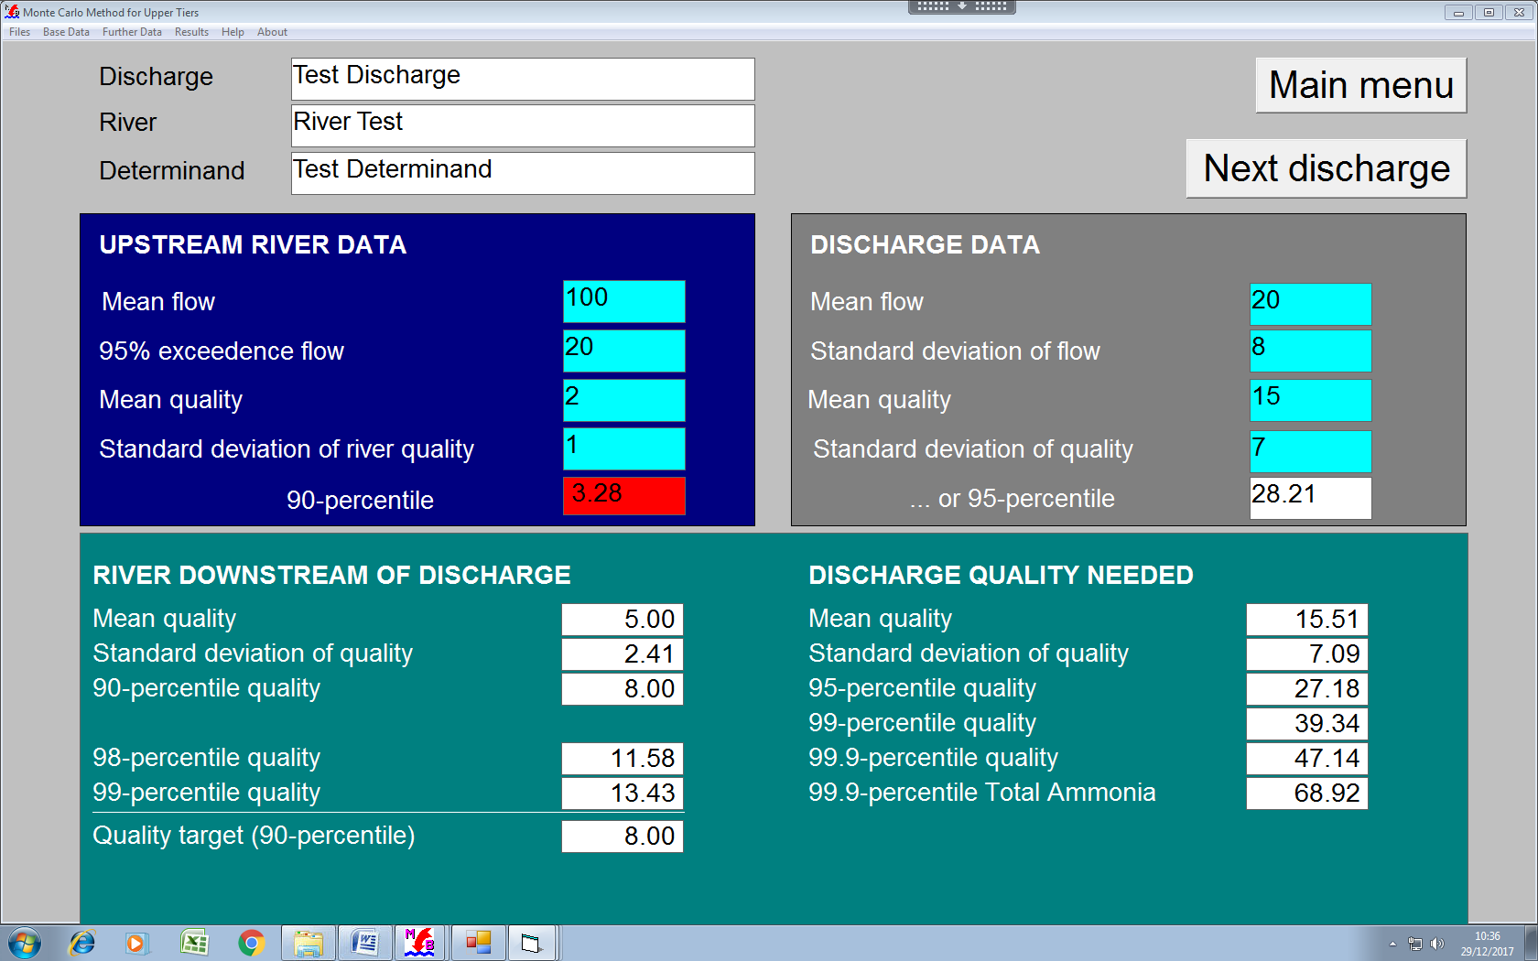

Comments

* Test data entered by typing 156 into the discharge box.
* Hardcopy available via Print option in Files drop down.

## 2.13 Intermittent discharges (simple) 4.5

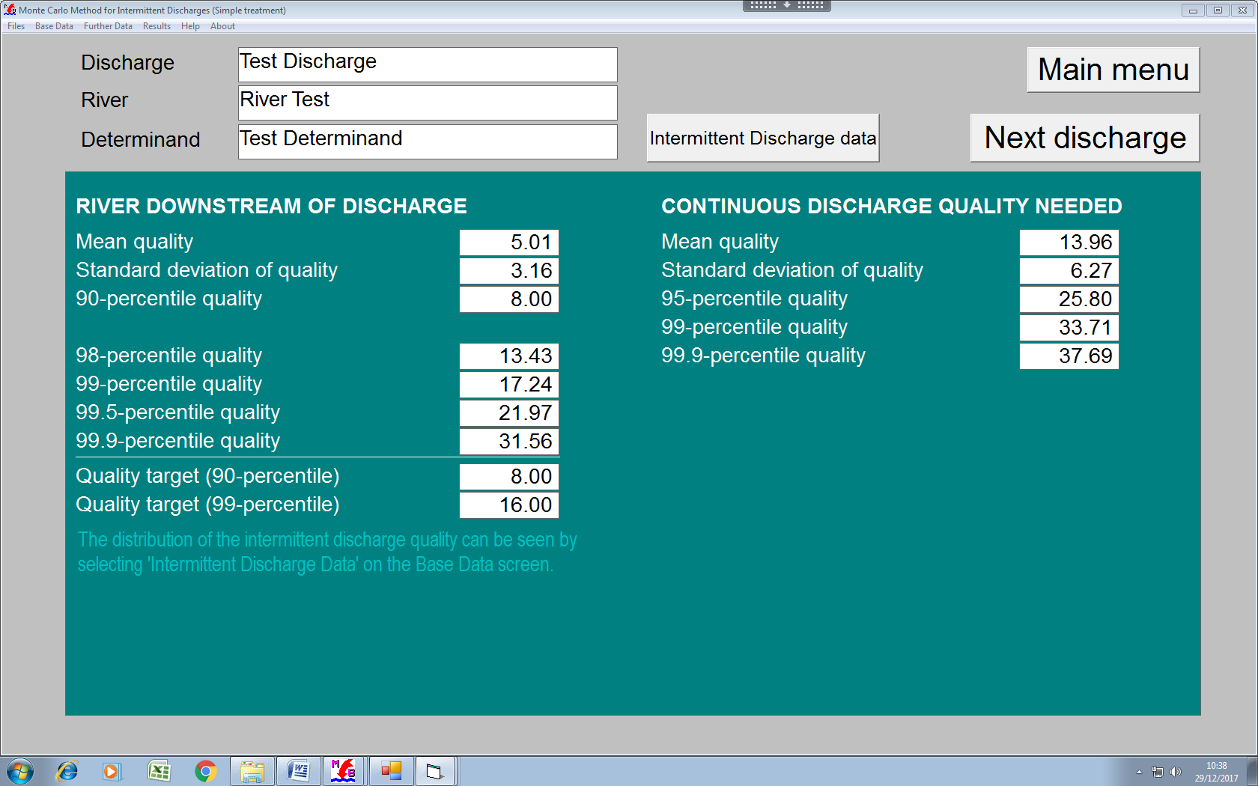

Comments

* Test data entered by typing 156 into the discharge box.
* Hardcopy available via Print option in Files drop down.

## 2.14 Intermittent discharges –Spirit 4.5

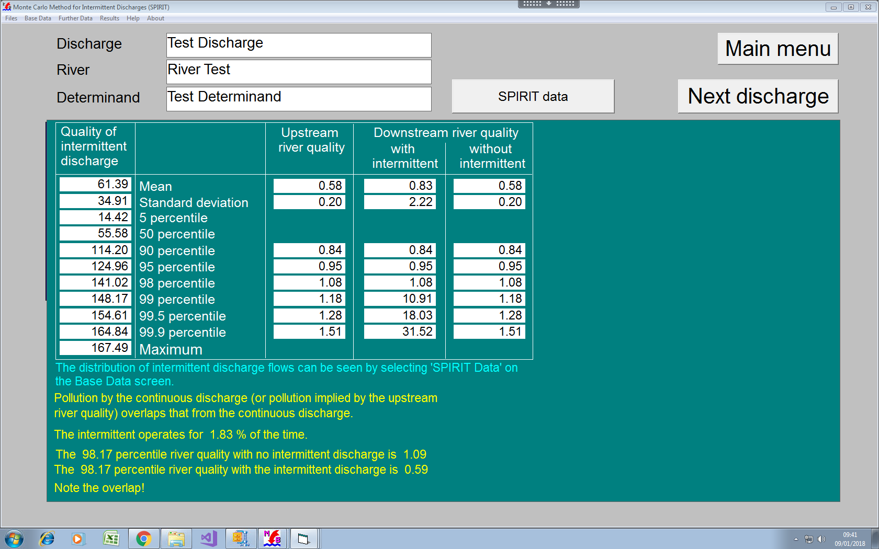

Comments

* Test data entered by typing 156 into the discharge box.
* Hardcopy available via Print option in Files drop down.

## 2.15 Fish farms 4.5

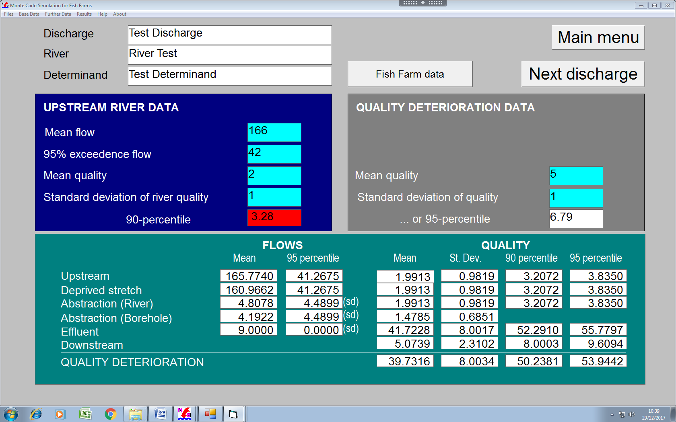

Comments

* Test data entered by typing 156 into the discharge box.
* Hardcopy available via Print option in Files drop down.

## 2.16 Confidence Limit – percentile

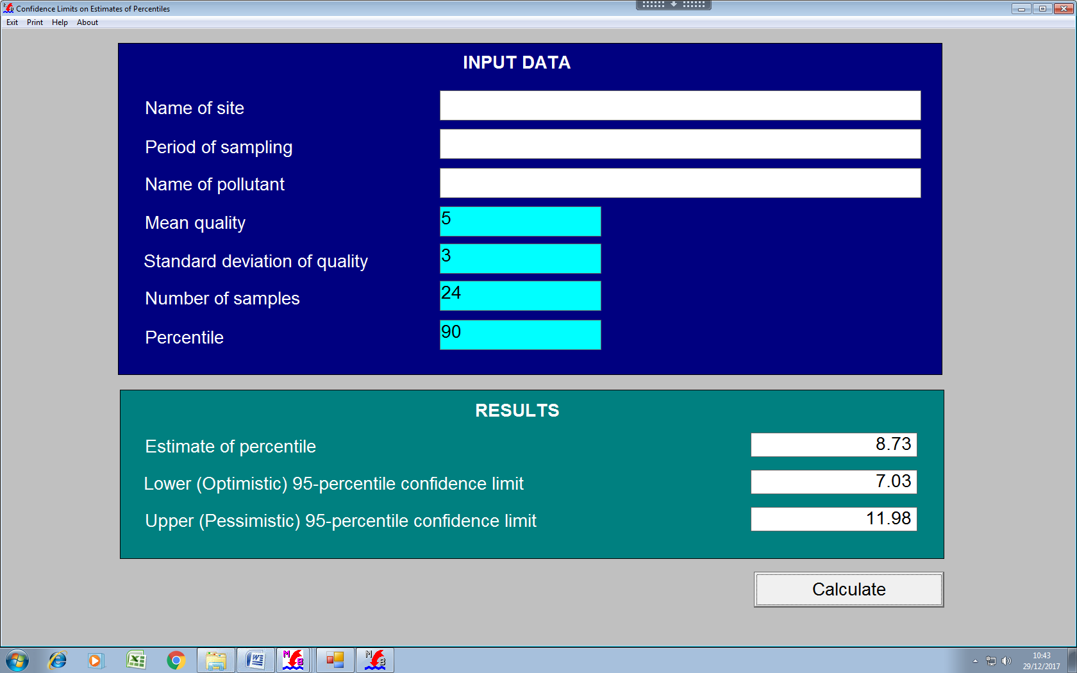

## 2.17 Mean and standard deviation from percentile 4.5

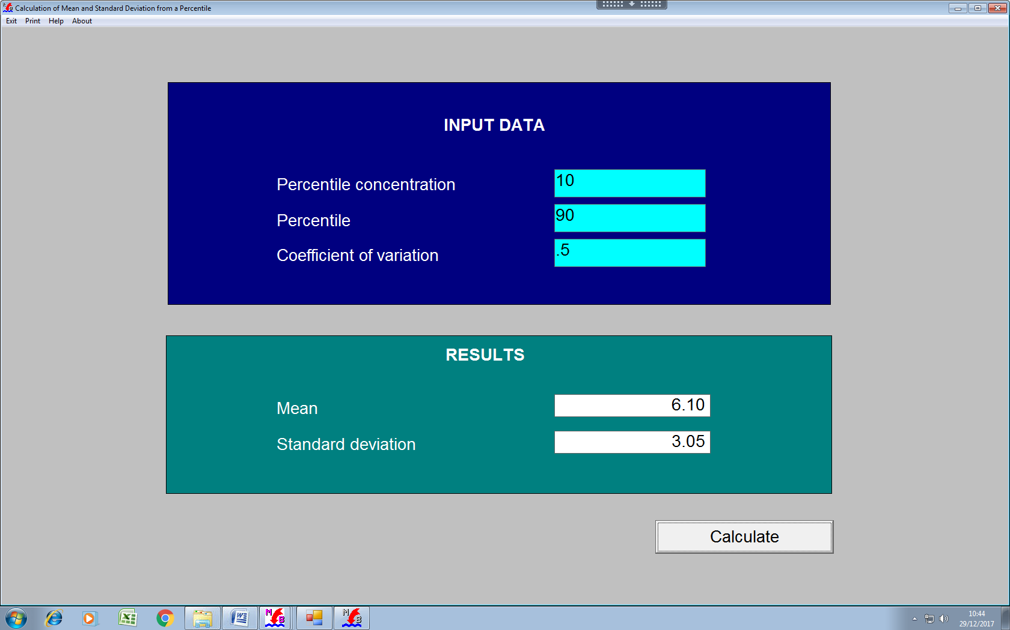

## 2.18 Compliance 4.5

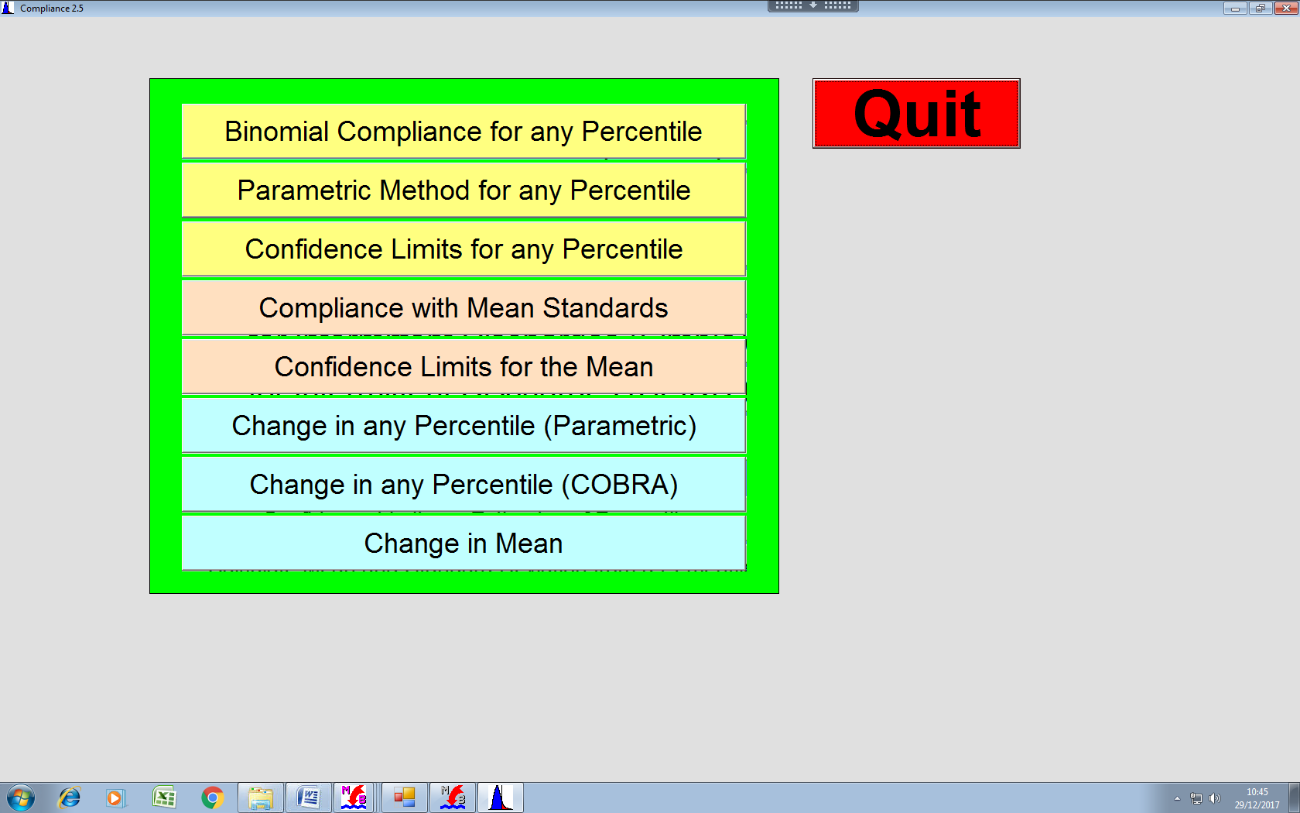

## 2.19 Binomial Compliance – Percentile 4.5

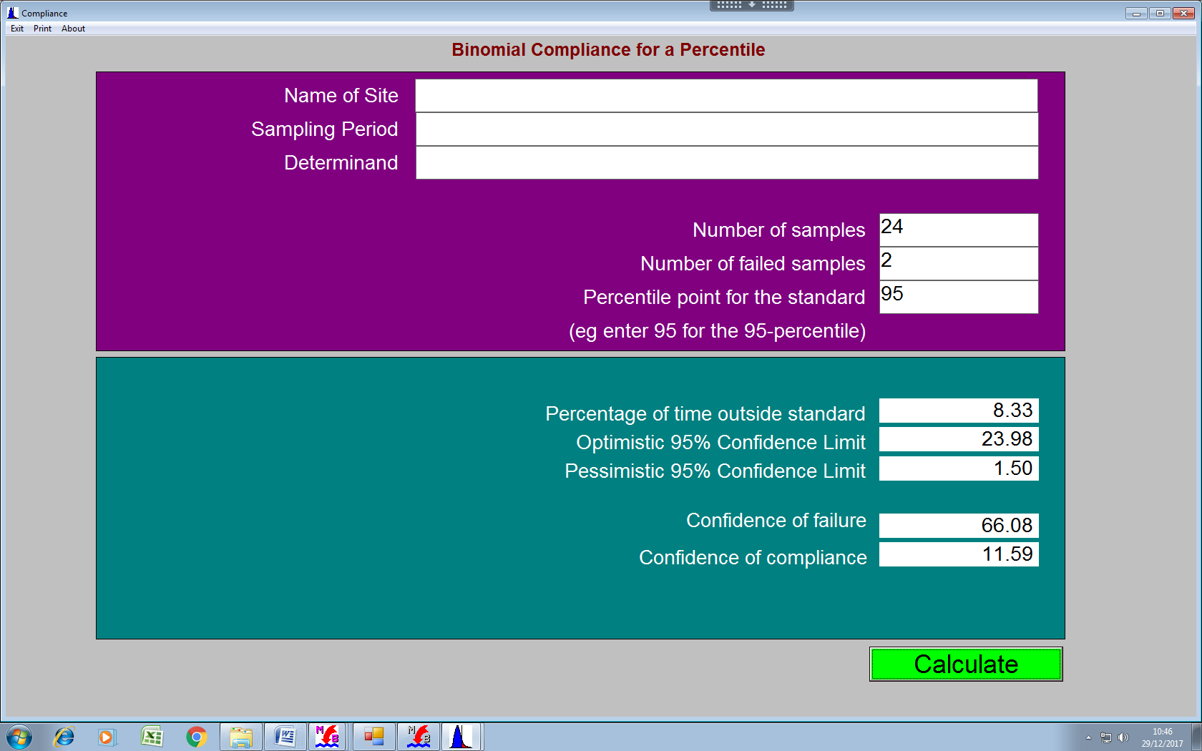

## 2.20 Parametric Compliance – Percentile 4.5

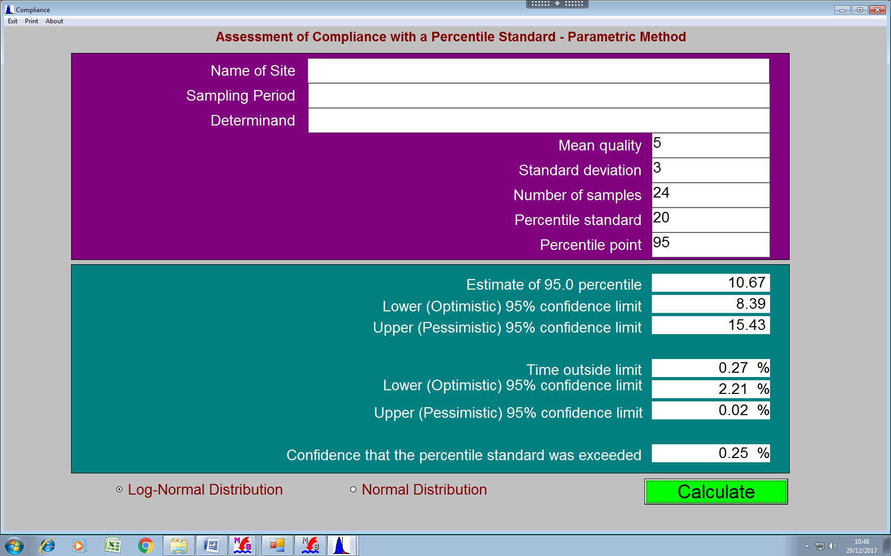

## 2.21 Confidence limits – Percentile 4.5

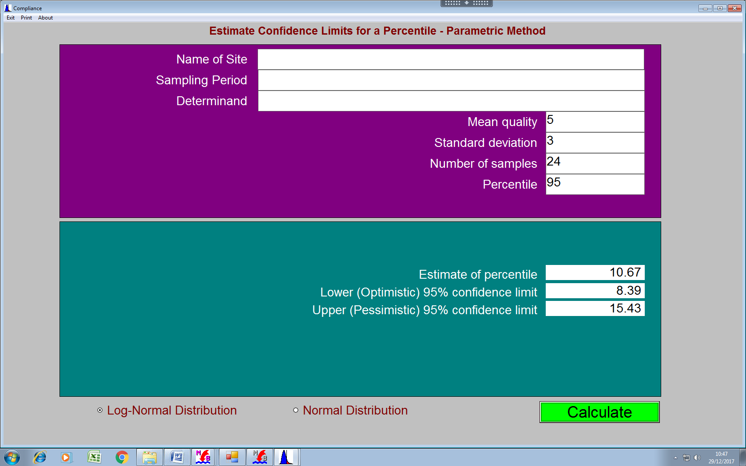

## 2.22 Compliance- Mean standard 4.5

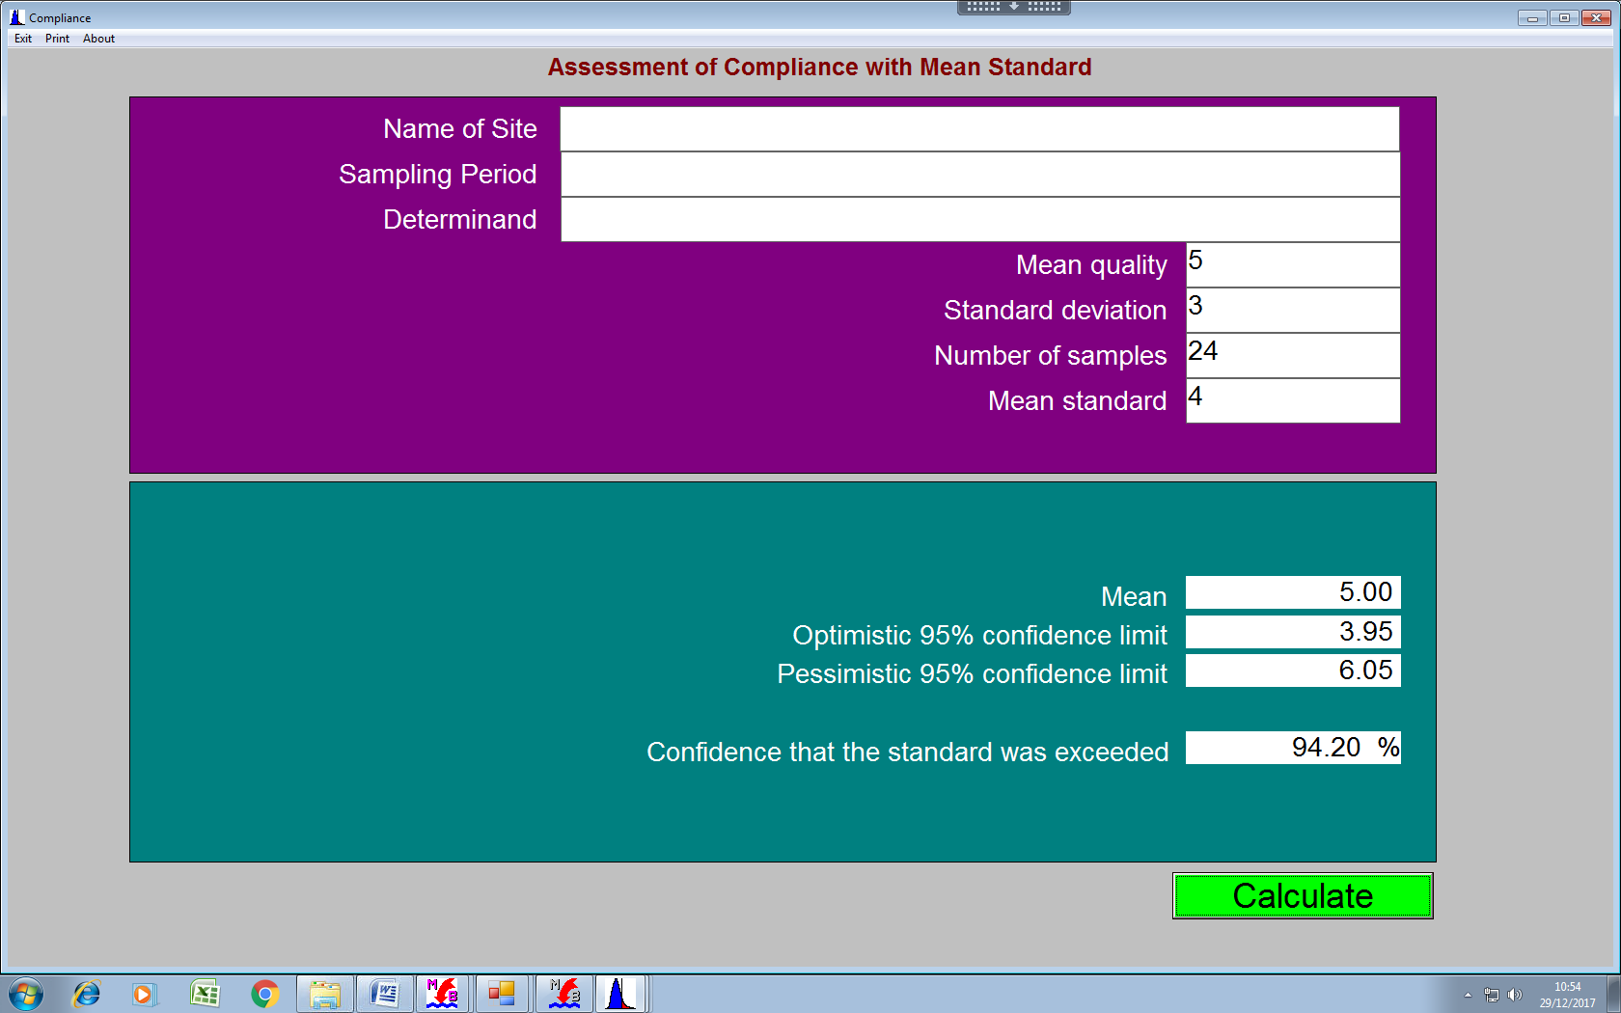

## 2.23 Confidence limits – mean 4.5

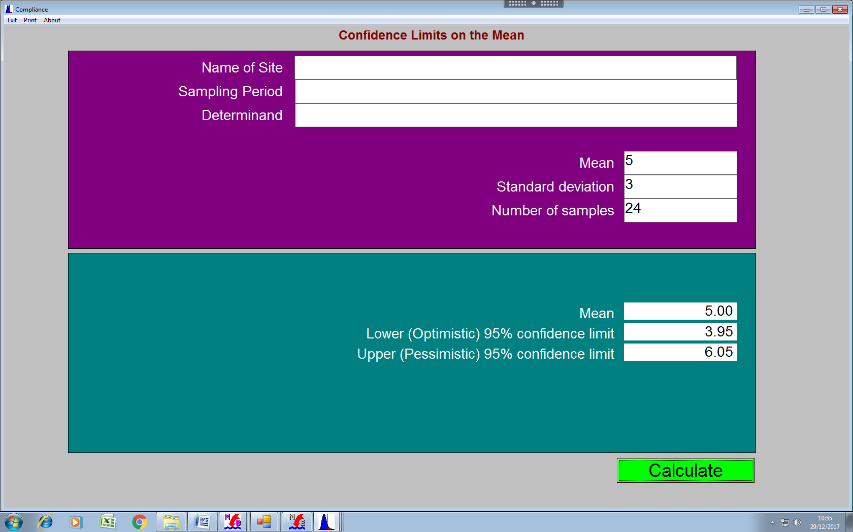

## 2.24 Change in percentile – parametric 4.5

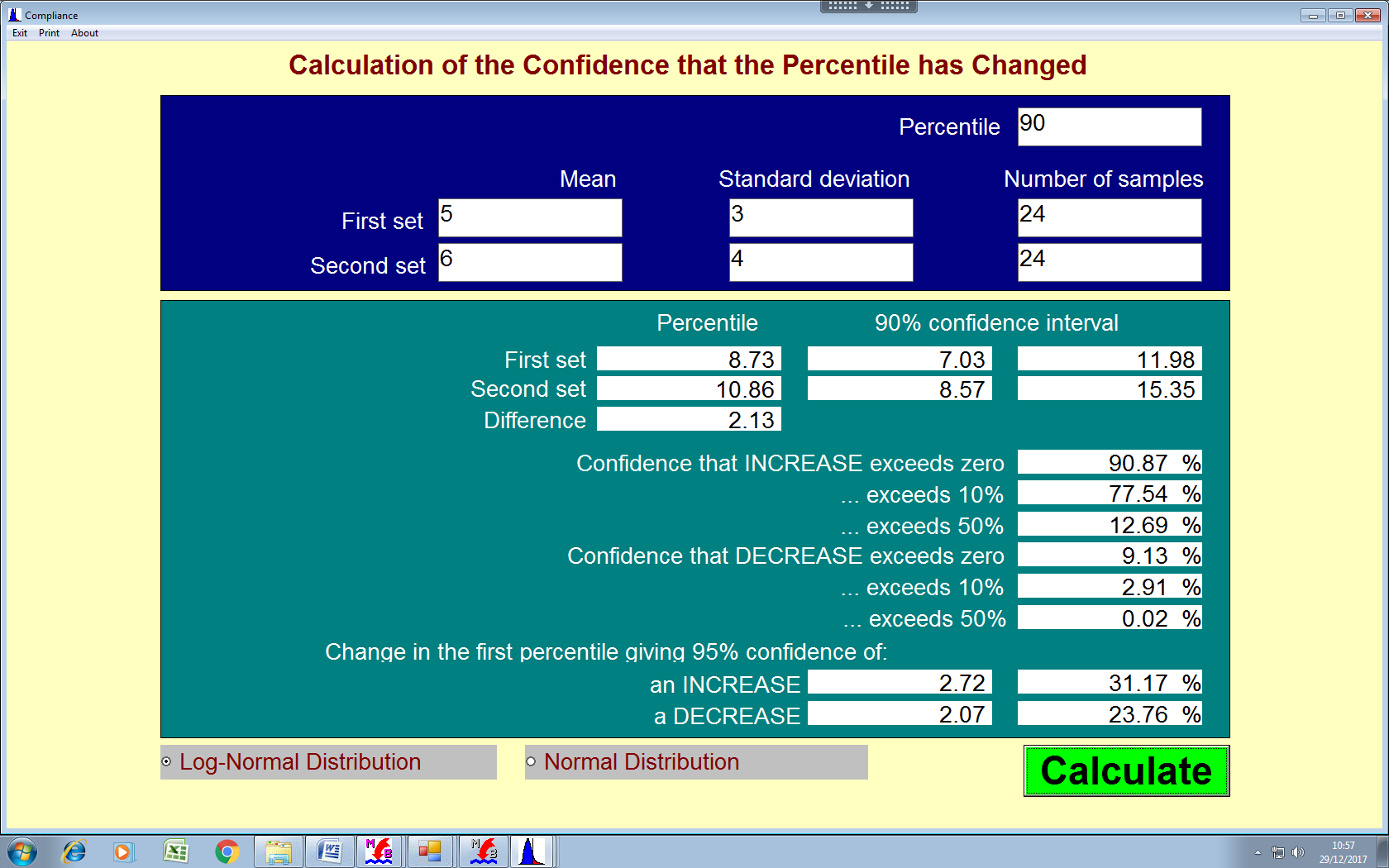

## 2.25 Change in percentile – COBRA 4.5

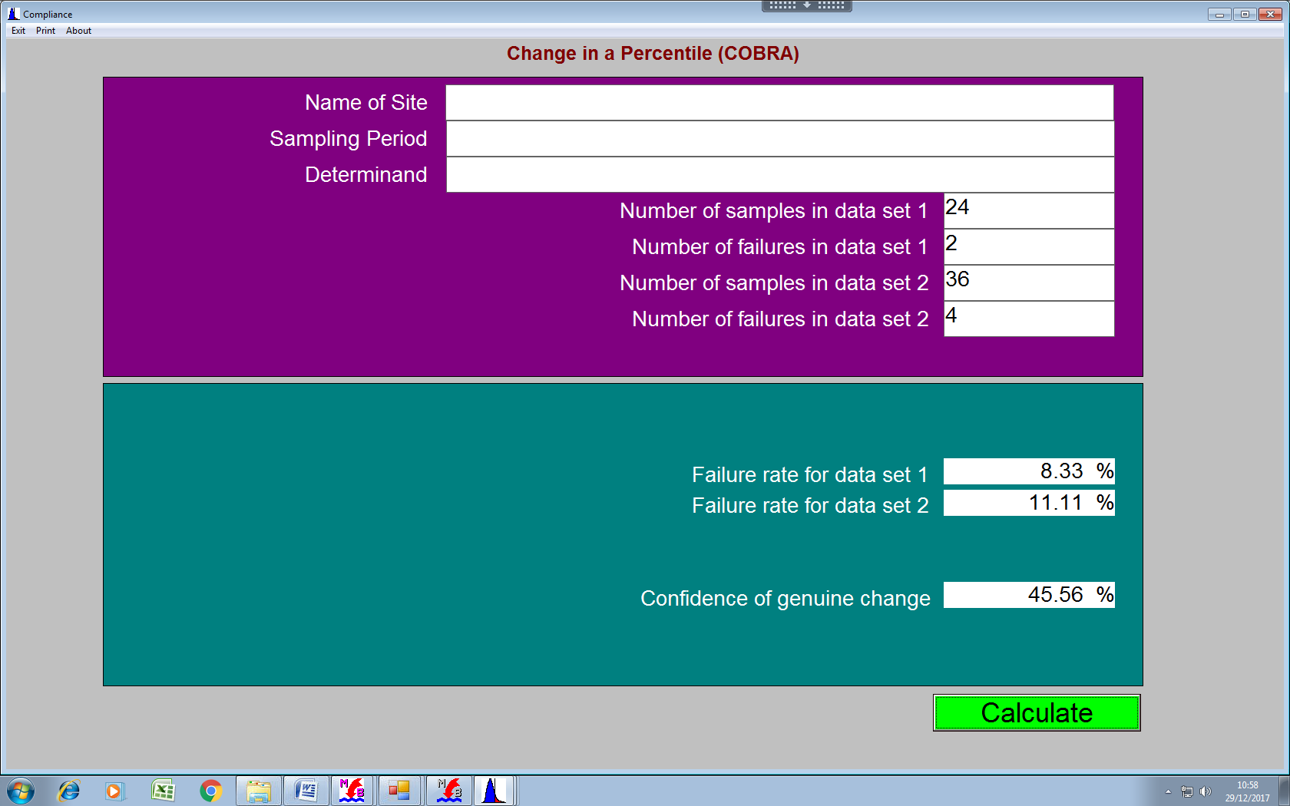

## 2.26 Change in Mean 4.5

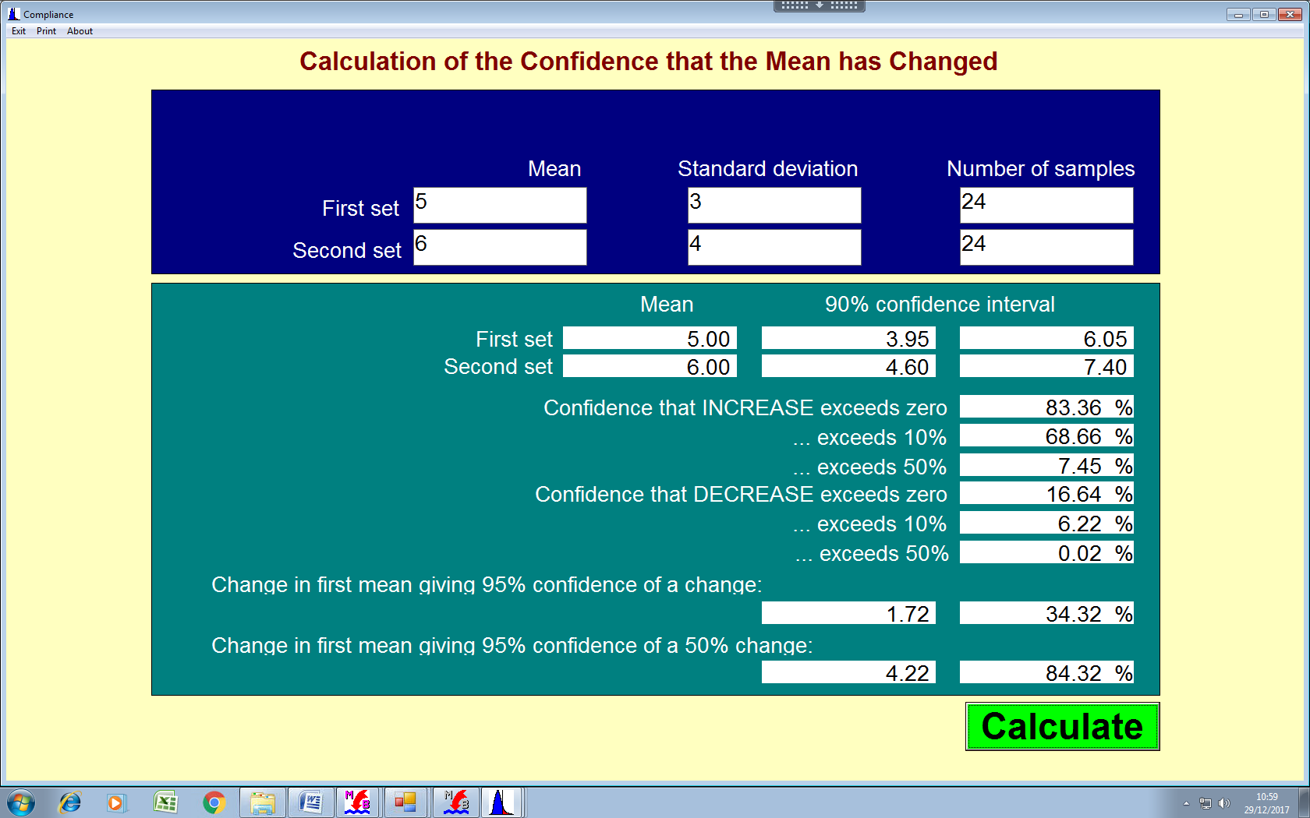

## 2.27 Warn Brew 4.5

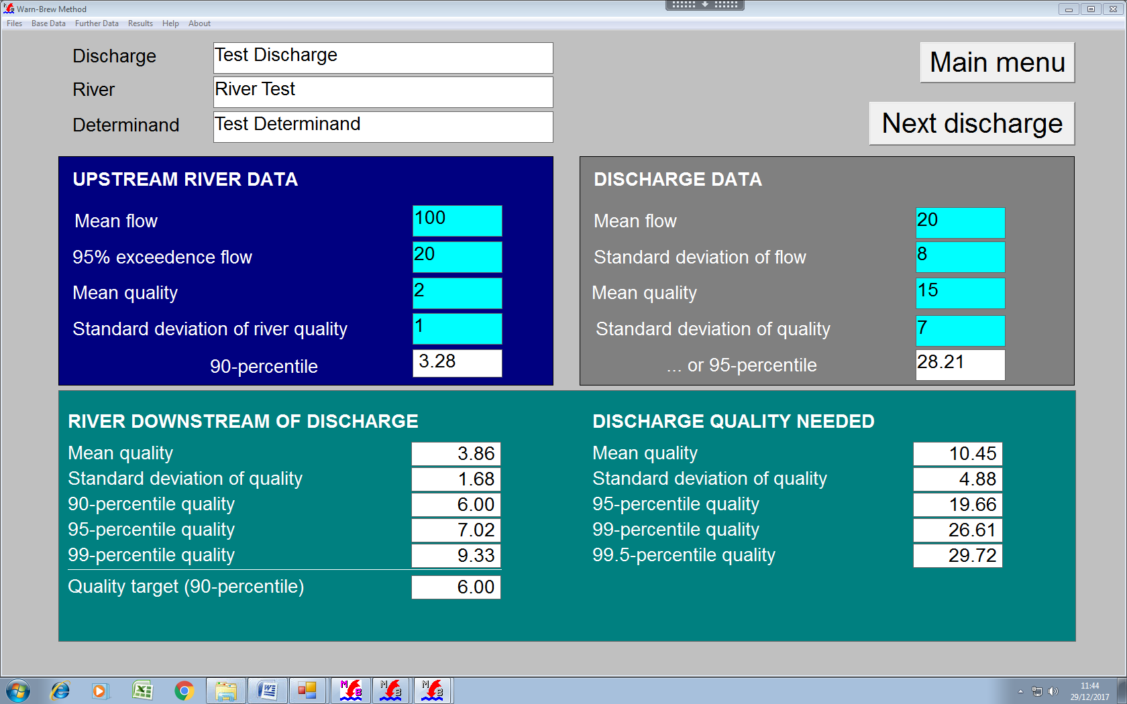

Comments

* Test data entered by typing 156 into the discharge box.
* Hardcopy available via Print option in Files drop down.

## 2.27 Opening Form - RQP Classic 2.5

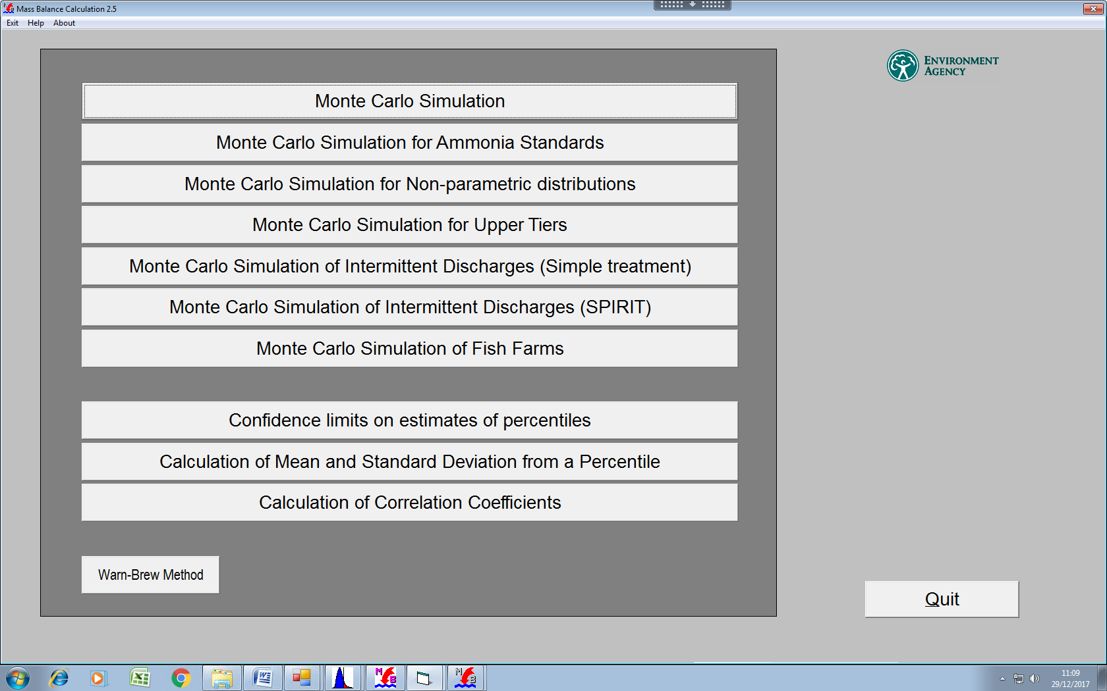

Comments

* In the following, test data entered by typing 156 into the discharge box. Additional and further date set as for 6.0.
* Hardcopy available via Print option in Files drop down.

## 2.28 Monte-Carlo 2.5

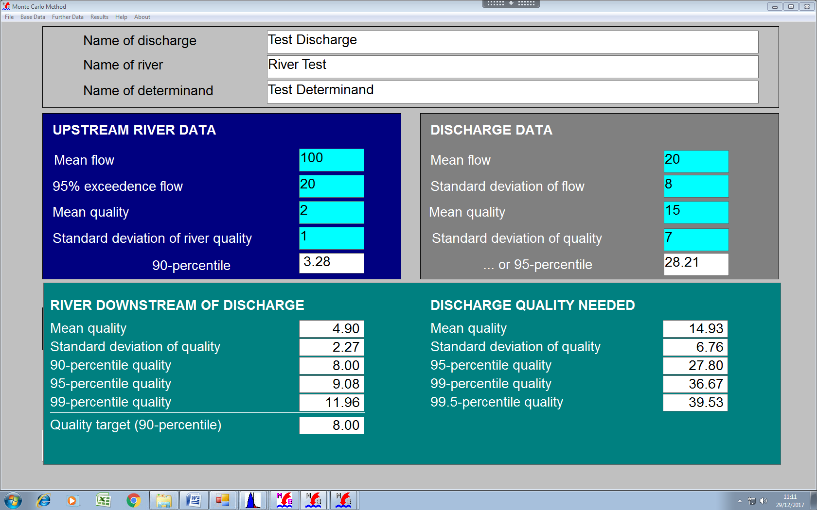

## 2.29 Ammonia 2.5

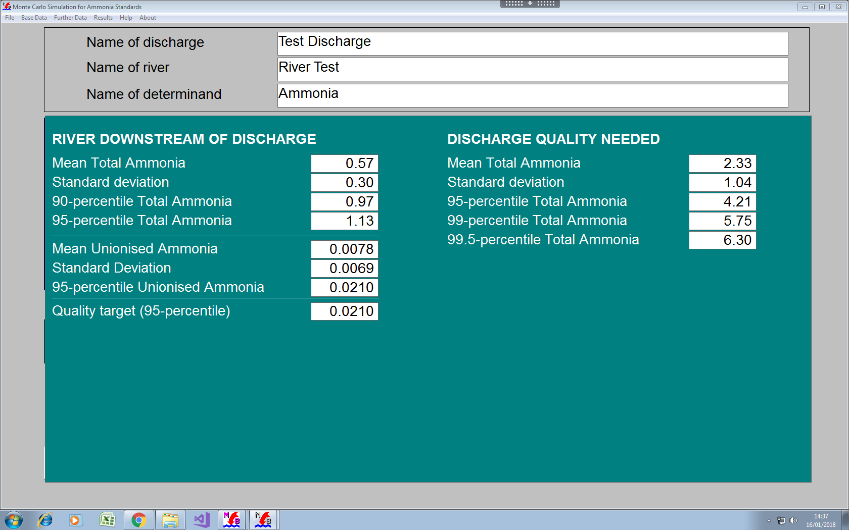

## 2.30 Non-Parametric 2.5

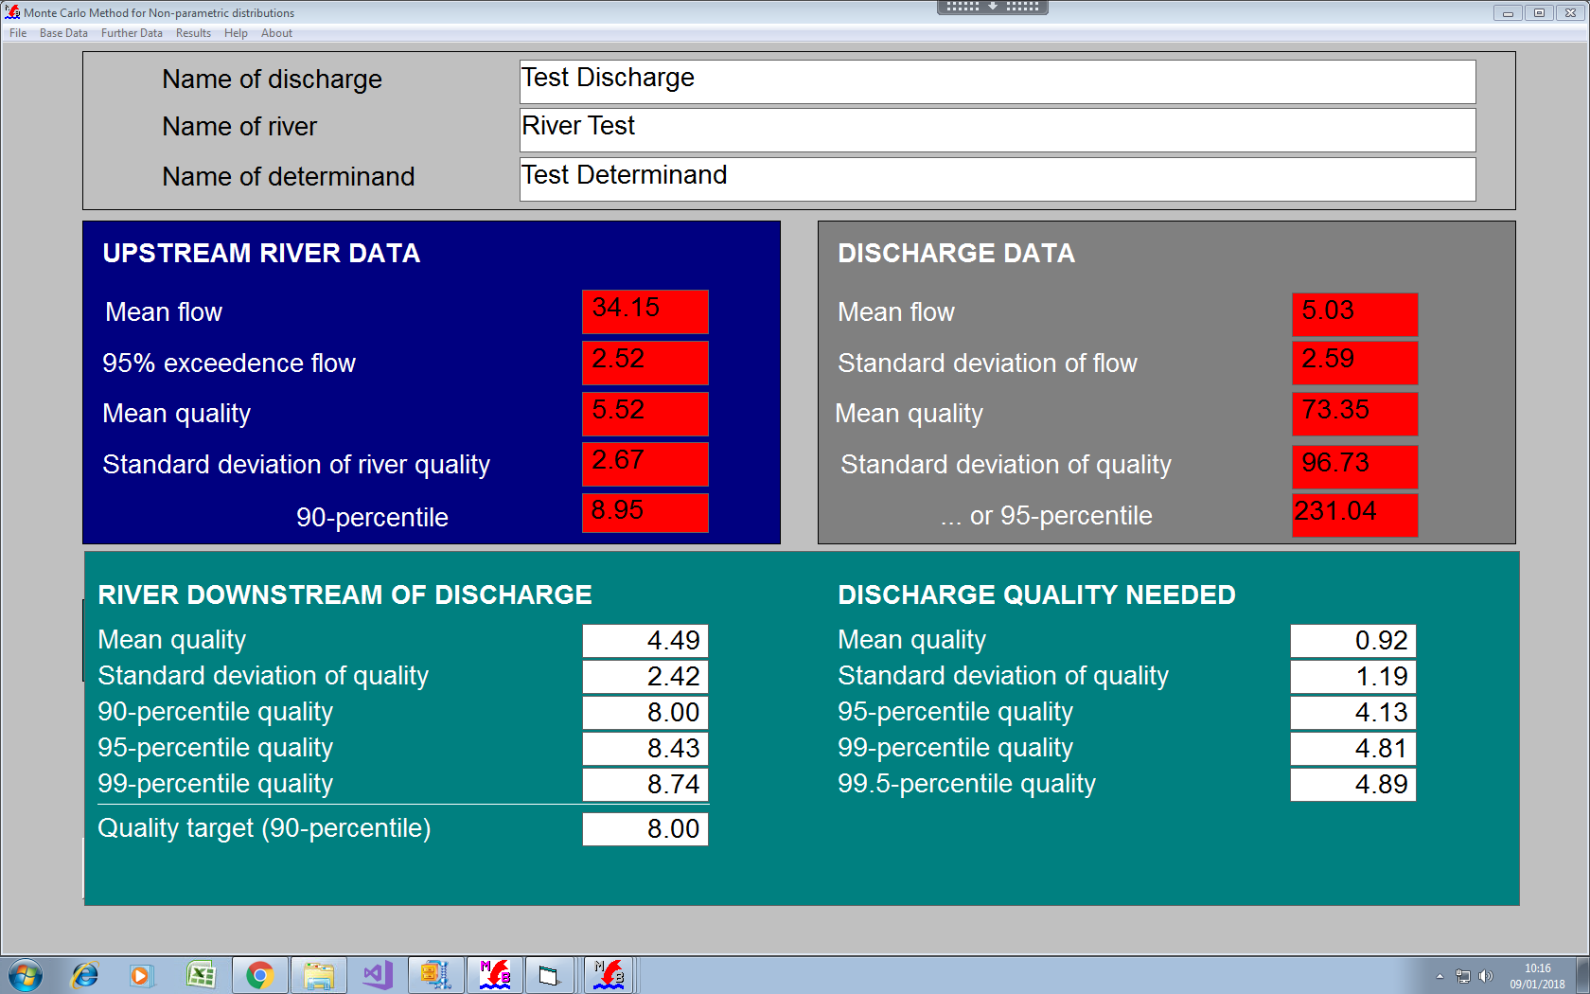

(5000 shots)

## 2.31 Upper Tiers 2.5

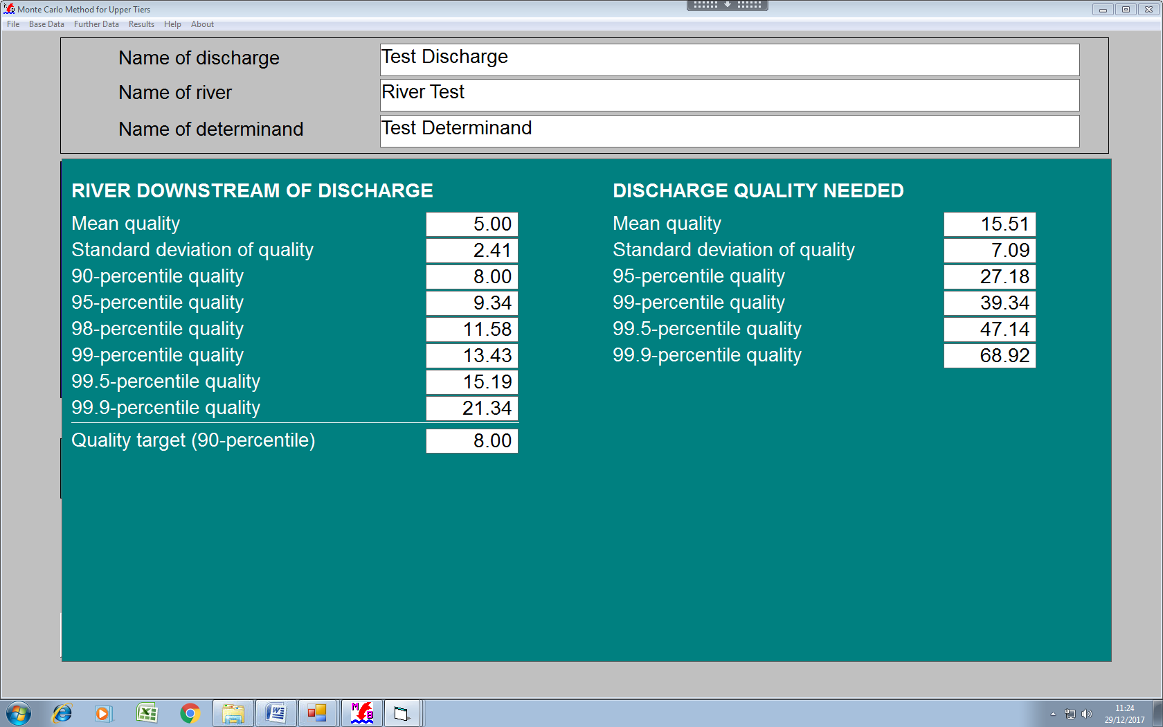

## 2.32 Intermittent – simple 2.5

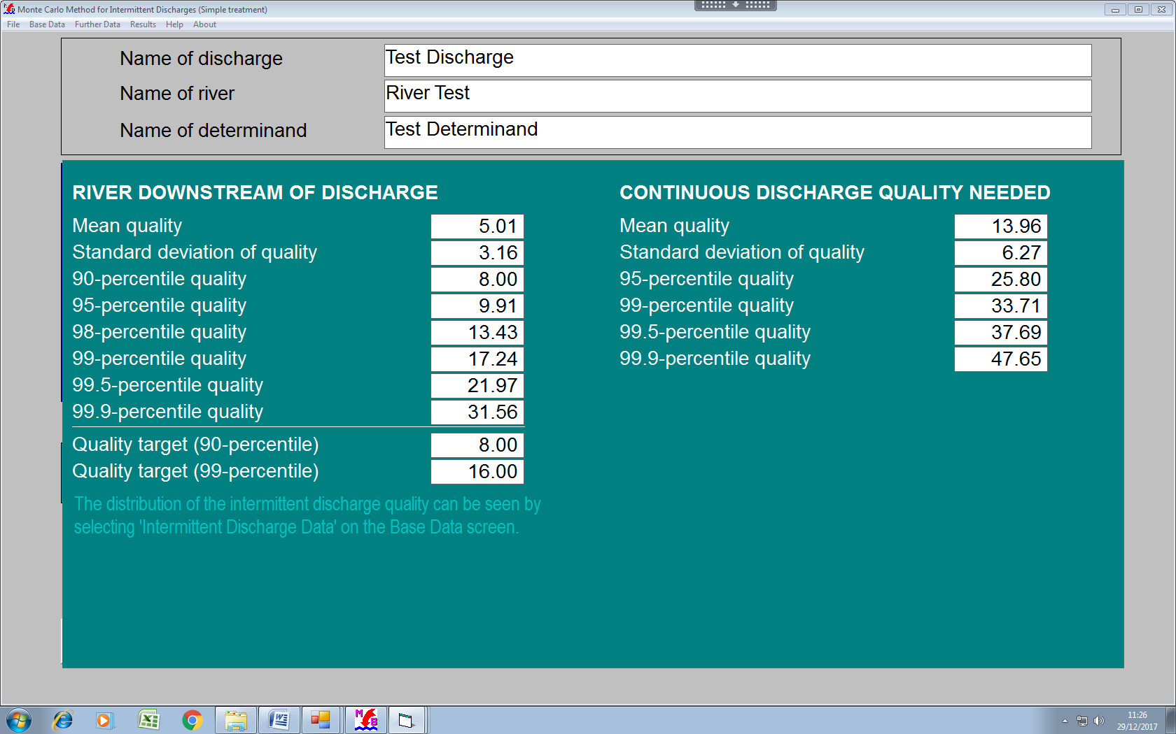

## 2.33 Intermittent – SPIRIT 2.5

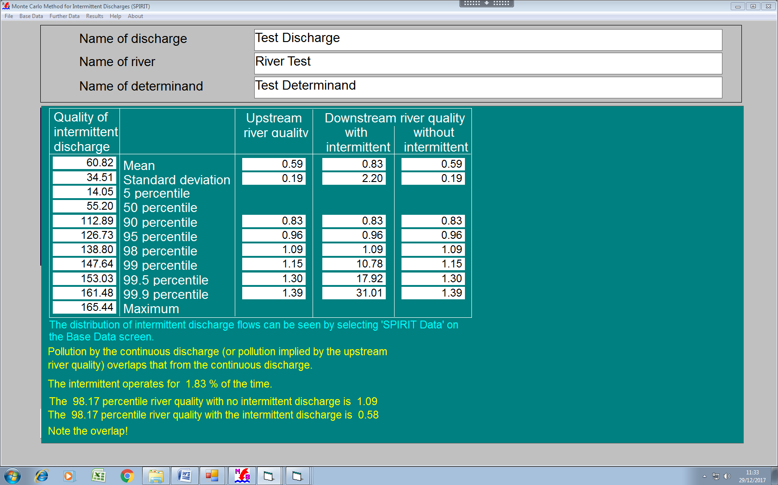

## 2.34 Fish farms 2.5

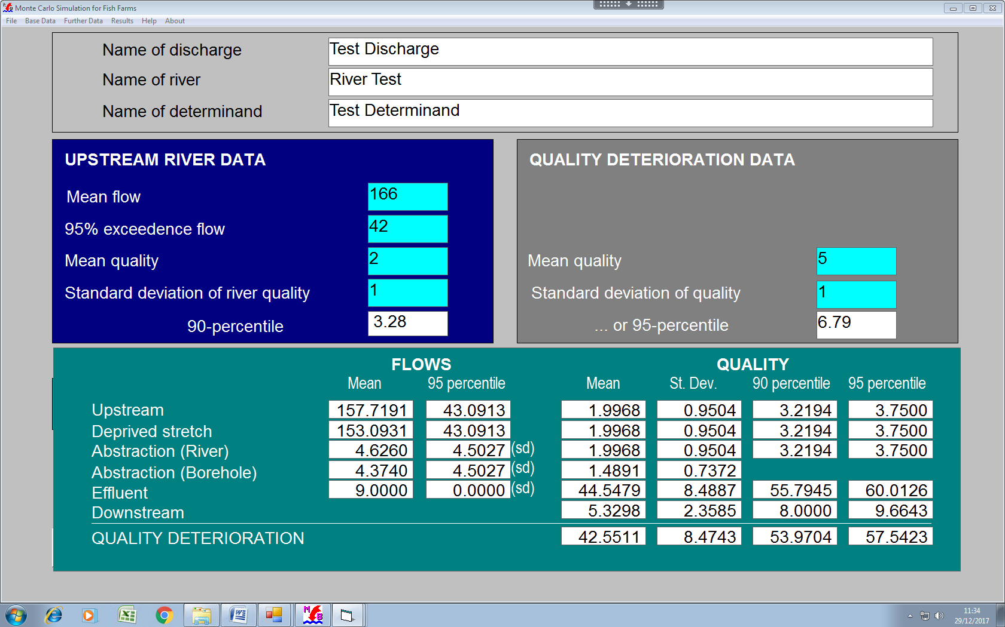

## 2.35 Percentile – from mean & SD 2.5

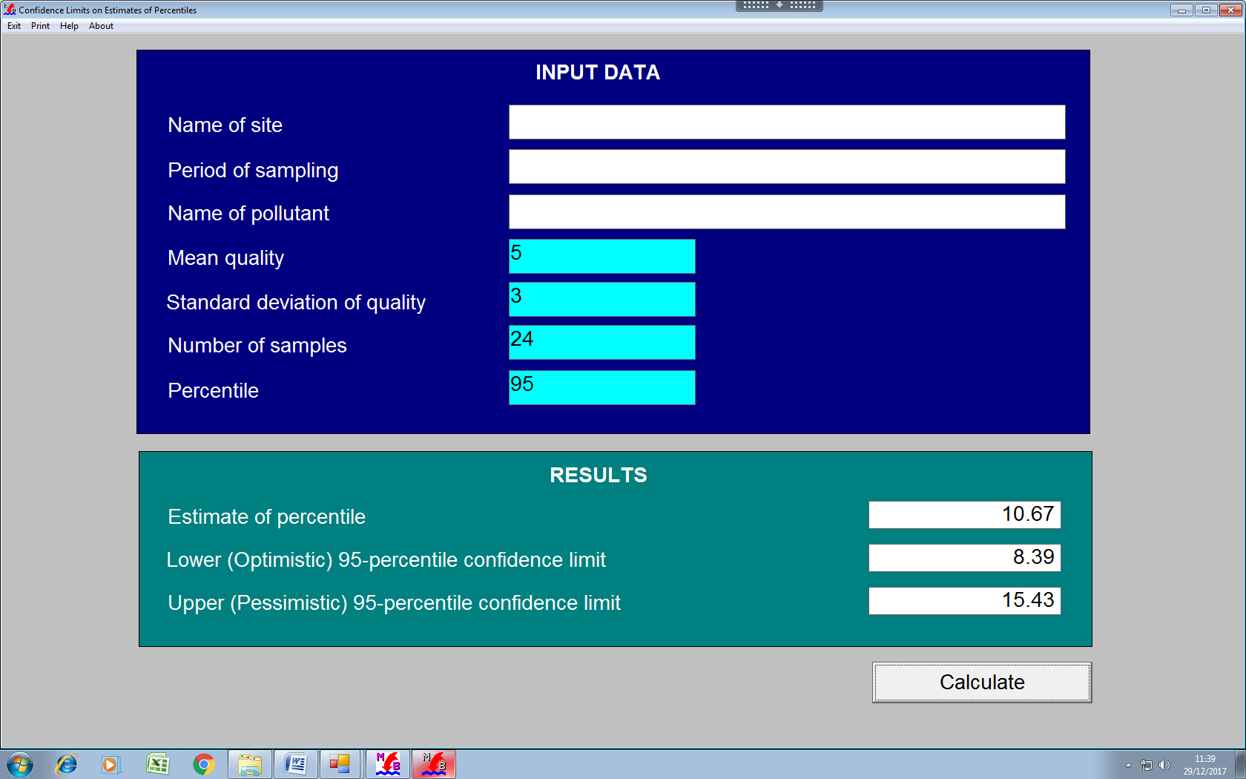

## 2.36 Mean & SD from percentile 2.5

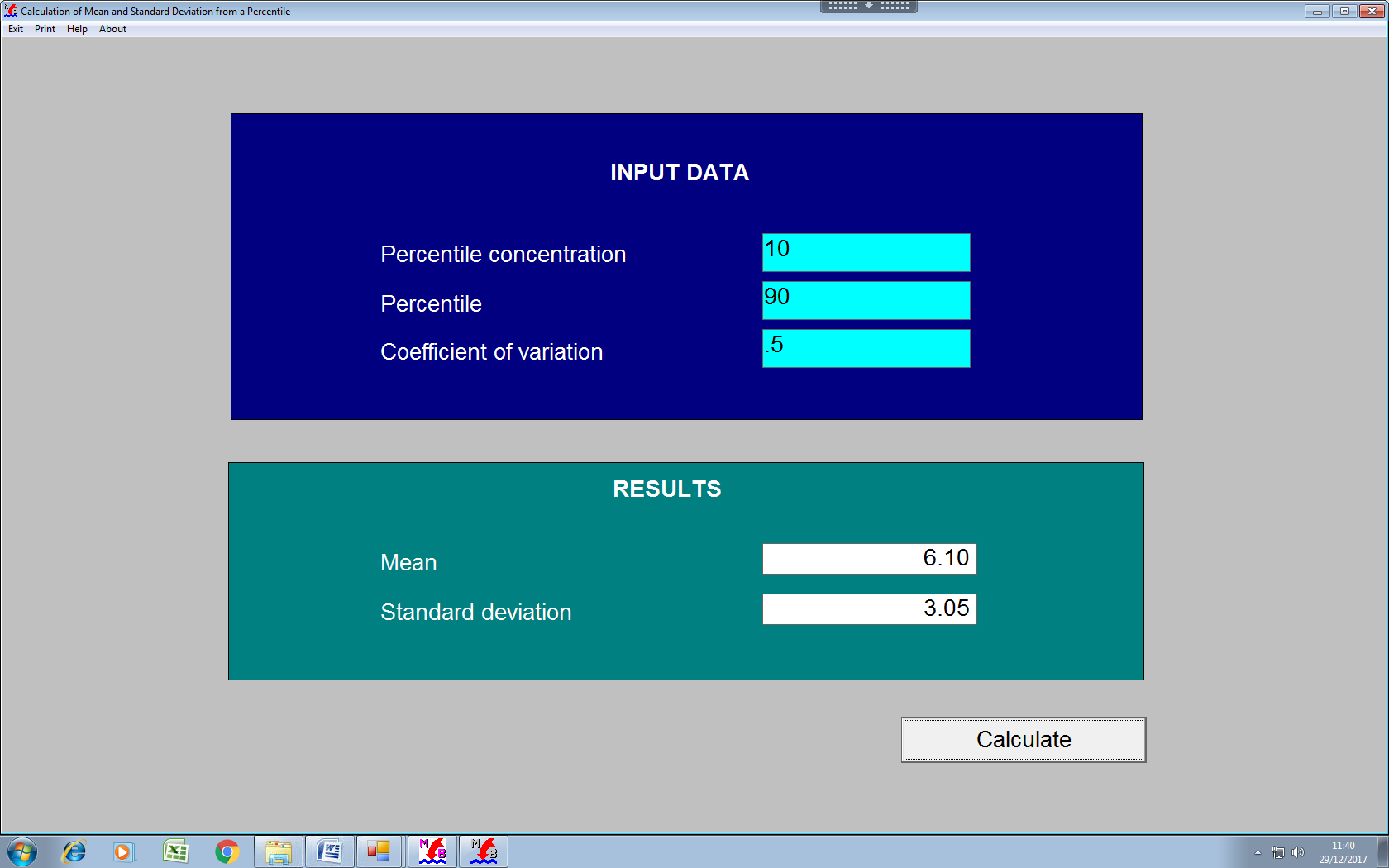

## 2.37 Warn Brew 2.5

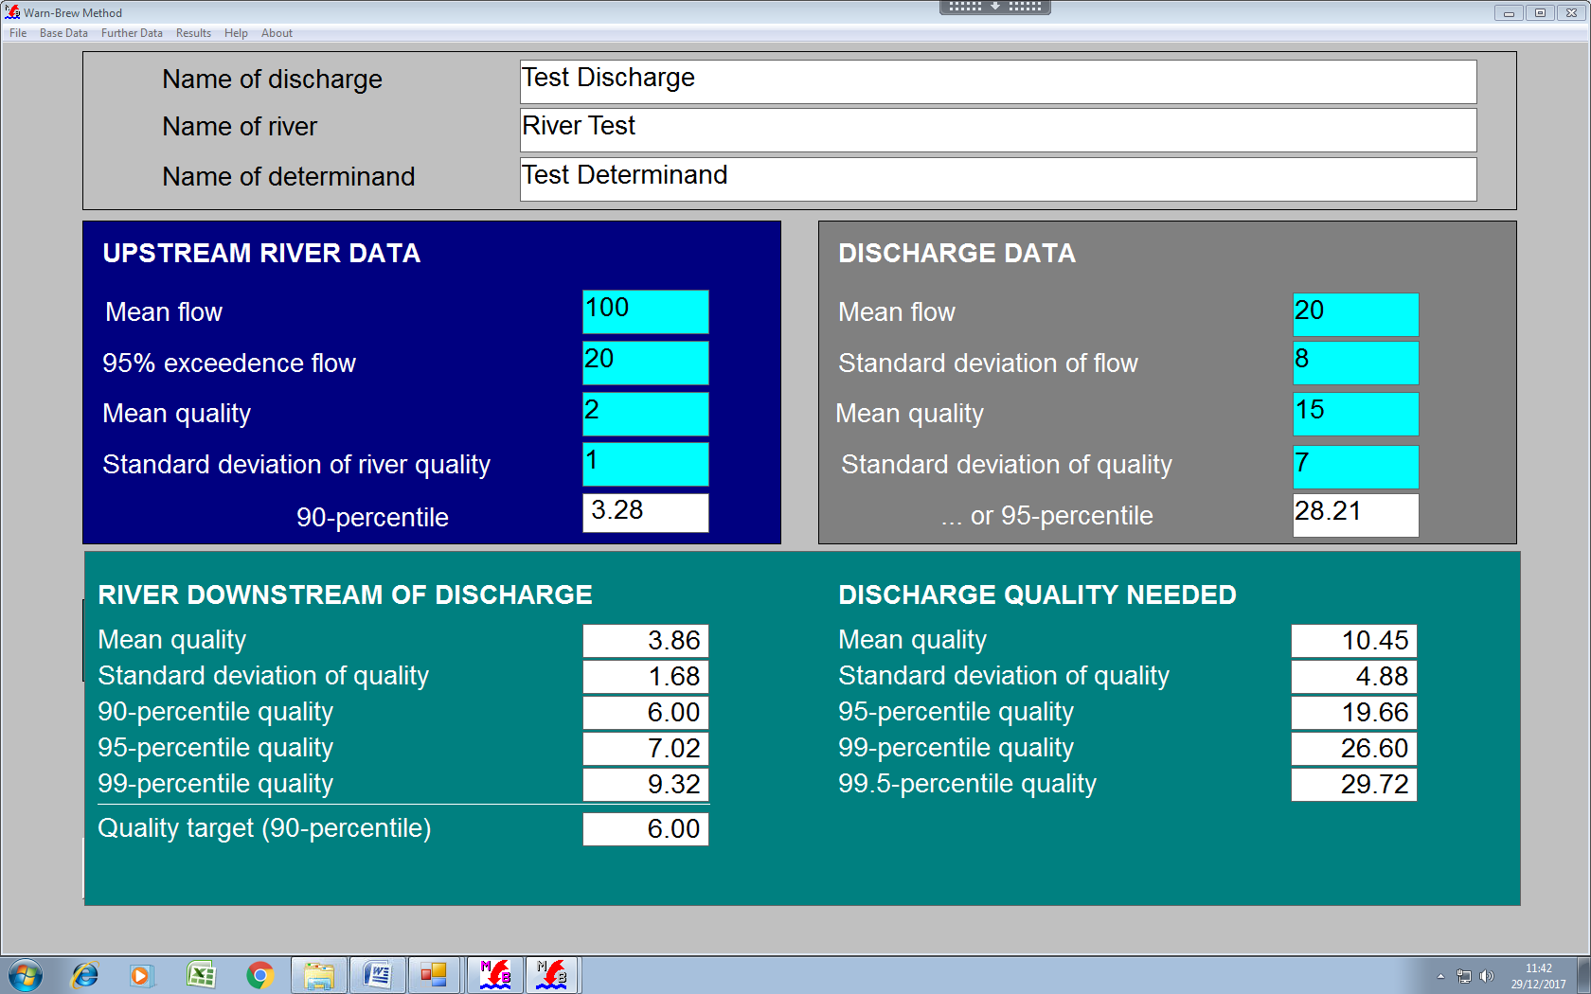

## 2.38 Phosphorus 1.0

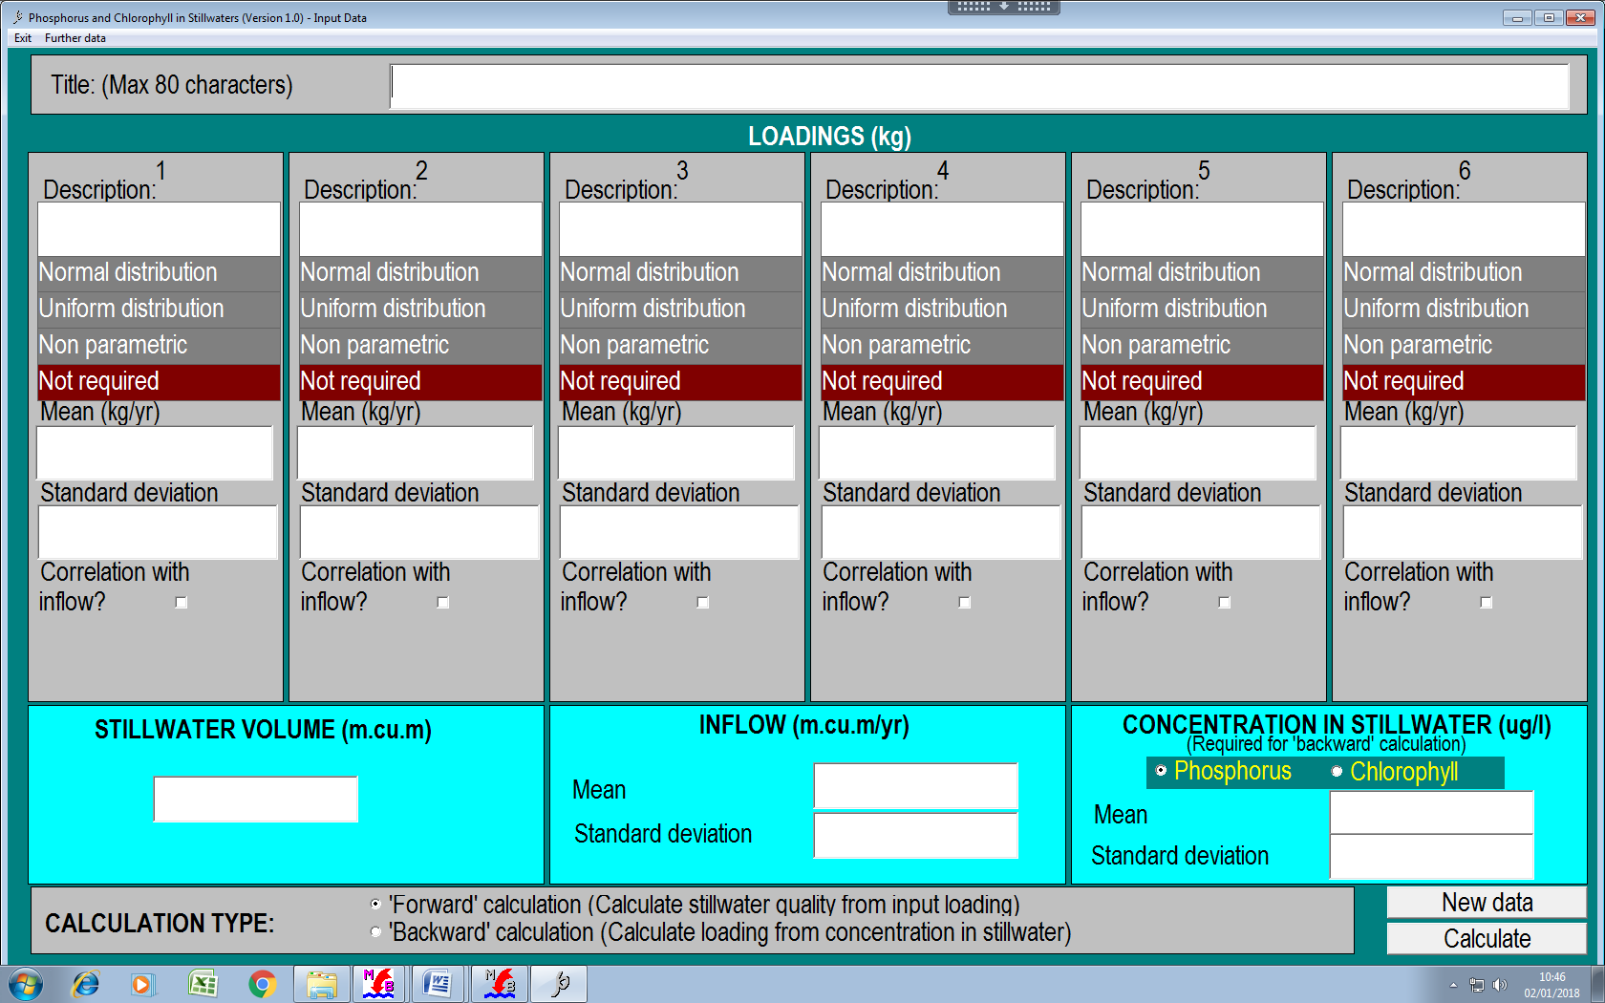

## 2.39 SIMCAT

See the SIMCAT Manual for comprehensive information on SIMCAT.

Three versions of SIMCAT are available 14.8,15.7 and 15.8.

* 14.8 is the PR19 version (accessed from the 4.5 form)
* 15.7 is the SAGIS code update version (accessed from the opening form)
* 15.8 is the latest version (accessed from the opening form)

As far as the calculations are concerned the 3 versions give the same results; and they are able to read any .dat file.

The 15.8 version has the opening screen shown below:



Point to note:

* The opening screen is quite different from previous versions.

There is some new functionality, in particular

* Graphs
* Results
* Viewing of files

Example graph:



Example results:

SIMCAT 15.8 Calculations: 18 December 2019 at 01:35

**Annual Mean Concentrations for Chloride...**

|  |  |  |  |
| --- | --- | --- | --- |
| LOCATION | Distance | Mean | Confidence |
| Start of Reach Upper Ouse | 0.00 | 35.0 | (33.6 - 36.4) |
| Pig Farm Gauging Station | 8.00 | 30.8 | (29.6 - 32.0) |
| Pig Farm Monitoring Station | 8.00 | 30.8 | (29.6 - 32.0) |
| Wellington STW | 16.00 | 37.2 | (34.9 - 39.5) |
| Wellington Monitoring Station | 18.00 | 36.5 | (34.1 - 38.8) |
| Middle Ouse Monitoring Station | 28.00 | 33.3 | (31.0 - 35.6) |
| End of Reach Upper Ouse | 29.00 | 33.0 | (30.7 - 35.4) |
| Start of Reach River Avon | 0.00 | 35.0 | (33.6 - 36.4) |
| Brickton STW | 6.00 | 44.9 | (41.4 - 48.4) |
| Valley Bottom Monitoring Station | 18.00 | 32.8 | (29.5 - 36.2) |
| Valley Bottom Gauging Station | 18.00 | 32.8 | (29.5 - 36.2) |
| End of Reach River Avon | 20.00 | 31.7 | (28.3 - 35.0) |
| Start of Reach Middle Ouse | 29.00 | 32.6 | (30.1 - 35.2) |
| Allied Industries | 31.00 | 32.9 | (30.2 - 35.6) |
| End of Reach Middle Ouse | 33.00 | 32.5 | (29.9 - 35.2) |
| Start of Reach Black Brook | 0.00 | 35.0 | (33.6 - 36.4) |
| Black Brook Monitoring Station | 4.00 | 17.3 | (16.4 - 18.1) |
| Appleford STW | 6.00 | 45.6 | (41.0 - 50.2) |
| End of Reach Black Brook | 10.00 | 38.0 | (33.7 - 42.3) |
| Start of Reach Lower Ouse I | 33.00 | 33.3 | (30.4 - 36.1) |
| New Mill Monitoring Station | 35.00 | 33.0 | (30.1 - 35.8) |
| New Mill Flow Gauging Station | 35.00 | 33.0 | (30.1 - 35.8) |
| End of Reach Lower Ouse I | 37.00 | 32.7 | (29.8 - 35.5) |
|  |  |  |  |
|  |  |  |  |
|  |  |  |  |

Note:

* The results utility can give an intermittent error. To remedy this, quit the form, return to the opening MPER-RQP form and then enter the Results form.

Viewing SIMCAT files:

Select one of the options below:



Note:

* You will get the error message below if you have not assigned the file type to be opened with WordPad/NotePad



## 3 Test data and Comparisons

## 3.1 Test data

For most of the Monte-Carlo applications (except bio-available MPER) typing 156 into the discharge box will enter the test data used above.

For MPER, type 15c (for copper), 15l (for lead), 15m (for manganese) 15n (for nickel) and 15z (for zinc) to enter test data.

For the compliance applications, there is no automatic entry. To test, use the values in the above forms.

## 3.2 Comparisons

The comparisons below are with the test data set ‘156’ (or bioavailable sets).

Where specific data (eg ammonia) and correlations differ, they have been matched to version 6.0 data.

### 3.2.1 Monte Carlo

|  |  |  |
| --- | --- | --- |
| Version  (Riv/dis flow corr = 0.6)  (others =0) | Forward Calculation  (Downstream concentration, confidence) | Back calculation  (emission limit, confidence) |
| 2.5 | 4.98 | 14.93 |
| 4.5 | 4.88 | 15.3 |
| 6.0 | 4.89 | 15.4 |

### 3,2,2 Bio-Available

|  |  |  |
| --- | --- | --- |
| Version  (Riv/dis flow corr = 0.6)  (River f/q =-.3, Dis f/q=-.2))  Copper | Forward Calculation  (Downstream concentration, confidence) | Back calculation  (emission limit, confidence) |
| 4.5 | 3.29 (2.16-4.42) | 42.7 (29.7-55.7) |
| 6.0 | 3.29 (2.16-4.42) | 42.7 (29.7-55.7) |

### 3.2.3 Ammonia

|  |  |  |
| --- | --- | --- |
| Version  (Riv/dis flow corr = 0.6)  (River f/q =-.3, Dis f/q=-.2)) | Forward Calculation  (Downstream concentration, confidence) | Back calculation  (emission limit, confidence) |
| 2.5 | 0.025 | 4.78 |
| 4.5 | 0.023 | 4.60 |
| 6.0 | 0.024 (0.019-0.029) | 4.59 (3.56 - 5.61) |

Note: Ammonia data and correlation set as for version 6.0



### 3.2.4 Non-parametric data

|  |  |  |
| --- | --- | --- |
| Version | Forward Calculation  (Downstream concentration, confidence) | Back calculation  (emission limit, confidence) |
| 2.5 (note – used 5000 shots) | 24.13 | 0.92 |
| 4.5 | 24.13 | 0.92 |

### 3.2.5 Upper Tiers

|  |  |  |
| --- | --- | --- |
| Version | Forward Calculation  (Downstream concentration, confidence) | Back calculation  (emission limit, confidence) |
| 2.5 | 4.82 | 15.51 |
| 4.5 | 4.82 | 15.51 |

### 3.2.6 Simple

|  |  |  |
| --- | --- | --- |
| Version | Forward Calculation  (Downstream concentration) | Back calculation  (emission limit,) |
| 2.5 | 5.01 | 14.97 |
| 4.5 | 5.01 | 14.97 |

### 3.2.7 Spirit

|  |  |  |
| --- | --- | --- |
| Version | Downstream with intermittent | Downstream without intermittent |
| 2.5 | 0.83 | 0.59 |
| 4.5 | 0.83 | 0.59 |

### 3.2.8 Fish Farms

|  |  |  |
| --- | --- | --- |
| Version | Forward calculation | Back calculation |
| 2.5 | 6.8 | 44.6 |
| 4.5 | 6.8 | 41.8 |

Note: Upstream flows differ. Error seems to be in version 2.5.

# 4 Input/Output files

## 4.1 Producing Input/ Output Files

For 6.0 applications

* Use WORD, EXCEL, Note (saves input only), Out (includes additional percentile information)

For 4.5 applications

* Use the drop down menu under ‘ file’:

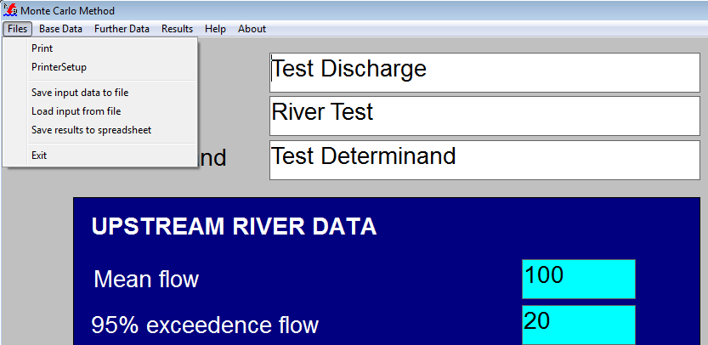

* Files are saved as text files with suffix .mbl or mbe (MPER)
* The Spreadsheet option should work, if the current Excel version is consistent with the application.

For 2.5 applications

* Use the drop down menu under ‘file’
* Files are saved as text files with suffix .mbl

Using Print Screen

* As most of the applications display the input and output data, you can use the Windows ‘Print Screen’ facility to copy the display and hence paste as needed.

## 4.2 Example files

### 4.2.1 Word/Print files

(157)

**MASS BALANCE (MONTE CARLO): Version 6.0**

Calculations: 13 December 2019 at 10:46

|  |  |  |  |  |
| --- | --- | --- | --- | --- |
| Discharge: | Clifton STW |  |  |  |
| River: | River Mall |  |  | 0 |
| Pollutant: | Test Pollutant | Target: | 6.0 | 90-percentile |

|  |  |  |  |  |  |
| --- | --- | --- | --- | --- | --- |
| Mean u/s river flow | 100 |  | Mean discharge flow | 20.0 |  |
| 95-percentile low flow | 20.0 |  | Standard deviation | 8.00 |  |
|  |  | (confidence) |  |  | (confidence) |
| Mean u/s river quality | 2.00 | (1.53 - 2.47) | Mean d/s river quality | 3.80 | (9.29 - 11.7) |
| Standard deviation | 1.00 | (0.69 - 1.33) | Standard deviation | 1.70 | (4.06 - 5.75) |
| Number of samples | 14 |  | Number of samples | 34 |  |
| 90-percentile | 3.23 | (2.55 - 4.80) | 90-percentile | 6.00 | (5.20 - 7.31) |
|  |  |  |  |  |  |
| **CURRENT DISCHARGE** |  | (confidence) | **REQUIRED DISCHARGE** |  | (confidence) |
| Mean discharge quality | 15.0 | (13.3 - 16.7) | Mean discharge quality | 10.5 | (9.29 - 11.7) |
| Standard deviation | 7.00 | (5.80 - 8.20) | Standard deviation | 4.90 | (4.06 - 5.75) |
| Number of samples | 47 |  | Number of samples | 47 |  |
| 95-percentile | 28.2 | (24.4 - 34.2) | 95-percentile | 28.2 | (17.5 - 24.4) |
| 99-percentile | 38.2 | (32.0 - 48.9) | 99-percentile | 38.2 | (22.4 - 34.3) |
| 99.5-percentile | 42.6 | (35.2 - 55.7) | 99.5-percentile | 42.6 | (24.4 - 38.8) |

|  |  |
| --- | --- |
| CORRELATION COEFFICIENTS |  |
| River and discharge flow | 0.6000 |
| River flow and quality | -0.3000 |
| Discharge flow and quality | -0.2000 |

|  |  |
| --- | --- |
|  | FILES WITH NON-PARAMETRIC DATA |
| River flow | none |
| River quality | none |
| Discharge flow | none |
| Discharge quality | none |
| Intermittent discharge flow |  |

|  |  |
| --- | --- |
|  | INTERMTTENT DISCHARGE ADDED |
| % time in operation | 0.0000 |
| Mean flow (when operating) | 0.0000 |
| Standard deviation | 0.0000 |
| Correlation coefficient | 0.0000 |
| Mean quality | 0.0000 |
| Standard deviation | (0.0000 - 0.0000) |
| Correlation with flow | 0 |

|  |  |
| --- | --- |
| Effects of ... | ... on the required discharge quality |
| 10% change in: in mean u/s river flow | 2.9 % |
| 95-river flow | 3.5 % |
| mean discharge flow | 8.4 % |
| standard deviation | 1.5 % |
| u/s river quality | 3.4 % |
| standard deviation | 1.2 % |
| variability of discharge quality | 3.4 % |
| river target | 16.2 % |
| 0.1 change in correlation of river and discharge flow | 1.7 % |
| 0.1 change in correlation of river flow and quality | 0.5 % |
| 0.1 change for discharge flow and quality | 1.8 % |

15c

**MASS BALANCE (BIO-AVAILABLE METALS): Version 6.0**

Calculations: 13 December 2019 at 10:50

|  |  |  |  |  |
| --- | --- | --- | --- | --- |
| Discharge: | Clifton STW |  |  |  |
| River: | River Mall |  | 1 | 0 |
| Pollutant: | Copper | Target: bio-metal | 1.00 | (mean) |

|  |  |  |  |  |  |
| --- | --- | --- | --- | --- | --- |
| Mean u/s river flow | 100 |  | Mean discharge flow | 20.0 |  |
| 95-percentile low flow | 10.0 |  | Standard deviation | 10.0 |  |
|  |  | (confidence) |  |  | (confidence) |
| Mean u/s diss. metal | 1.00 | (0.55 - 1.45) | Mean d/s diss. metal | 12.4 | (8.76 - 16.1) |
| Standard deviation | 1.00 | (0.69 - 1.31) | Standard deviation | 14.5 | (12.0 - 17.1) |
| Number of samples | 15 |  | Number of samples | 45 |  |
| 95-percentile diss. metal | 2.86 | (1.86 - 6.06) | 95-percentile diss. metal | 37.9 | (28.4 - 55.9) |
| Mean u/s bio-metal | 0.35 | (0.15 - 0.56) | Mean d/s bio-metal | 1.00 | (0.66 - 1.34) |
| Standard deviation | 0.42 | (0.28 - 0.56) | Standard deviation | 1.16 | (0.92 - 1.39) |
| Number of samples | 15 |  | Number of samples | 45 |  |
|  |  |  |  |  |  |
| **CURRENT DISCHARGE** |  | (confidence) | **REQUIRED DISCHARGE** |  | (confidence) |
| Mean discharge quality | 150 | (114 - 186) | Mean discharge quality | 42.7 | (29.7 - 55.7) |
| Standard deviation | 150 | (125 - 175) | Standard deviation | 42.7 | (33.6 - 51.8) |
| Number of samples | 49 |  | Number of samples | 49 |  |
| 95-percentile | 417 | (320 - 594) | 95-percentile | 121 | (85.5 - 189) |
| 99-percentile | 736 | (530 - 1156) | 99-percentile | 213 | (131 - 394) |
| 99.5-percentile | 906 | (636 - 1477) | 99.5-percentile | 247 | (136 - 503) |

|  |  |
| --- | --- |
| CORRELATION COEFFICIENTS |  |
| River and discharge flow | 0.6000 |
| River flow and quality | 0.1000 |
| Discharge flow and quality | -0.2000 |

|  |  |  |  |  |  |
| --- | --- | --- | --- | --- | --- |
| Mean pH (u/s & d/s) | 8.00 | (7.91 - 8.09) | Mean calcium (u/s & d/s) | 50.0 | (46.1 - 53.9) |
| Standard deviation | 0.28 | (0.22 - 0.34) | Standard deviation | 12.5 | (9.80 - 15.2) |
| Number of samples | 30 |  | Number of samples | 30 |  |
| Mean DOC in u/s river | 1.50 | (1.25 - 1.75) | Mean DOC in discharge | 15.0 | (12.5 - 17.5) |
| Standard deviation | 0.80 | (0.63 - 0.97) | Standard deviation | 8.00 | (6.27 - 9.73) |
| Number of samples | 30 |  | Number of samples | 30 |  |

|  |  |
| --- | --- |
| MORE CORRELATION COEFFICIENTS |  |
| pH and river flow | 0.1200 |
| Calcium and river flow | 0.6000 |
| Calcium and pH | 0.1011 |
| Upstream DOC and river flow | -0.1100 |
| Discharge DOC and flow | -0.2000 |

|  |  |
| --- | --- |
| Effects of ... | ... on the required discharge quality |
| 10% change in: in mean u/s river flow | 1.1 % |
| 95-river flow | 0.8 % |
| mean discharge flow | 2.3 % |
| standard deviation | 0.4 % |
| u/s river quality | 1.0 % |
| standard deviation | 0.0 % |
| variability of discharge quality | 0.3 % |
| river target | 12.2 % |
| 0.1 change in correlation of river and discharge flow | 0.1 % |
| 0.1 change in correlation of river flow and quality | 0.5 % |
| 0.1 change for discharge flow and quality | 1.3 % |

|  |  |
| --- | --- |
| Effects of 10% change in ... | ... on the required discharge quality |
| 2% change in: mean pH | 19.2 % |
| 10% change in: standard deviation | -1.3 % |
| mean calcium | 1.0 % |
| standard deviation | 0.0 % |
| mean upstream DOC | 5.0 % |
| standard deviation | -0.3 % |
| mean discharge DOC | 13.2 % |
| standard deviation | -3.4 % |
| 0.1 change in correlation of pH and river flow | -0.1 % |
| 0.1 for calcium and river flow | 0.3 % |
| 0.1 for calcium and pH | 0.3 % |
| 0.1 change for upstream DOC and flow | 0.9 % |
| 0.1 change for discharge DOC and flow | -0.1 % |

156

**MASS BALANCE (AMMONIA): Version 6.0**

Calculations: 13 December 2019 at 10:53

|  |  |  |  |  |
| --- | --- | --- | --- | --- |
| Discharge: | Clifton STW |  |  |  |
| River: | River Mall |  | 1 | 0 |
| Pollutant: | Free Ammonia | Target: | 0.020 | (mean) |

|  |  |  |  |  |  |
| --- | --- | --- | --- | --- | --- |
| Mean u/s river flow | 100 |  | Mean discharge flow | 20.0 |  |
| 95-percentile low flow | 20.0 |  | Standard deviation | 8.00 |  |
|  |  | (confidence) |  |  | (confidence) |
| Mean u/s total ammonia | 0.10 | (0.053 - 0.15) | Mean d/s total ammonia | 2.76 | (2.32 - 3.19) |
| Standard deviation | 0.10 | (0.064 - 0.13) | Standard deviation | 1.76 | (1.45 - 2.07) |
| Number of samples | 14 |  | Number of samples | 46 |  |
|  |  |  |  |  |  |
| Mean u/s free ammonia | 0.0007 | (0.0003 - 0.0011) | Mean d/s free ammonia | 0.020 | (0.016 - 0.024) |
| Standard deviation | 0.0008 | (0.0006 - 0.0011) | Standard deviation | 0.018 | (0.015 - 0.021) |
| Number of samples | 14 |  | Number of samples | 46 |  |
|  |  |  |  |  |  |
| **CURRENT DISCHARGE** |  | (confidence) | **REQUIRED DISCHARGE** |  | (confidence) |
| Mean discharge quality | 15.0 | (13.3 - 16.7) | Mean discharge quality | 12.4 | (9.79 - 14.9) |
| Standard deviation | 7.00 | (5.80 - 8.20) | Standard deviation | 5.57 | (3.76 - 7.38) |
| Number of samples | 47 |  | Number of samples | 47 |  |
| 95-percentile | 28.2 | (24.4 - 34.2) | 95-percentile | 28.2 | (16.1 - 34.9) |
| 99-percentile | 38.2 | (32.0 - 48.9) | 99-percentile | 38.2 | (17.1 - 57.2) |
| 99.5-percentile | 42.6 | (35.2 - 55.7) | 99.5-percentile | 42.6 | (15.6 - 68.3) |

|  |  |
| --- | --- |
| CORRELATION COEFFICIENTS |  |
| River and discharge flow | 0.6000 |
| River flow and quality | -0.3000 |
| Discharge flow and quality | -0.2000 |

|  |  |  |  |  |  |
| --- | --- | --- | --- | --- | --- |
| Mean pH | 7.80 | (7.70 - 7.90) | Mean alkalinity | 100 | (94.8 - 105) |
| Standard deviation | 0.20 | (0.13 - 0.27) | Standard deviation | 15.0 | (11.4 - 18.6) |
| Number of samples | 12 |  | Number of samples | 24 |  |
| Total dissolved solids | 260 | (244 - 276) | Mean dissolved oxygen | 7.00 | (6.01 - 7.99) |
| Standard deviation | 30.0 | (19.0 - 41.0) | Standard deviation | 2.00 | (1.33 - 2.67) |
| Number of samples | 11 |  | Number of samples | 13 |  |
| Mean temperature | 10.0 |  |  |  |  |
| Standard deviation | 2.00 |  |  |  |  |

|  |  |
| --- | --- |
| MORE CORRELATION COEFFICIENTS |  |
| pH and temperature | 0.1100 |
| River flow and temperature | 0.1200 |
| Alkalinity and temperature | 0.1400 |
| TDS and river flow | 0.1300 |

|  |  |
| --- | --- |
| Effects of ... | ... on the required discharge quality |
| 10% change in: in mean u/s river flow | 3.8 % |
| 95-river flow | 3.8 % |
| mean discharge flow | 9.8 % |
| standard deviation | 1.7 % |
| u/s river quality | 0.3 % |
| standard deviation | 0.0 % |
| variability of discharge quality | 5.4 % |
| river target | 11.4 % |
| 0.1 change in correlation of river and discharge flow | 1.5 % |
| 0.1 change in correlation of river flow and quality | 0.2 % |
| 0.1 change for discharge flow and quality | 1.8 % |

|  |  |
| --- | --- |
| Effects of 10% change ... | ... on the required discharge quality |
| 2% change in: mean pH | 25.7 % |
| 10% change in: standard deviation | -0.4 % |
| mean temperature | 6.9 % |
| standard deviation | 0.2 % |
| mean alkalinity | 4.7 % |
| standard deviation | -0.1 % |
| total dissolved solids | 0.2 % |
| standard deviation | 0.0 % |
| total dissolved solids | 5.4 % |
| standard deviation | -0.9 % |
| 0.1 change in correlation of pH and temperature | -0.8 % |
| 0.1 for alkalinity and temperature | 0.1 % |
| 0.1 change for river flow and temperature | 0.4 % |
| 0.1 change for river flow and total dissolved solids | 0.0 % |

### 4.2.2 Excel Files

157



15c

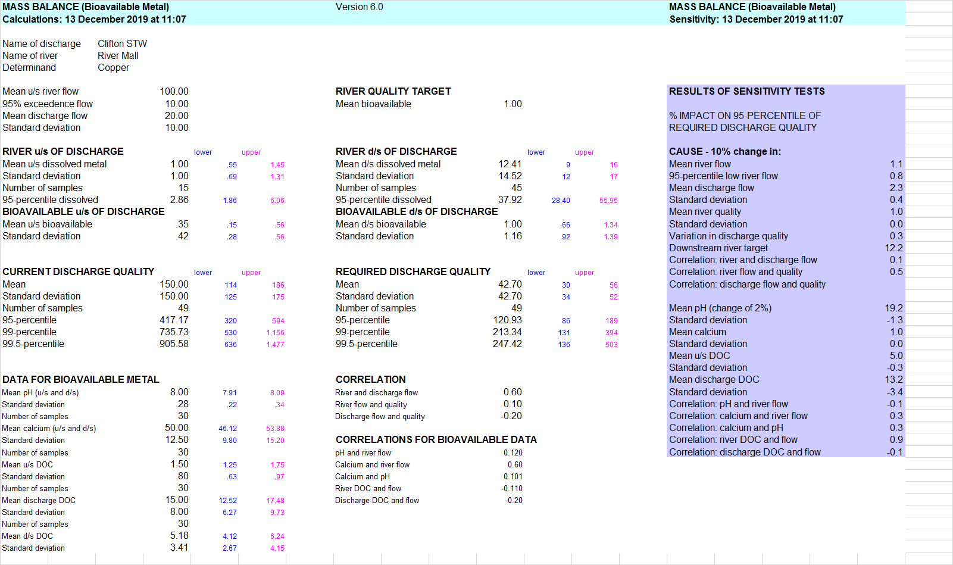

156

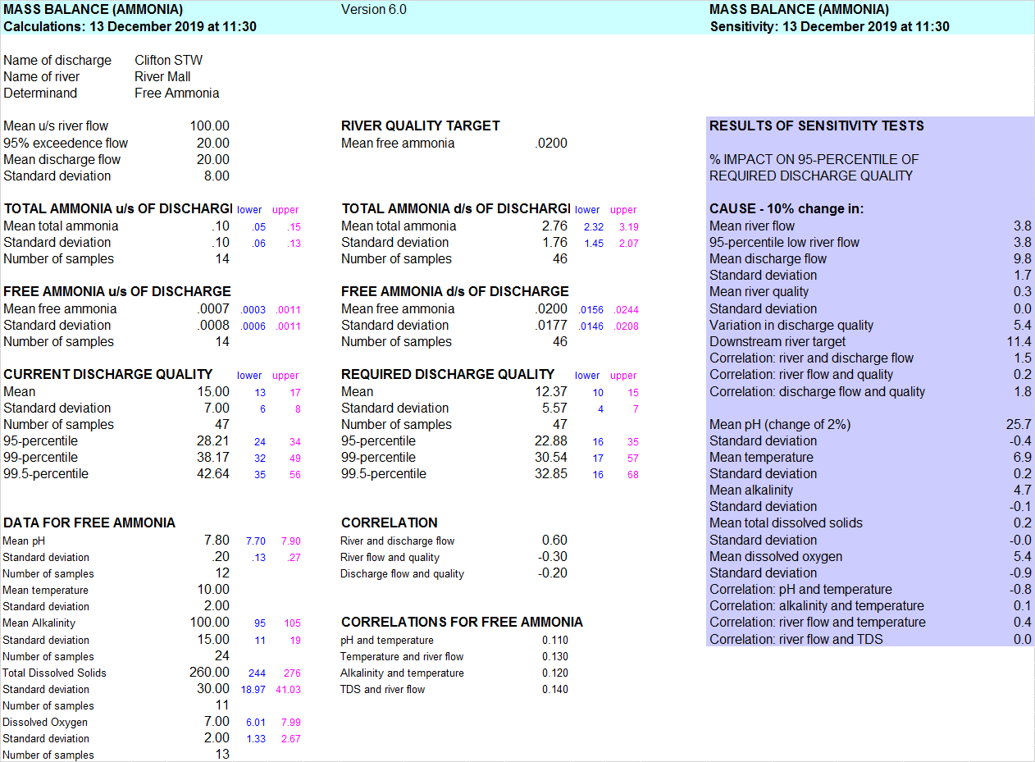

156

|  |  |  |  |  |  |  |  |  |
| --- | --- | --- | --- | --- | --- | --- | --- | --- |
| **MASS BALANCE (MONTE CARLO SIMULATION)** | | | | |  | Version 4.4 |  |  |
| **Calculations done:** | |  |  |  |  | 13/12/2019 at 11:14 | | |
|  |  |  |  |  |  |  |  |  |
| Name of discharge | | Test Discharge | |  |  |  |  |  |
| Name of river | | River Test | |  |  |  |  |  |
| Determinand | | Test Determinand | | |  |  |  |  |
|  |  |  |  |  |  |  |  |  |
| **UPSTREAM RIVER** | |  |  |  | **RIVER DOWNSTREAM OF DISCHARGE** | | | |
| Mean flow |  |  | 100.00 |  |  |  |  |  |
| 95% exceedence flow | |  | 20.00 |  |  |  |  |  |
| Mean quality | |  | 2.00 |  | Mean quality | |  | 4.95 |
| Standard deviation | |  | 1.00 |  | Standard deviation | |  | 2.36 |
| 90-percentile | |  | 3.28 |  | 90-percentile | |  | 8.00 |
|  |  |  |  |  |  |  |  |  |
|  |  |  |  |  | Target |  |  | 8.00 |
|  |  |  |  |  |  |  |  |  |
| **DISCHARGE** | |  |  |  | **REQUIRED DISCHARGE QUALITY** | | | |
| Mean flow |  |  | 20.00 |  |  |  |  |  |
| Standard deviation | |  | 8.00 |  |  |  |  |  |
| Mean quality | |  | 15.00 |  | Mean quality | |  | 15.28 |
| Standard deviation | |  | 7.00 |  | Standard deviation | |  | 6.86 |
| 95-percentile | |  | 28.21 |  | 95-percentile | |  | 28.24 |
| 99-percentile | |  | 38.18 |  | 99-percentile | |  | 36.90 |
| 99.5-percentile | |  | 42.65 |  | 99.5-percentile | |  | 41.25 |
| 99.9-percentile | |  | 53.58 |  | 99.9-percentile | |  | 52.15 |
|  |  |  |  |  |  |  |  |  |
|  |  |  |  |  |  |  |  |  |

15c



156



4.3 MBL and MBE files

MBE

B

Clifton STW

River Mall

Copper

100 'Mean upstream river flow'

10 '95-percentile low flow'

1 'Mean upstream river quality'

1 'Standard deviation'

15 'Number of samples'

20 'Mean discharge flow'

10 'Standard deviation'

150 'Mean discharge quality'

150 'Standard deviation'

49 'Number of samples'

1 'Target concentration'

1 'Type of calculation'

0 'Percentile'

0 'Forward or backward calculation'

0.1 'Correlation between upstream flow and quality'

0.6 'Correlation between river and discharge flow'

0 'Correlation between river flow and discharge quality'

0 'Correlation between discharge flow and river quality'

-0.2 'Correlation between discharge flow and quality'

0 'Correlation between river and discharge quality'

1.5 0.8 -0.11 30 'Upstream DOC'

8 0.28 0.12 30 0.12 'Downstream pH'

50 12.5 0.6 30 'Downstream calcium'

15 8 -0.2 30 'Discharge DOC'

MBL

MC

Test Discharge

River Test

Test Determinand

100 Mean upstream river flow

20 95-percentile low flow

2 Mean upstream river quality

1 Standard deviation

20 Mean discharge flow

8 Standard deviation

15 Mean discharge quality

7 Standard deviation

8 Target concentration

90 Percentile

0 Forward or backward calculation

0 Correlation between upstream flow and quality

0.6 Correlation between river and discharge flow

0 Correlation between river flow and discharge quality

0 Correlation between discharge flow and river quality

0 Correlation between discharge flow and quality

0 Correlation between river and discharge quality

0 Added flow

0 Regulated flow

0 Shift parameter for upstream river flow

0 Mean quality of added water

0 Standard deviation

5000 Number of Monte Carlo shots

-1996 Random number starter

4.4 Additional files from MPER 4.5

MPER 4.5 also generates the following files (which are held RQP 4.5 subdirectory):

* Bio.csv
* Bio.cur
* Bio.mod
* Biodat.csv

# 5 Printing

For 6.0 applications

* Save the output in WORD/EXCEL and print from there.

For 4.5 applications

* Use the Print facility under the ‘files’ drop down



* Except for MPER where you use the print menu button

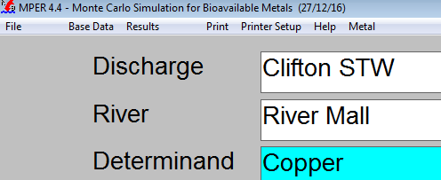

You can also save as spreadsheet and print it.

For 2.5 applications

* As for 4.4

# 6 Software

## 6.1 System Directories

The system directories are shown below:

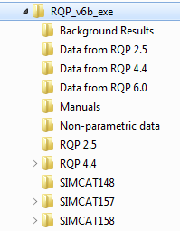

The contents are:

|  |  |
| --- | --- |
| Directory | Contents |
| ‘Top’  (here RQP_v6) | Applications and .dll for 6.0  Run time output files.  ‘Bioavailable’ output files. |
| Background Results | Contains output files, which are automatically generated and overwritten on each run from some 6.0 applications (MC,Bio, Amm). (Useful for program diagnostic purposes) |
| DATA* | Example output files |
| MPER_RQP_v6_manual | This document |
| Non-parametric data | Example input data |
| RQP 2.5 | RQP programs, .dlls and run time files |
| RQP 4.4 | RQP programs, .dlls and run time files |
| SIMCAT148 | Example input/output files for SIMCAT 148 |
| SIMCAT157 | Example input/output files for SIMCAT 157 |
| SIMCAT158 | Example input/output files for SIMCAT 158 |

## 6.2 Files

| Directory | Type | Sub system | Name | Description |
| --- | --- | --- | --- | --- |
| RQP_v6 | Application | 6.0 | RQP_v6.exe | Opens main form and runs 6.0 apps (Monte-Carlo,Bio-Av.,Ammonia, Warn Brew) |
| RQP_V6 | Application | 6.0 | SIMCAT157.exe | SIMCAT user interface |
| RQP_V6 | Application | 6.0 | SIMCATf157.exe | SIMCAT calculations |
| RQP_V6 | Application | 6.0 | SIMCAT148.exe | SIMCAT user interface |
| RQP_V6 | Application | 6.0 | SIMCATf148.exe | SIMCAT calculations |
| RQP_V6 | Application | 6.0 | Compliance.exe |  |
| RQP_V6 | .dll | 6.0 | BLACK_AM | Ammonia |
| RQP_V6 | .dll | 6.0 | BLACK_BA | Bio available |
| RQP_V6 | .dll | 6.0 | BLACK_CP | Compliance |
| RQP_V6 | .dll | 6.0 | BLACK_MC | Monte-Carlo |
| RQP_V6 | .dll | 6.0 | BLACK_MCNP | Monte-Carlo |
| RQP_V6 | .dll | 6.0 | BLACK_WB | Warn Brew (*NOT IMPLEMENTED)* |
| RQP_V6 | Output/Runtime | 6.0 | Equations.txt | Phosphate |
| RQP_V6 | Output/Runtime | 6.0 | Equations_master.txt | Phosphate |
| RQP_V6 | Output/Runtime | 6.0 | Org.org | ? |
| RQP_V6 | Output/Runtime | 6.0 | Misc.dat | For SIMCAT control |
| RQP_V6 | Output/Runtime | 6.0 | Misc2.dat | For SIMCAT control |
| RQP_V6 | Output/Runtime | 6.0 | Files.tmp | For SIMCAT control |
| RQP_V6 | Output/Runtime | 6.0 | Rundat.tmp | For SIMCAT control |
| RQP_V6 | Output/Runtime | 6.0 | Bio.dat | From bio available |
| RQP_V6 | Output/Runtime | 6.0 | Results.dat | ? |
| RQP_V6 | Output/Runtime | 6.0 | Mb3.ico |  |
| RQP_V6 | Output/Runtime | 6.0 | SIMCAT.ico |  |
| ..\RQP4.4 | Application | 4.5 | MassBalance.exe | Opens 4.5 menu and runs apps |
| ..\RQP4.4 | Application | 4.5 | MPERVB.exe | MPER user interface |
| ..\RQP4.4 | Application | 4.5 | MPER.exe | MPER calculations |
| ..\RQP4.4 | Application | 4.5 | MPERsen.exe | MPER sensitivity calculations |
| ..\RQP4.4 | Application | 4.5 | Compye.exe |  |
| ..\RQP4.4 | Application | 4.5 | SIMCAT48.exe | SIMCAT user interface |
| ..\RQP4.4 | Application | 4.5 | SIMCATf148.exe | SIMCAT calculations |
| ..\RQP4.4 | .dll | 4.5 | BLACK_AM_dvf | Ammonia |
| ..\RQP4.4 | .dll | 4.5 | BLACK_CL_dvf | Confidence limits |
| ..\RQP4.4 | .dll | 4.5 | BLACK_CP_dvf | Compliance |
| ..\RQP4.4 | .dll | 4.5 | BLack_ff_dvf | Fish farms |
| ..\RQP4.4 | .dll | 4.5 | BLACK_IN_dvf | Intermittents |
| ..\RQP4.4 | .dll | 4.5 | BLACK_MC_dvf | Monte-carlo |
| ..\RQP4.4 | .dll | 4.5 | BLACK_ms_dvf |  |
| ..\RQP4.4 | .dll | 4.5 | BLACK_rg_dvf |  |
| ..\RQP4.4 | .dll | 4.5 | BLACK_WB_dvf | Warn Brew |
| ..\RQP4.4 | Output/Runtime | 4.5 | BIO.csv | Created by MPER 4.5 |
| ..\RQP4.4 | Output/Runtime | 4.5 | Biodat.csv | Created by MPER 4.5 |
| ..\RQP4.4 | Output/Runtime | 4.5 | Bio.cur | Created by MPER 4.5 |
| ..\RQP4.4 | Output/Runtime | 4.5 | Bio.mod | Created by MPER 4.5 |
| ..\RQP4.4 | Output/Runtime | 4.5 | Bio.dat | Created by MPER 4.5 |
| ..\RQP4.4 | Output/Runtime | 4.5 | Rundat.tmp | Created by MPER 4.5 |
| ..\RQP4.4 | Output/Runtime | 4.5 | Files.tmp | Created by all |
| ..\RQP4.4 | Output/Runtime | 4.5 | Misc2.txt | Created by all |
| ..\RQP4.4 | Output/Runtime | 4.5 | Results.dat | Created by Fish Farms |
| ..\RQP4.4 | Output/Runtime | 4.5 | Help.txt |  |
| ..\RQP4.4 | Output/Runtime | 4.5 | Helpm.txt |  |
| ..\RQP4.4 | Output/Runtime | 4.5 | Spill.dat | Used by SPIRIT |
| ..\RQP4.4 | Output/Runtime | 4.5 | Spirit.out | Created by SPIRIT |
| ..\RQP4.4 | Output/Runtime | 4.5 | Org.org | ? |
| ..\RQP2.5 | Application | 2.5 | Consentsclassic.exe | Opens and runs 2.5 apps |
| ..\RQP2.5 | Application | 2.5 | Comply_classic.exe |  |
| ..\RQP2.5 | Application | 2.5 | Phosphorus_1.0.exe |  |
| ..\RQP2.5 | .dll | 2.5 | BLACK_AM_dvf | Ammonia |
| ..\RQP2.5 | .dll | 2.5 | BLACK_CL_dvf | Confidence limits |
| ..\RQP2.5 | .dll | 2.5 | BLACK_CP_dvf | Compliance |
| ..\RQP2.5 | .dll | 2.5 | BLack_ff_dvf | Fish farms |
| ..\RQP2.5 | .dll | 2.5 | BLACK_IN_dvf | Intermittents |
| ..\RQP2.5 | .dll | 2.5 | BLACK_MC_dvf | Monte-carlo |
| ..\RQP2.5 | .dll | 2.5 | BLACK_ms_dvf |  |
| ..\RQP2.5 | .dll | 2.5 | BLACK_rg_dvf |  |
| ..\RQP2.5 | .dll | 2.5 | BLACK_WB_dvf | Warn Brew |
| ..\RQP2.5 | .dll | 2.5 | COMCAT | System |
| ..\RQP2.5 | .dll | 2.5 | DFORRT | System |
| ..\RQP2.5 | .dll | 2.5 | MSVBVM60 | System |
| ..\RQP2.5 | .dll | 2.5 | OLEAUT32 | System |
| ..\RQP2.5 | .dll | 2.5 | OLEPRO32 | System |
| ..\RQP2.5 | .dll | 2.5 | Phossort | Phosphate? |
| ..\RQP2.5 | .dll | 2.5 | AYSCFILT | System |
| ..\RQP2.5 | .dll | 2.5 | VB6STKIT | System |
| ..\RQP2.5 | Active X | 2.5 | COMDLG32 |  |
| ..\RQP2.5 | Active X | 2.5 | MSFLXGRD |  |
| ..\RQP2.5 | Active X | 2.5 | SYSINFO |  |
| ..\RQP2.5 | Output/Runtime | 2.5 | Files.tmp | Created by all |
| ..\RQP2.5 | Output/Runtime | 2.5 | Misc2.txt | Created by all |
| ..\RQP2.5 | Output/Runtime | 2.5 | Results.dat | Created by Fish Farms |
| ..\RQP2.5 | Output/Runtime | 2.5 | Help.txt |  |
| ..\RQP2.5 | Output/Runtime | 2.5 | Spill.dat | Used by SPIRIT |
| ..\RQP2.5 | Output/Runtime | 2.5 | Spirit.out | Created by SPIRIT |
| ..\RQP2.5 | Output/Runtime | 2.5 | Org.org | ? |
| ..\RQP2.5 | Installation | 2.5 | STUNST.000 | Old set up file |
| ..\RQP2.5 | Installation | 2.5 | STUNST.exe | Old set up file |
| ..\RQP2.5 | Installation | 2.5 | STUNST.log | Old set up file, useful info re system file registration. See Appendix C. |
| ..\SIMCAT157 | Input/output | 6 | Eg.* | Contains SIMCAT input/output example |
| ..\SIMCAT148 | Input/output | 6 | Eg.* | Contains SIMCAT input/output example |
| ..\non parametic data | Example input data | all | For example:   * Ec.npd effluent quality * Ef.npd effluent flow * Rc.npd river quality * Rf.npd river flow | Used by various applications  (Also there are some intermittent data files) |
| ..\data from 6.0 | Example output files | 6.0 |  |  |
| ..\data from RQP 4.4 | Example output files | 4.4 |  |  |
| ..\data from RQP 2.5 | Example output files | 2.5 |  |  |
| ..\manuals | Document | all | MPER_RQP_v6_manual.docx | This manual |
|  |  |  | 181118 SIMCAT Manual | SIMCAT Manual |

Note: There may be other .ocx files needed, if they are not in the current system.

## 6.3 Installation and Running the software

To install the system:

* The system should be installed on a user accessible drive
* Unzip the supplied RQP_v6.zip file to create the above directory structure.

To run the system:

* Click on RQP_v6.exe

Potential issues:

|  |
| --- |
| COMDLG32 |
| MSFLXGRD |
| SYSINFO |

* The system or some of the sub-programs may fail to run if some system files are not registered. These system files are listed in the above file table. They should be registered. The following .ocx need to be registered:
* Excel and Word may fail if the versions on your computer are inconsistent with those referenced by RQP_v6 system.
* There may be some screen resolution issues. Try to use the maximum resolution.

Start Menu:

The start menu should look something like this:

* River Quality Planning v 6.0
  + Calculations *(calls RQP_v6)*
  + MPER-RQP Manual *(opens the manual)*
  + SIMCAT Manual *(opens the manual)*

# 7 Additional data

The additional data are:

* Correlations
* Chemicals – for the bio-available and ammonia calculations.

The correlations are visible on the calculation form for version 6.0 and are accessed via the ‘further data’ drop down in versions 4.5 and 2.5, as shown below:

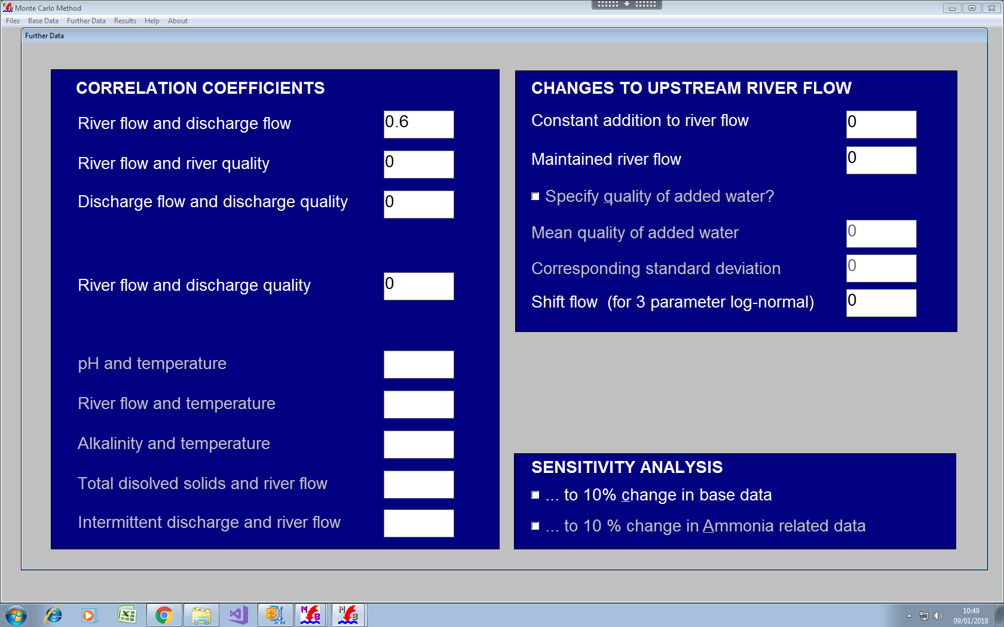

## 7.1 Bio available additional data 6.0

The additional data for bio-availability are accessed from the calculation form and are displayed thus:



## 7.2 Bio available additional data 6.0

For bio-availability 4.5 they are also accessed from the calculation form:

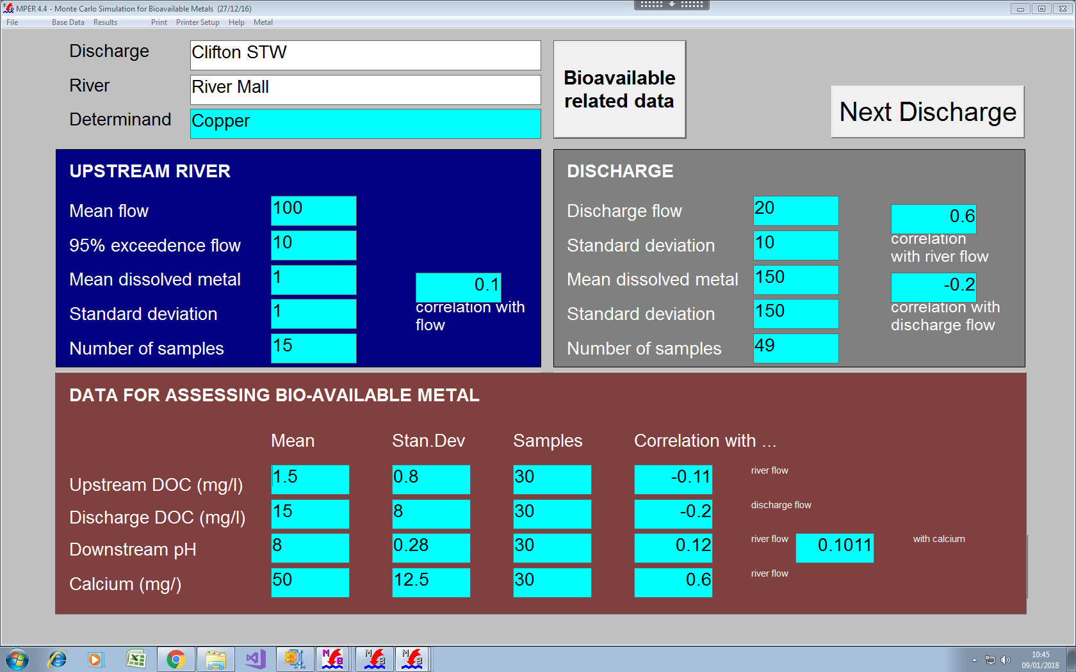

## 7.3 Ammonia additional data 6.0

The additional data for ammonia are accessed from the calculation form and are displayed thus:

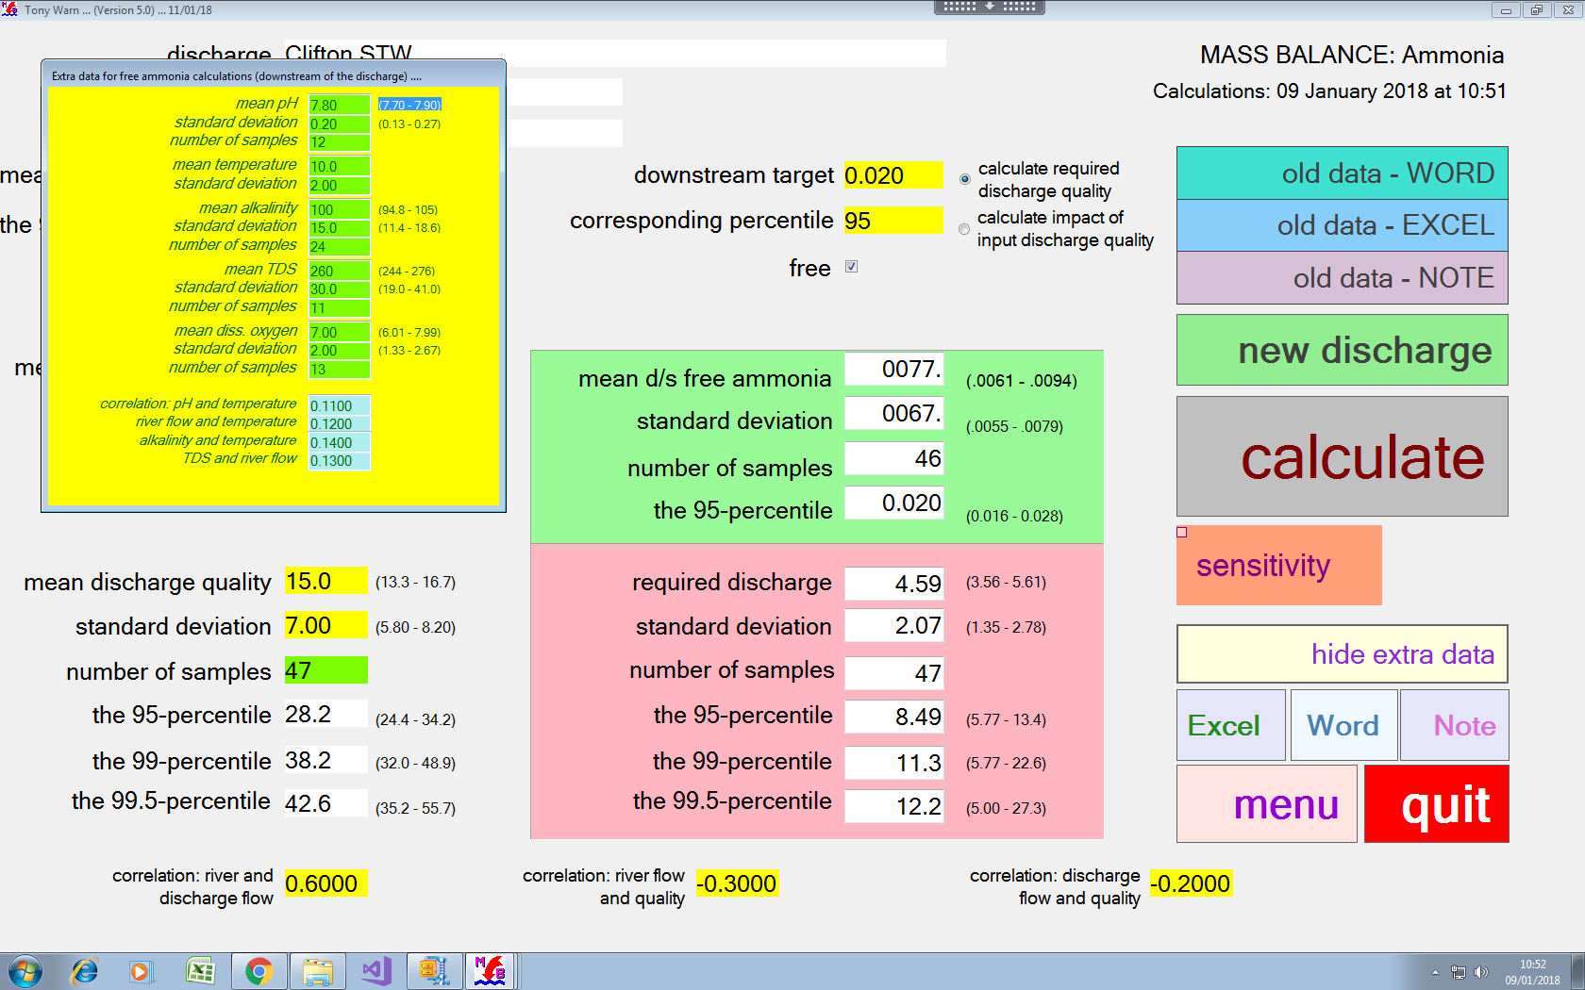

## 7.4 Ammonia additional data 4.5

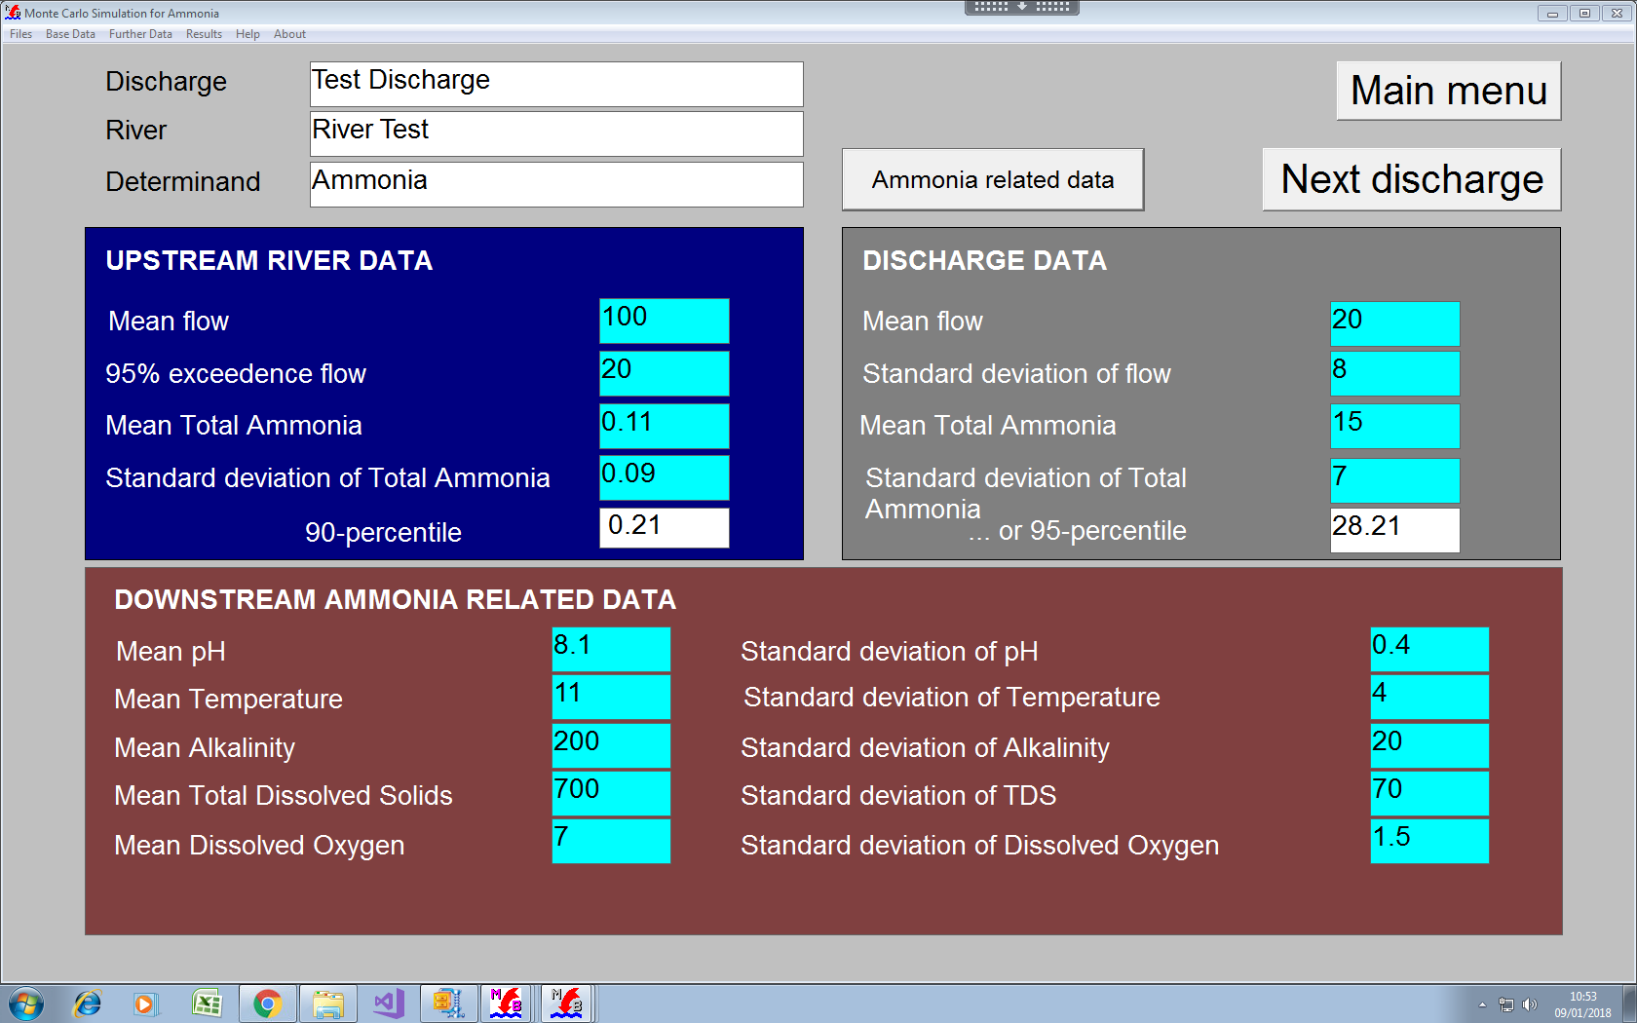

# Appendix 1 MPER Guide

**MPER: the calculation of limits for metals in discharges to rivers**

Tony Warn 13/12/17

## Summary

There are new standards for rivers for copper, zinc, manganese, nickel and lead. This note describes MPER – an app for setting controls on discharges so that these standards are meet.

The standards seek to provide better targeting of action: they aim to pinpoint a fraction of the dissolved metal that causes real damage – the part that is “bioavailable”.

From the 40 sets of data looked at in the development of MPER:

* The new standard for copper appears to be 64 times laxer for rivers of low hardness, but 60% tighter in rivers that are very hard.
* That for zinc is 4 times laxer for rivers of low hardness, and 60% stricter for rivers that are very hard.
* That for manganese is 5 times laxer in hard waters and 23 times laxer in soft waters
* That for nickel is 30% stricter for rivers of low hardness and 75% tighter for rivers that are very hard.
* The one for lead is generally 85% more strict (and does not depend on hardness).

These figures will change as a result of tests that reflect the full variety of conditions that occur in our rivers, and the types of conditions that are most common.

One feature of MPER is to allow for the impact on concentrations of bioavailable metal of the levels of dissolved organic carbon in discharges. This raises difficulties for policies based on “allowed deterioration” in which the downstream target is set as the upstream mean bioavailable metal plus a fraction of the new standard.

MPER is now being tested as a procedure to calculate the controls that will be needed to meet the new standards for rivers.

## Sensitivity of the results to data

MPER calculates the effect on its results of uncertainties in the data.

From examples checked to date, the new standard for copper leads, on average, to a 26% increase in the uncertainty caused by sampling rates. But the actual increase varies strongly from case to case. It increases with low dilution, with high levels of metal upstream of the discharge, low sampling for pH, and low variation in the DOC in the discharge. In examples that combine these, the overall errors can be huge.

A corresponding average for nickel is 20%. It too increases with low dilution, high levels of metal upstream of the discharge, low sampling for pH, and low variation in the discharge DOC. An average figure for zinc is 7%. This increases with low dilution, high levels of metal upstream of the discharge, and low variation in the discharge DOC. But it is less than a quarter as sensitive to pH as copper.

A figure for manganese is 5%. This increases with high levels of metal upstream of the discharge, low sampling for pH, low variation in the discharge DOC, and with high calcium. A number for lead is 7%. Calculations for lead do not involve pH and calcium. It too increases with low dilution, high levels of metal upstream of the discharge, and low variation in the discharge DOC.

Part of this inflated sensitivity occurs because it has been agreed that the calculations for DOC will take account of the DOC in the discharge.

## The correct form of standards

Work on the toxicity of a chemical may lead to a concentration that is declared “safe”. If this to be used as a standard, we must nail down how often such a concentration can be exceeded.

The simplest option is to define a standard an annual mean or an annual percentile. These act as a surrogate for the full statistical distribution of the variations of concentrations at a point in the river[1]. When we meet, say, an annual mean standard, we are sanctioning a shape – we are allowing within a year, particular scales of variations above and below the mean concentration.

This form of standard is also the simplest that can be used; it allows a correct calculation of action to avoid or correct failed standards. No hidden risks to rivers, nor unfair costs to industry, need stem from the calculation itself. And the impacts of limited data can be quantified correctly and used to help take sensible decisions.

Such a standard is also the simplest that allows an assessment of compliance that is a correct basis for praising success or taking action on failure. Such standards have been used for 40 years to target and justify the £billions spent on improving river quality.

(It may be that more complex forms of standards are thought to be required – ones that spells out the duration, frequencies and return periods of concentrations. As a minimum, such a standard must allow all the correct decision-making calculations that are described above for the annual mean (and annual percentiles). In practice, more complicated standards can be shown to be unnecessary and are rendered obsolete by the errors linked to sampling frequencies.)

## Calculating limits in discharges to rivers

The mixing of a discharge with a river is described by the *Mass Balance Equation*:

|  |
| --- |
|  |

|  |  |
| --- | --- |
| In this: | F is the river flow upstream of the discharge  C is the concentration of pollutant in the river upstream of the discharge  f is the flow of the discharge  c is the concentration of pollutant in the discharge  T is the concentration downstream of the discharge. |

If values of F, C, f and c refer to the same instant of time, we can calculate the value of T at that time.

A single application of this equation cannot calculate a permit limit needed to meet a river target. This is because the standards for rivers and discharges are (and need to be) annual means or annual percentiles. We have to use something like **Monte-Carlo Simulation** to do the correct arithmetic[2]. In this, we create thousands of sets of values of F, C, f and c, and use each set to calculate the resulting thousands of values of T.

In its simplest form, the Monte Carlo calculation extracts its thousands of values of F, C, f and c from distributions that are assumed to be log-normal. But all forms of distribution can be used, including non-parametric[3].

The results of the calculation define the link between the calculated distributions of c and T and, accordingly, how the mean and percentile values of T vary with the mean and percentile values of flow and quality for the discharge and the upstream river.

The results depend on correlations between F, C, f and c. These correlations describe, for example, the extent to which discharge flow increases with river flow, or how upstream river quality varies with the time of year.

The required correlation coefficients can be calculated by performing a linear regression on paired sets of data. A history of such calculations can lead to sets of general values that can be used as defaults in particular regions, or for particular types of chemical and discharge.

## New river quality standards for metals

The old standards were defined in terms of dissolved metal. The new standards are based on the “bioavailable” concentration – the fraction of dissolved metal that causes damage:

|  |  |
| --- | --- |
| Copper: annual mean | 1.0 μg/l bioavailable metal |
| Zinc: annual mean | 10.9 μg/l bioavailable metal (added to the natural background) |
| Manganese: annual mean | 123 μg/l bioavailable metal |
| Nickel: annual mean | 4.0 μg/l bioavailable metal |
| Lead: annual mean | 1.2 μg/l (called an “availability-based” standard) |

The bioavailable fraction varies. Given values of pH, calcium and dissolved organic carbon (DOC), we can estimate the “bioavailable” component in any concentration of dissolved metal. The values of the bioavailable concentration depend on equations such as:

Bioavailable fraction = (a function of pH, calcium and dissolved organic carbon)

The capacity to do these calculations is built into MPER. This uses the data that define the statistical distributions of pH, calcium and dissolved organic carbon.

Note that the equation does not describe the link between the summary statistics of the dissolved metal, the bioavailable concentration, pH, calcium and dissolved organic carbon[4]. Such a calculation requires an approach like Monte Carlo Simulation – thousands of calculations.

As with F, C, f and c, the new items can be set up as log-normal distributions or as any of the options available for F, C, f and c. It can be important to know how the new items are correlated with one another, and with the values of F, C, f and c.

## Uncertainties in the calculation of bioavailable concentrations

The equations provided for MPER to calculate the concentrations of bioavailable metal are simplified versions of elaborate models that are thought too complicated for routine use.

The following diagram[5] shows the agreement for copper between the “simple” and the “elaborate” equation. The “relative prediction error” is the difference between them. It is expressed as a percentage of the results from the “elaborate” model.

The bias in the curve is about +20% more than zero. This makes the standard 20% less strict than that from the “elaborate” equation. In addition, the width of the curve suggests a coefficient of variation is 85%: in other words, an estimated value of 10 has a standard deviation of 8.5.

MPER’s dozens of sensitivity tests include an estimate the sensitivity of MPER’s results to the bias and errors in the “simple” bio-equation. But they are not built into the MPER’s estimates of the confidence limits in its estimates of the controls on discharges, say, 42 (30-56), that would meet river standards.

I believe that the data used to construct the above curve is compounded from lots of samples taken at hundreds of sites. I have assumed that the curve applies separately to each and every one of the samples taken.

An alternative view is that the error embodied in the above curve reflects the differences between the sites themselves and that within this, the error is not much affected by variation from sample to sample at a particular site. I have added an extra test of sensitivity that looks at this view but it does not feature in the released version of MPER.

## MPER

The widely used version is designed to resemble the classic sets of systems designed 20-30 years ago to calculate permits in discharges. This set-up is called RQP (River Quality Planning).

## Data for the calculations

Input data are entered the yellow, pink, green and blue boxes of the following screens.

Standards can be entered for bio-available metal or the dissolved metal. These can be the annual mean or any annual percentile.

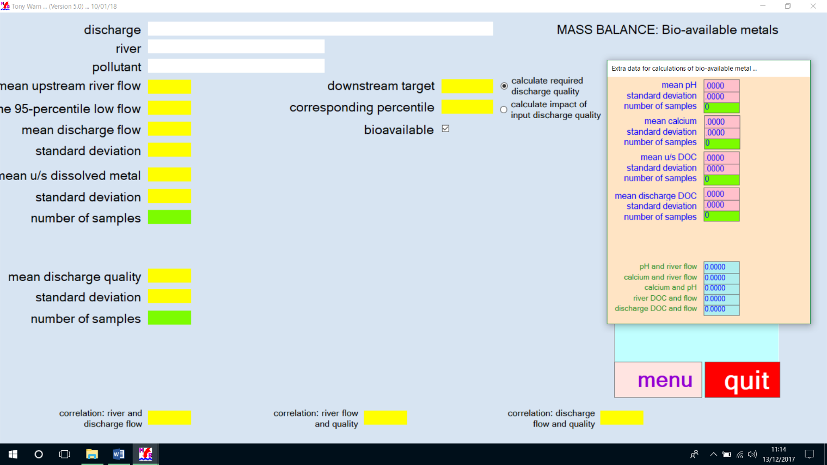

For standards defined as dissolved metal, the calculations are the same as those long used by the water industry[6]. With standards for bioavailable metal, the following sets of data are used; items 3, 6, 7 and 8 have been added:

1. The river flows upstream of the discharge
2. The concentrations of dissolved metal in the river upstream of the discharge
3. Dissolved organic carbon in the river upstream of the discharge
4. The flows of the discharge
5. A starting set of concentrations of the dissolved metal in the discharge
6. Dissolved organic carbon in the discharge
7. pH in the river – assumed to be the same up and downstream of the discharge[7]
8. Calcium in the river – taken to be the same up and downstream of the discharge

## The calculations

The calculations take the form:

1. A single value for each of the items 1 to 8 is extracted from its distribution, making use of the correlation coefficients to impose links between the values.
2. Items 1, 2, 4 and 5 are used in the Mass Balance Equation to calculate the concentration of dissolved metal in the river downstream of the discharge.
3. Items 1, 3, 4 and 6 are used in the Mass Balance Equation to calculate the DOC in the river downstream of the discharge.
4. The resulting value for DOC is used with items 7 and 8, and the result of step b), to calculate the bioavailable concentration in the river downstream of the discharge.
5. Steps a) to d) are repeated 2000[8] times. This gives the distributions of dissolved metal and bioavailable metal in the river downstream of the discharge.
6. The steps from a) to e) are repeated again and again in an iterative process that homes in on a discharge quality (the 2000 values of dissolved metal) that meets the standard in the river (bioavailable metal). Summary statistics from the distribution of discharge quality are options for a permit limit.

It has been agreed that the calculations for DOC will take account of the DOC in the discharge. But within MPER there is a device by which the calculations for DOC can also be treated like those for pH and calcium – values can be entered for the downstream river rather than calculated by mixing the discharge with the river. This device is activated by defining DOC for the discharge quality as zero. The data for the downstream DOC are then set equal to what has been provided for the upstream river.

## An example for copper

We might first calculate the effect on river water quality of the current discharge. We would have typed in the numbers into the coloured and green boxes; adding the names of the discharge, river and pollutant.

We then click the box marked “bioavailable”; click the box marked “calculate impact of input discharge quality”; and, finally, click the big grey box marked “Calculate”.

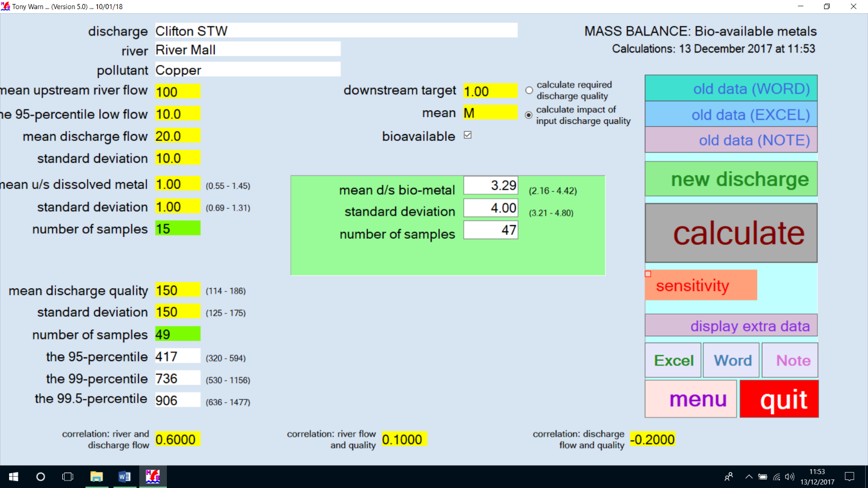

MPER can also produce output in terms of WORD or EXCEL by clicking on the boxes labelled “Excel” or “Word”. A section of such reports is shown below. The reports can be stored and used as input in future calculation, thus saving the time needed to fill the boxes with numbers on future sessions with MPER.

|  |  |  |  |  |  |
| --- | --- | --- | --- | --- | --- |
| Mean u/s river flow | 100.00 |  | Mean discharge flow | 20.0 |  |
| 95-percentile low flow | 10.0 |  | Standard deviation | 10.0 |  |
|  |  | (confidence) |  |  | (confidence) |
| Mean u/s diss. Metal | 1.00 | (0.55 - 1.45) | Mean d/s diss. metal | 41.8 | (29.3 - 54.2) |
| Standard deviation | 1.00 | (0.69 - 1.31) | Standard deviation | 51.1 | (42.4 - 59.9) |
| Number of samples | 15 |  | Number of samples | 47 |  |
|  |  |  |  |  |  |
| Mean u/s bio-metal | 0.35 | (0.15 - 0.56) | Mean d/s bio-metal | 3.29 | (2.16 - 4.42) |
| Standard deviation | 0.42 | (0.28 - 0.56) | Standard deviation | 4.00 | (3.21 - 4.80) |
| Number of samples | 15 |  | Number of samples | 47 |  |
|  |  |  |  |  |  |
| **CURRENT DISCHARGE** |  | (confidence) |  |  |  |
| Mean discharge quality | 150 | (114 - 186) |  |  |  |
| Standard deviation | 150 | (125 - 175) |  |  |  |
| Number of samples | 49 |  |  |  |  |
| 95-percentile | 417 | (320 - 594) |  |  |  |
| 99-percentile | 736 | (530 - 1156) |  |  |  |
| 99.5-percentile | 906 | (636 - 1477) |  |  |  |

For this example, MPER has calculated that the current quality of the discharge is 150 (114-186)[9]. The bioavailable copper downstream of this discharge quality is calculated to be 3.29 (3.16-4.42)[10]:

We might then calculate the discharge quality needed to achieve the river quality standard for bioavailable copper:

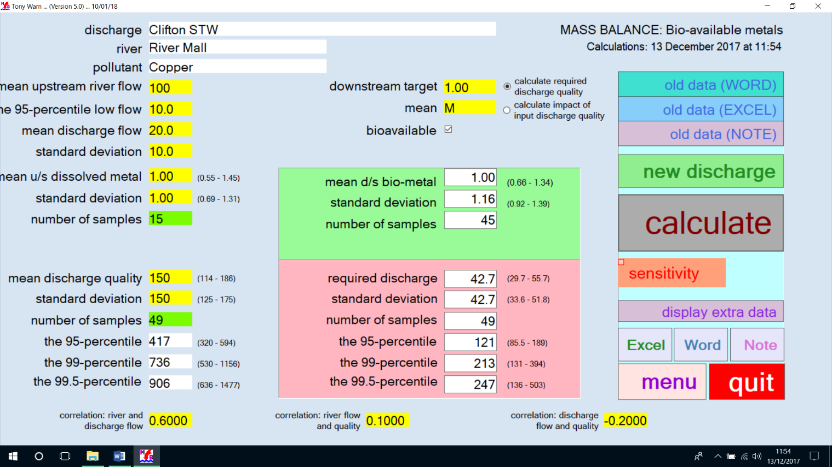

As before the data and results can be written to WORD or Excel.

**MASS BALANCE (BIO-AVAILABLE METALS): Version 4.5**

Calculations: 03 December 2017 at 02:42

|  |  |  |  |  |  |
| --- | --- | --- | --- | --- | --- |
| Mean u/s river flow | 100.00 |  | Mean discharge flow | 20.0 |  |
| 95-percentile low flow | 10.0 |  | Standard deviation | 10.0 |  |
|  |  | (confidence) |  |  | (confidence) |
| Mean u/s diss. metal | 1.00 | (0.55 - 1.45) | Mean d/s diss. metal | 12.4 | (8.76 - 16.1) |
| Standard deviation | 1.00 | (0.69 - 1.31) | Standard deviation | 14.5 | (12.0 - 17.1) |
| Number of samples | 15 |  | Number of samples | 45 |  |
|  |  |  |  |  |  |
| Mean u/s bio-metal | 0.35 | (0.15 - 0.56) | Mean d/s bio-metal | 1.00 | (0.66 - 1.34) |
| Standard deviation | 0.42 | (0.28 - 0.56) | Standard deviation | 1.16 | (0.92 - 1.39) |
| Number of samples | 15 |  | Number of samples | 45 |  |
|  |  |  |  |  |  |
| **CURRENT DISCHARGE** |  | (confidence) | **REQUIRED DISCHARGE** |  | (confidence) |
| Mean discharge quality | 150 | (114 - 186) | Mean discharge quality | 42.7 | (29.7 - 55.7) |
| Standard deviation | 150 | (125 - 175) | Standard deviation | 42.7 | (33.6 - 51.8) |
| Number of samples | 49 |  | Number of samples | 49 |  |
| 95-percentile | 417 | (320 - 594) | 95-percentile | 121 | (85.5 - 189) |
| 99-percentile | 736 | (530 - 1156) | 99-percentile | 213 | (131 - 394) |
| 99.5-percentile | 906 | (636 - 1477) | 99.5-percentile | 247 | (136 - 503) |
|  |  |  |  |  |  |

In these figures for discharge quality we see that possible candidates for permit limits include a mean of 43 (30-56), a 95-percentile of 86-189, and a 99.5-percentile of 136-503. The resulting bioavailable copper “meets” the standard of 1.0 in the downstream river: 1.0 (0.7-1.3).

## Where discharges cause failure of the new river standards

We noted above that the candidates for required permit limits include an annual mean of 42 for dissolved metal. The value of 42 has confidence limits of (30-56)[11]. A limit of 56 controls the risk of wasting money by imposing a permit that, in truth, is not needed[12]. This use of 56 makes sense if reduced uncertainty could have been achieved by extra monitoring of the river and discharge[13]. Future years of monitoring can be used to assess whether the 56 should be tightened.

Alternatively, the permit limit might be set at the central value of 42. In this case the method of assessing compliance would need to mirror the Look-up-Table in which a reported failure required at least 95% confidence[14].

In a case where the new standard for river quality was linked to uncertain and dangerous effects not fully covered by the work that led to the new standard, policy may be such as to require a standard of 29. This gives the environment or public health, the benefit of the known doubt that stems from limited monitoring.

Suppose the above example featured a “new discharge”[15]. If the aim were to protect the standard of 1.0 and if the permit limit were to be an annual mean, it might be policy to set this as the central estimate of 42, rather than 56[16].

## Comparisons with the old standards for copper

The old standard for copper varies with hardness of the water. For the size of river and discharge represented by the example discussed above, the new standard for copper leads to limits for discharges that are 64 times laxer for rivers of low hardness, but 57% tighter for rivers that are very hard.

In calculating these we select values of calcium that match the degrees of hardness used to choose which old standard to use:

| Old standard: annual mean of dissolved copper (μg/l) | Hardness applied to the old standard  (mg/1 as CaCO3) | Permit limit under the old standard | Permit limit under new standard | Ca | pH | Change |
| --- | --- | --- | --- | --- | --- | --- |
| 1 | 0 to 50 | 4.4 | 281 | 10 | 7.0 | x 64 |
| 6 | 50 to 100 | 88 | 319 | 30 | 7.3 | x 3.6 |
| 10 | 100 to 250 | 154 | 281 | 65 | 7.7 | x 1.8 |
| 28 | > 250 | 455 | 194 | 120 | 8.0 | x 0.43 |

## Uncertainties in the calculations for copper

As noted above, the mean of 3.29 for bioavailable copper downstream of the current discharge has confidence limits of 2.16 – 4.42. The lower limit of 2.16 demonstrates confidence[17] that the standard of 1.0 is failed[18].

As noted in Section **2** range like 2.16 to 4.42 is caused by the sampling rates for dissolved copper in the upstream river and the discharge as well as the effects of the sampling rates for pH, calcium and DOC (Annex 3). The value of 4.42 is 34% bigger than 3.29.

For the corresponding mean for dissolved copper, the upper confidence limit of 54.2 is 30% bigger than the mean of 41.8. The change from 30% to 34% indicates that the new standards for copper cause a 13% increase in the errors for this particular calculation[19]

In the example looked at above, the estimate of 43 for the mean permit limit for copper has a set confidence limits dictated by the sampling rates for dissolved copper, pH, calcium and DOC. This produces a range of 30 – 56, i.e. plus or minus 13. There is 90% confidence that the value lies between these two numbers.

On their own, the sampling rates for dissolved copper in the upstream river and the discharge leads confidence limits of 33 – 53 (plus or minus 10). The particular sampling rates for pH, calcium and DOC used in the calculation lead, in this case, to an increase to plus or minus 13.

## Sensitivity to data of the results for copper

By changing the values entered a user can test the sensitivity of the results. MPER also includes options to conduct automatic tests on the sensitivity of a single set results to changes in data. To use this, click the orange box marked “Sensitivity” before clicking “Calculate”.

For the calculation for copper discussed above, results of such checks are listed below. The values show, for example, that a 2% decrease in the estimate of mean pH causes a 19% reduction in the severity of the standard. (The effect is 10% in similar calculations for soft waters).

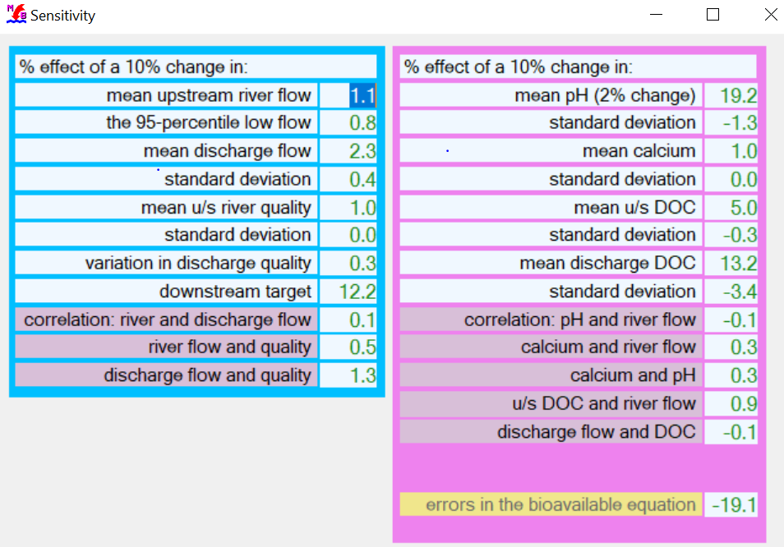

As already discussed, the equation used to calculate the concentration of bioavailable copper produced, within MPER, large statistical errors in some of the calculations. Volatile results tended to occur at places where:

1. The river provides little dilution
2. The water is hard
3. The river and discharge contain lots of dissolved organic carbon (a factor also influenced by item (a) dilution)
4. Low rates of sampling for things like pH and dissolved organic carbon.

These conditions produce a distribution of bioavailable copper downstream of the discharge in which 1% of the calculated values are 100 times the value of the mean.  This distorted shape is the cause of the volatile results, as in the following example in a calculation by an early user:

|  |  |  |  |  |  |
| --- | --- | --- | --- | --- | --- |
| Mean u/s river flow | 66760 |  | Mean discharge flow | 1166 |  |
| 95-percentile low flow | 18144 |  | Standard deviation | 0.010 |  |
|  |  | (confidence) |  |  | (confidence) |
| Mean u/s diss. metal | 27.5 | (.0000 - 62.3) | Mean d/s diss. metal | 27.5 | (.0000 - 56.4) |
| Standard deviation | 47.4 | (24.9 - 69.9) | Standard deviation | 41.0 | (22.2 - 59.8) |
| Number of samples | 7 |  | Number of samples | 7 |  |
|  |  |  |  |  |  |
| Mean u/s bio-metal | 2.94 | (.0000 - 6.77) | Mean d/s bio-metal | 3.01 | (.0000 - 6.70) |
| Standard deviation | 4.89 | (2.42 - 7.37) | Standard deviation | 4.85 | (2.45 - 7.26) |
| Number of samples | 7 |  | Number of samples | 7 |  |
|  |  |  |  |  |  |
| **CURRENT DISCHARGE** |  | (confidence) | **REQUIRED DISCHARGE** |  | (confidence) |
| Mean discharge quality | 64.7 | (10.8 - 119) | Mean discharge quality | 36.6 | (.0000 - 301) |
| Standard deviation | 104 | (67.5 - 140) | Standard deviation | 58.8 | (.0000 - 237) |
| Number of samples | 12 |  | Number of samples | 12 |  |
| 95-percentile | 219 | (113 - 751) | 95-percentile | 125 | (40.7 - 1411) |
| 99-percentile | 473 | (212 - 2353) | 99-percentile | 280 | (.000 - 13982) |
| 99.5-percentile | 627 | (265 - 3595) | 99.5-percentile | 367 | (.000 - 33095) |

|  |  |  |  |  |  |
| --- | --- | --- | --- | --- | --- |
| Mean pH (u/s & d/s) | 8.21 | (8.01 - 8.41) | Mean calcium (u/s & d/s) | 57.3 | (49.7 - 64.9) |
| Standard deviation | 0.27 | (0.14 - 0.40) | Standard deviation | 10.3 | (5.41 - 15.2) |
| Number of samples | 7 |  | Number of samples | 7 |  |
| Mean DOC in u/s river | 4.60 | (3.49 - 5.71) | Mean DOC in discharge | 2.10 | (1.90 - 2.30) |
| Standard deviation | 1.35 | (0.65 - 2.05) | Standard deviation | 0.17 | (0.056 - 0.28) |
| Number of samples | 6 |  | Number of samples | 4 |  |

## Allowed deterioration

We have looked at options for setting the river quality standard downstream of a discharge as equal to any fraction of a specified standard but where this fraction is added to the value of the corresponding summary statistic for river quality upstream of the discharge. This option is called Allowed Deterioration.

But the process is rendered volatile and can produce strange results because of the role assumed for dissolved organic carbon in the discharge. This can wipe out non-compliance in the upstream river, and so allow the discharge to add more metal despite the upstream failure.

A permit for metals for an “Allowed Deterioration” of 0.01% may produce 4 times more pollution than the next 20%. The cause of this strange result is the use in the calculations of Dissolved Organic Carbon (DOC). We could:

* Ignore this – but explain why it happens; why we need not worry; and why similar effects for pH and calcium are not part of our calculations.
* And, as necessary, use SIMCAT to model the DOC, pH and calcium, taking account of all the accumulated downstream impacts of inputs, losses and dilution.
* Or change the definition of “Allowed Deterioration”: refuse the discharge the benefit of its own DOC in reducing the toxicity of upstream metal.
* Or stop using the measured discharge DOC for calculating the permit for the metal; use levels for an effluent of top quality.
* Or, use values of DOC that represent all the river (or sections of it); ignore how local DOC is altered by the discharge whose permit is being calculated.

Tony Warn 13/12/17

**Annex 1: The calculation of combined errors**

In the example looked at above, the estimate of 43 for the mean permit limit for copper has a set confidence limits dictated by the sampling rates for dissolved copper, pH, calcium and DOC.

The sampling rates for dissolved copper in the upstream river and the discharge leads confidence limits of 33 and 53 (or 43 plus or minus 10). If we add in the effects of sampling for pH, calcium and DOC the range expands to 3 and 56 (plus or minus 13).

The combined effect of the errors is calculated in the following way. The 49 samples of DOC in the discharge leads to confidence limits of 12.5 and 17.5 for the estimate of the mean DOC of 15.0. When a mean value of 12.5 is used instead of 15.0 in the calculation of the permit limit for copper, the resulting 95-percentile of the required discharge quality is 36.6 instead of 42.7. With a value of 17.5, the value is 47.4.

This set of confidence limits (36.6 and 47.4) are translated into estimates of extra standard error, attributable to the number of samples, in the estimate of the permit limit. A similar process is followed for the samples of pH and calcium. The overall standard error in the estimate of the permit limit, S, is then calculated within M-PER from the sum of the squares of all these standard errors:

|  |
| --- |
|  |

This process has been checked by taking a Monte Carlo calculation and its 2000 shots and repeating the entire calculation 4000 times.

In each of the 4000 repeats the values of the specified numbers of samples are selected from the declared distributions. The results showed that the simpler approach based on the above equation works well.

**Annex 2: MPER’s adjustment to the bioavailable equation**

For a fixed pair of values of calcium and pH an increase in dissolved organic carbon reduces the proportion of copper that is bioavailable.  But at a point where the dissolved organic carbon reaches something like 15 mg/l[20] the trend reverses.  The point of reversal depends on the values of pH and calcium.  In calculations done so far it ranges from 9 to 20 mg/l. This reversal (and the point where it starts) produces volatile results.

The reversal is considered to be an unwelcome aspect of the equation. M-PER now performs checks on every set of data. If the phenomenon is detected it is removed within MPER after calculating the concentration of dissolved organic carbon at which this increase starts to happen. This value is then used as a cut-off point in the calculation of the impact of the discharge. If any one of the 2000 values of dissolved organic carbon exceeds the cut-off, the value is set equal to the calculated cut-off value.

# Appendix 2 RQP Guide

# 1 Permits

## 1.1 Introduction

Discharges into the water environment are regulated by the Environment Agency. Agency policies and procedures for this regulation are defined in the Agency permitting documentation.

This document focuses on the technical rather than the procedural policy aspects of setting a permit

## 1.2 Concepts

The basic methodology of calculating a discharge consent is the MONTE-CARLO Method. This method is underpinned by a number of fundamental concepts, which are now discussed.

### 1.2.1 Emission

An emission is a discharge of chemicals into the water. The emission is characterised by its flow and concentration. The product of the flow and concentration is the load:



Flow is often measured in cubic metres per second and concentration in milligrams per litre, in which case the load is in units of grams per second.

### 1.2.2 Receiving Waters

The receiving water is the environment into which the emission flows. The receiving waters will also be characterised by a (background) concentration, a flow and a load.

### 1.2.3 Mixing Zone

This is the region is the receiving waters in which the emission mixes with the water. Beyond the mixing zone the emission is fully mixed in the receiving waters

### 1.2.4 Emission Control

The are two approaches to controlling the emission. The first is to specify absolute standards for emission, thereby fixing the flow and concentration, or load, without direct regard to the receiving waters. The second approach is to set the emission flow, concentration (and/or load) with regard to the receiving waters.

It is the second approach that is more commonly used. The rationale is that in the environment the impact will depend upon concentration of pollutant, and this concentration is strongly influenced by dilution in the receiving waters.

In order to quantify and hence implement this control, standards and calculation methods are needed. These are now described.

### 1.2.5 Standards

A standard will, inter alia, define a concentration limit and a percentile. For a discussion of standards see Tony Warn's paper in appendix A.

### 1.2.6 Mass Balance

The greatest influence on emission concentrations is dilution. The concentration, as a result of dilution, is determined by the mass balance equation:



where

*F* is the river flow

*f* is the discharge flow

*C* is the river concentration

*c* is the discharge concentration

*R* is the resultant, in river, concentration

### 1.2.7 Simple Mass Balance Calculation

The simple mass balance calculation uses single values for the flows and concentrations. The problem with this is the statistical relationship between the (input) flows and concentrations and the result is indeterminate. For example mean input values will not give the mean resultant value.

### 1.2.8 Combined Distribution Method

The combined distribution method overcomes the problem with the simple mass balance calculation. It replaces the single flow and concentration values with their distributions.

The equation is then solved, either by the MONTE_CARLO, or by the Warn Brew method.

### 1.2.9 Warn Brew Method

This method solves the combined distribution problem when the input distributions are parametric. It was introduced in the 1970s and was computationally efficient, because it was an analytic method.

### 1.2.9 MONTE-CARLO Method

This method requires more computational resource than Warn Brew and so its uptake was retarded initially. Computational resource is no longer a problem and because MONTE- CARLO is more flexible it is used in preference to Warn Brew. It can handle correlations and non-parametric inputs. The name of the method reflects the approach of randomly sampling the input distributions and solving the mass balance equation with the sampled values. This is repeated many times (~1000) and a result distribution formed. From this distribution the target/standard percentile is extracted.

### 1.2.10 Warn Brew Method

This method solves the combined distribution problem when the input distributions are parametric. It was introduced in the 1970s and was computationally efficient, because it was an analytic method.

Note; The MONTE-CARLO rather than the Warn Brew method is now the preferred approach

# 2 Monte Carlo Software

## 2.1 Introduction

The current software for carrying out mass balance calculations is RQP Mass Balance Calculation v2.5. Once started, you are presented with a front screen, which offers 11 buttons, each of which starts a different part of the software.

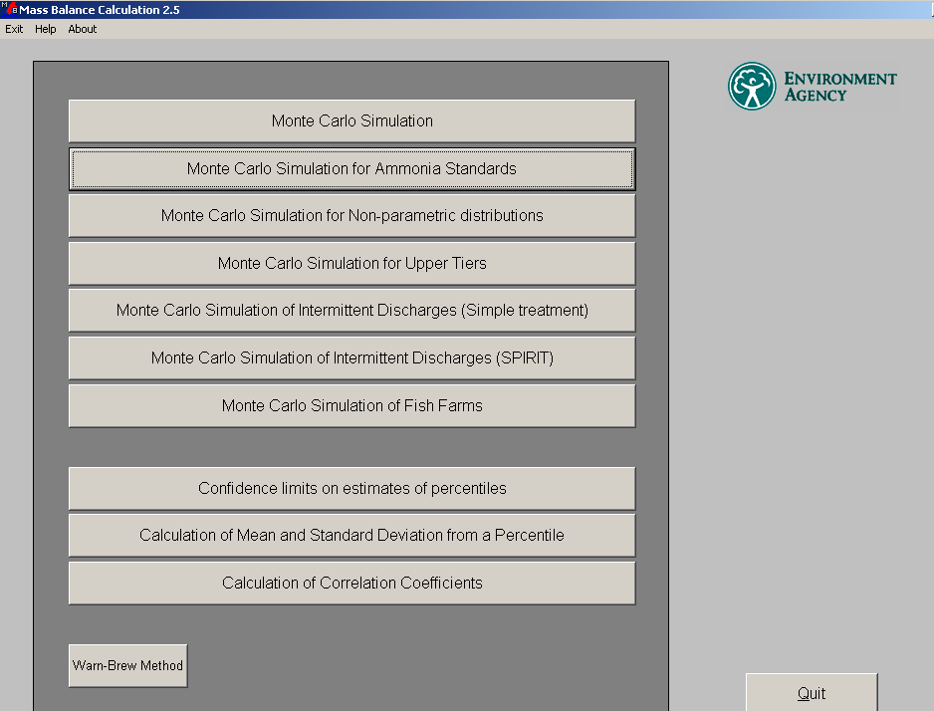

There are three main groups of software:, Monte-Carlo method of calculation , the Warn Brew method and some utilities.

Monte-Calro and Warn Brew are both methods for combining distributions. Warn-Brew was developed when Monte-Carlo calculations took a long time to run. It used a set of formulae to represent the shapes of log-normal distributions given the mean and standard deviation. The software is limited in that it cannot deal with non log-normal distributions. The increase in computing power means that Monte-Carlo calculations now run much faster and have mostly superseded Warn-Brew.

Therefore, only the Monte-Carlo method is considered here..

## 2.2 Monte-Carlo Software

There are seven parts to the Monte-Carlo software. Monte Carlo Simulation is the basic and most commonly used part of the package. Most of the other parts are modifications of this basic version for specific circumstances or events. All of the software have similar screen layouts.

Monte-Carlo Simulation

Start the software; you are presented with the Base Data screen. The data you enter in the white boxes are not essential and just used for printouts. Data must be entered in the blue boxes.

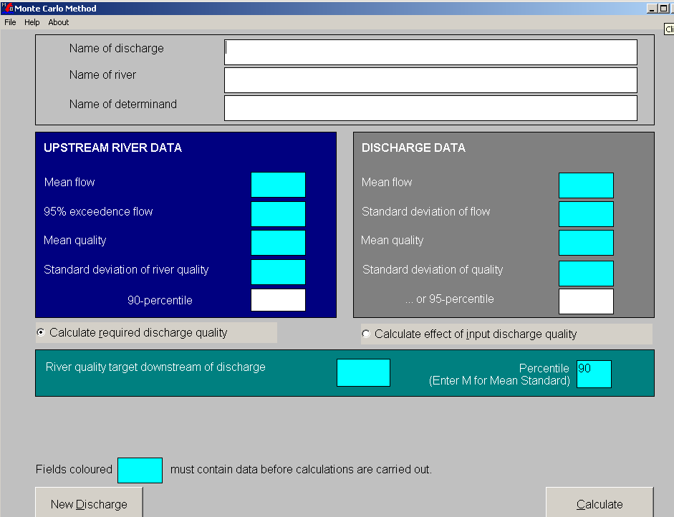

There are two ways of carrying out the calculation. A *forward calculation* allows you to calculate the effect of a discharge on downstream water quality, given the upstream flow and quality in the river and the flow and quality for the discharge. A *backward calculation* allows you to calculate what the discharge quality must be given the above data and a target quality for the river downstream (given as a percentile).

When the calculate button is pressed, the results are presented at the bottom of the screen. After the results are presented you can go back and change data in the boxes and recalculate. When you change a number in the blue boxes a red dot appears at the side. This indicates that that number has changed and will only be retained for the next calculation, after that it will return to the default. Clicking with the right mouse button in the box and then anywhere outside the box with the left mouse button changes the dot to yellow. This has set the present value as the default.

Once the results have been calculated some more menu options appear at the top of the screen. Base data and Results allow you to see the screens already mentioned, the rest are self-explanatory. Further data take you to a new screen that allows you to alter more of the parameters used in the calculations.

*Correlation Coefficients* allow you to force a correlation between two parameters. One of these, river and discharge flow, has a default. To calculate whether two parameters have a correlation you can use the Calculation of Coefficient part of the RQP software, or other software such as AARDVARK or Excel

*Changes to Upstream River Flow* allows you to set or place conditions on flow in the river upstream of the discharge.

*Monte Carlo Parameters* allows you to change the statistical parameters The range may be set between 100-5000.

*Sensitivity Analysis*. If turned on, the software re-runs the simulation several times with variations of up to 10% on the Base data and 0.1 in the correlation coefficients. The results you get show percentage change that it produces in the calculated data. Sensitivity analysis can be applied to forward and backward calculations.

Clicking on Base data will get you back to the original screen and allow you to re-run the model.

Monte Carlo Simulation is limited:

* Requires data are log-normal distributed
* Effects of chemical interactions are not included
* Only applies to continuous discharges

So, we have several other parts to the RQP package to deal with these other situations, which are described in the next section.

# 3 Other MONTE-CARLO Options

## 3.1 Applications



The other MONTE-CARLO applications are shown below.

## 

## 3.2 Ammonia Standards

Un-ionised ammonia impacts on fish gills. To protect against this, the receiving waters statistics for un-ionised ammonia needs to be determined. This may be derived from total ammonia concentrations, supplemented by additional pH, temperature, alkalinity, suspended solids and dissolved oxygen data.

## 3.3 Non-Parametric Distributions

This is as for the basic MONTE-CARLO but allows the use of non-parametric data. These data are read in from an ASCII file, where the first field is the number of values, followed by the values, e.g.:

10 23.4 56.4 345.5 67.8 45.6 23.4 56.7 34.5 34.6 45.6

## Monte-Carlo simulation for Upper Tiers

This is very similar to the basic Monte-Carlo simulation

The difference is that the Upper Tiers version provides information for additional percentiles, including the 99.9th

## 3.5 Intermittent discharges (Simple Method)

This is for a continuous discharge plus an intermittent discharge. The continuous discharge is as for the basic case (section 2 above).

The intermittent is defined as a separate discharge. The results are for the combined effect of the intermittent and the continuous.

## 3.6 Intermittent Discharges (SPIRIT)

This is for UPM use. It draws on research Gunby report, which shows equivalence between UPM standards and percentile standards.

## 3.7 Fish Farms

This is used for performing the calculations to apply the Fish Farm policy in the Discharge Consents Manual.

# 4 Compliance

## 4.1 Introduction

The aim of compliance assessment is to determine whether or not a quality standard or permit is being breached.

The assessment is empirical and hence based on sample data.

The technical issue is to determine whether or not the sample data indicate a breach of permit or standard.

## 4.2 Standards and Permits

There are 2 types of standard, a pass/fail standard and a statistical (percentile/mean) standard.

### 4.2.1 Pass/ Fail Standards

Such a standard states the number of samples which must pass in a specified duration. An example is the Bathing waters standard, which says that 95 per cent of samples must pass each year. For 20 samples this means that only 1 failure is allowed.

There is no problem in compliance assessment for such standards. Simply count up the number of failures and compare with the standard.

### 4.2.2 Statistical Standards

These standards apply to the underlying population. They are of the form described in Tony Warn's paper (appendix A).

Sampling provides limited information on the population. There will always be uncertainty associated with inferences made from sampling programmes and this uncertainty is quantified by confidence limits.

Therefore it is never possible to say with 100 per cent certainty that there has been compliance with a statistical standard. It is possible to quantify the confidence that the standard has been breached. Conventionally the rule is that 95 per cent confidence of failure is required to 'confirm' failure.

### 4.2.3 Relationship between Pass/Fail and Statistical Standards.

For each pass/fail standard there is an equivalent statistical standard; and vice versa.

For example the 19 out of 20 successes for the Bathing Waters pass/fail standard is equivalent to a 98.2 percentile statistical standard.

The derivation of this equivalent is complicated and uses the concept of statistical power curves and the binomial theorem.

The translation of a statistical standard to a pass/fail standard provides the number of allowed failures for a given number of samples. This is the basis of the look up tables.

# 5 Compliance Software

## 5.1 Introduction

There are a number of utilities in the RQP compliance software suite which are used to assess compliance.

The various utilities are shown below:

## 

## 

## 5.2 Binomial Compliance for any Percentile

This deals with the case where there is a percentile standard and a number of samples have been taken. Some of these samples have failed (i.e. have greater than the permitted concentration).

The program then calculates the confidence that the standard was exceeded. Again, for security this should be 95 per cent or more.

## 5.3 Parametric Method for any Percentile

In this case the sample data presented are the mean, standard deviation and number of samples. This information is compared with the standard percentile and value.

The program then calculates the confidence that the standard was exceeded. Again, for security this should be 95 per cent or more.

## 5.4 Compliance with Mean Standard

This is as for 5.3, but for a mean standard.

## 5.5 Confidence Limits for any Percentile

From the mean, standard deviation, number of samples and percentile, the percentile value, with upper and lower confidences are found.

## 5.6 Confidence Limits for Mean Values

This is as for 5.5, but for mean standards.

## Change in any Percentile (Parametric)

This is used to detect a change for a given percentile between two sample sets. The data are assumed to be parametric.

## Change in any Percentile (Parametric)

This is used to detect a change in failure rate between two sample sets.

## Change in Mean

This is used to detect a change in mean between two sample sets.

# Appendix 2.A Environmental Standards

|  |  |  |
| --- | --- | --- |
| Environment Agency | Version 3 | Item 10a |
| Environment Quality Group | **Environmental Standards for Water Quality Planning** | |
| 9 May 2000 |

Purpose

To set out the agreed policy for defining and using environmental standards.

Basics

1. Every Water Quality Standard is to be interpreted as an **Ideal Standard**. That is, a standard that includes the following five points:

* a limit, say a concentration of 10 μg/l;
* a summary statistic, for example, how often the limit may be exceeded, say 1% of the time;
* the period of time over which this statistic applies, say a calendar year; and,
* the definition of the design risk – the proportion of time periods for which failure to meet the standard is planned as accepted, say 1 in 20 calendar years.

To which we add:

* the statistical confidence with which non-compliance is to be demonstrated before failure is reported.

1. Examples include:

* In the long run, the 95-percentile value of the concentration of E.Coli at the monitoring point must be less than 200 no/ml in 19 summers out or 20.
* In the long run, the 90-percentile value of the concentration of ammonia at the point of mixing must be less than 0.6 mg/l in 5 sets of three consecutive calendar years out of 10.
* In the long run, the 95-percentile value of the concentration of unionised ammonia at the monitoring point must be less than 0.205 mg/l in 9 calendar years out of 10.
* In the long run, the concentration of Dissolved Oxygen at the point of mixing can exceed 4.5 mg/l for up to six hours, no more than 40 times in 10 years
* These definitions establish the principle that the design risk is a matter of policy and not modelling.
* It has been the custom in the past to leave to modellers the definition of the design risk. This made for inconsistency.
* Also because of the possibility of Judicial Review, we shall need to demonstrate that our decisions were calculated according to an explicit Agency-wide statement of the accepted risk that the water quality standards would not be met.

Modelling Applications involving Water Quality Standards

1. These must calculate the impact on water quality in the form of changes to the values of summary statistics and design risk that are used in the Water Quality Standards.
2. It must be clear from the established capabilities of the model, or from the way in which the guidance insists it is used, that these requirements are met.
3. We intend by this to exclude models which describe a short period of time or a particular event lasting a day or week, which lack the capacity or surrounding logic to place this event in a long term context of return period.
4. Such models may be useful and interesting but they are not to be used to take decisions on the measures needed to achieve standards.

Where there are no Standards

1. Where the intention is to use the results of the model to decide the action needed to improve water quality, the impact on water quality must be demonstrated in the model’s output in the form of changes in the values of summary statistics that can be estimated from monitoring programmes.
2. Mainly, this would require estimates of the change in mean or percentiles of water quality for a set period of time (say a calendar year, or a summer). In addition, it must also be clear, from the modelling or the way in which the model is used, that we know the Return Period for the summary. For example:

* In the long run, the mean value of the concentration of phosphate at the monitoring point in summer (the value expected to be exceeded in 1 summer in 5)

Tony Warn

21 January 2000

# Appendix 2.B STATISTICS

## Introduction

Statistics are used in the water industry because we take samples from which we need to deduce some information.

## Concepts

The basic concepts used in statistics are now outlined.

### Samples and Populations

A population is a sequence of values of a physical (or other) variable. The sequence may have a very large, or infinite, number of members. For example the number of ammonia values, averaged over 5 seconds, at a specified river site over a year are 6,307,200. At present it is not practical for the Agency to record all these values. In fact, we are doing well if we have 12 sample values. This is a mere 0.000001902 of the total.

The aim of statistics is to deduce information about the population from the samples. In this example, the number of samples is a very small fraction of the population, hence it is anticipated that there will be some uncertainty about the information deduced.

### Summary Statistics

Summary statistics are used to describe gross characteristics of a set of samples or population. There are two common type of measure; these are the central tendency measure and the spread or dispersion measure.

The commonly used central tendency measures are the mean, mode, and median.

Dispersion is the spread of data about the average. The commonly used measure of this is the standard deviation.

The mean and the standard deviation are related by the coefficient of variation, which is the ratio of the standard deviation to the mean. A high value for the coefficient indicates a relatively wide spread in the data. This can be used in assessing how well controlled a Sewage Treatment Works is performing; a high coefficient of variation will be symptomatic of a poorly controlled discharge.

### Confidence

Samples merely estimate properties of a distribution. Thus the sample mean will not necessarily be the same as the (true) population mean, and in fact there is no way to know **exactly** how close or far it is from the mean. Certainty is an illusion in statistical theory; there will always be some error. This error is known as the **sampling error**. It is possible however to apply some degree of confidence over a range of values in which the mean is expected to lie. This range is called the confidence interval. The confidence interval will have a degree of confidence, which is expressed as a percentage. The width of the interval is proportional to the confidence. Thus a 99 per cent interval will be greater than a 90 per cent interval.

The notion of confidence can be applied to other statistical measures, including percentiles.

### Percentiles

Percentiles are important because they are used in setting environmental standards. They are often used to characterise extreme properties of a sample distribution. Percentiles are formed by rank ordering data and they then measure the distance along the ordered data. For example the 90th percentile will be ninety per cent along the ordered data sequence and so ninety per cent of the data will be less than and 10 per cent greater than the ninety percentile value.

### Distributions

Two types of distribution are commonly used, the normal and the log-normal distribution. Both of these use 2 parameters, the mean and the standard deviation. A log-normal distribution is formed by logging the data and then applying a normal distribution. Data that cannot be described by a distribution are called non-parametric.

### Hypotheses Testing

It should be clear by now that samples provided limited information on the underlying populations. A hypothesis asserts that the underlying population has a particular structure. The data are then tested to see if they are consistent with this hypothesis. Again, it is not possible to prove if the hypothesis is correct, and hypotheses are couched in terms of confidence. In practice hypothesis testing is applied in determining if for example a population distribution is normal etc.

### Correlations

If two data sequences are related then they are said to be correlated. 'Being related' means they behave in a similar manner, so if one increases the other increases and vice versa. The correlation can be weak, so that in part one data sequence follows the behaviour of another, or strong which means the two sequences very closely follow each other. A parameter, called the 'r' value is used to express the degree of correlation. A zero value implies no correlation, whilst a value of 1 means they exactly follow each other. In addition, data sequences can be anti-correlated, which means that that their behaviour is contrary. If completely anti-correlated, the 'r' value is -1.

# Appendix C System files

The listing below is from the RQP 2.5 install. It indicates which system files are required.

%% PLEASE DO NOT MODIFY OR DELETE THIS FILE! %%

%% This file contains information about the installation of an application. %%

%% It will be used to automatically remove all application components from your computer if you choose to do so. %%

NOTE: Beginning of the bootstrapper section

CONFIG: Title: "River Quality Planning"

ACTION: RegKey: "HKEY_LOCAL_MACHINE\SOFTWARE\Microsoft\Windows\CurrentVersion", "SharedDLLs"

ACTION: SystemFile: "C:\Windows\System32\VB6STKIT.DLL"

(File currently on disk was already up to date)

ACTION: SystemFile: "C:\Windows\System32\COMCAT.DLL"

(File currently on disk was already up to date)

ACTION: SystemFile: "C:\Windows\System32\stdole2.tlb"

(File currently on disk was already up to date)

ACTION: SystemFile: "C:\Windows\System32\asycfilt.dll"

(File currently on disk was already up to date)

ACTION: SystemFile: "C:\Windows\System32\olepro32.dll"

(File currently on disk was already up to date)

ACTION: SystemFile: "C:\Windows\System32\oleaut32.dll"

(File currently on disk was already up to date)

ACTION: DllSelfRegister: "C:\WINDOWS\SYSTEM32\COMCAT.DLL"

ACTION: TLBRegister: "C:\WINDOWS\SYSTEM32\stdole2.tlb"

ACTION: DllSelfRegister: "C:\WINDOWS\SYSTEM32\olepro32.dll"

ACTION: DllSelfRegister: "C:\WINDOWS\SYSTEM32\oleaut32.dll"

NOTE: End of the bootstrapper section

NOTE: Now spawning the main Setup program 'Setup1.exe'....

ACTION: CreateDir: "C:\Program Files (x86)\Project1"

ACTION: PrivateFile: "C:\Program Files (x86)\Project1\spill.dat"

(File was not found or was an older version -- new file copied)

ACTION: PrivateFile: "C:\Program Files (x86)\Project1\rf.dat"

(File was not found or was an older version -- new file copied)

ACTION: PrivateFile: "C:\Program Files (x86)\Project1\reg.dat"

(File was not found or was an older version -- new file copied)

ACTION: PrivateFile: "C:\Program Files (x86)\Project1\rc.dat"

(File was not found or was an older version -- new file copied)

ACTION: PrivateFile: "C:\Program Files (x86)\Project1\org.org"

(File was not found or was an older version -- new file copied)

ACTION: PrivateFile: "C:\Program Files (x86)\Project1\logo2.dat"

(File was not found or was an older version -- new file copied)

ACTION: PrivateFile: "C:\Program Files (x86)\Project1\in2.dat"

(File was not found or was an older version -- new file copied)

ACTION: PrivateFile: "C:\Program Files (x86)\Project1\in1.dat"

(File was not found or was an older version -- new file copied)

ACTION: PrivateFile: "C:\Program Files (x86)\Project1\help.txt"

(File was not found or was an older version -- new file copied)

ACTION: PrivateFile: "C:\Program Files (x86)\Project1\ef.dat"

(File was not found or was an older version -- new file copied)

ACTION: PrivateFile: "C:\Program Files (x86)\Project1\ec.dat"

(File was not found or was an older version -- new file copied)

ACTION: PrivateFile: "C:\Program Files (x86)\Project1\ealogo.dat"

(File was not found or was an older version -- new file copied)

ACTION: PrivateFile: "C:\Program Files (x86)\Project1\black_wb_dvf.dll"

(File was not found or was an older version -- new file copied)

ACTION: PrivateFile: "C:\Program Files (x86)\Project1\black_sp_dvf.dll"

(File was not found or was an older version -- new file copied)

ACTION: PrivateFile: "C:\Program Files (x86)\Project1\black_rg_dvf.dll"

(File was not found or was an older version -- new file copied)

ACTION: PrivateFile: "C:\Program Files (x86)\Project1\black_ms_dvf.dll"

(File was not found or was an older version -- new file copied)

ACTION: PrivateFile: "C:\Program Files (x86)\Project1\black_in_dvf.dll"

(File was not found or was an older version -- new file copied)

ACTION: PrivateFile: "C:\Program Files (x86)\Project1\black_ff_dvf.dll"

(File was not found or was an older version -- new file copied)

ACTION: PrivateFile: "C:\Program Files (x86)\Project1\Black_cp_dvf.dll"

(File was not found or was an older version -- new file copied)

ACTION: PrivateFile: "C:\Program Files (x86)\Project1\Consents.exe"

(File was not found or was an older version -- new file copied)

ACTION: PrivateFile: "C:\Program Files (x86)\Project1\conclass.exe"

(File was not found or was an older version -- new file copied)

ACTION: PrivateFile: "C:\Program Files (x86)\Project1\Comply.exe"

(File was not found or was an older version -- new file copied)

ACTION: PrivateFile: "C:\Program Files (x86)\Project1\conclass.dat"

(File was not found or was an older version -- new file copied)

ACTION: SharedFile: "C:\Windows\system32\Sysinfo.ocx"

(File was not found or was an older version -- new file copied)

ACTION: SharedFile: "C:\Windows\system32\COMDLG32.OCX"

(File currently on disk was already up to date)

ACTION: PrivateFile: "C:\Program Files (x86)\Project1\DFORRT.DLL"

(File was not found or was an older version -- new file copied)

ACTION: PrivateFile: "C:\Program Files (x86)\Project1\Black_cl_DVF.dll"

(File was not found or was an older version -- new file copied)

ACTION: PrivateFile: "C:\Program Files (x86)\Project1\Black_cc_dvf.dll"

(File was not found or was an older version -- new file copied)

ACTION: PrivateFile: "C:\Program Files (x86)\Project1\Black_am_dvf.dll"

(File was not found or was an older version -- new file copied)

ACTION: DllSelfRegister: "C:\Windows\system32\Sysinfo.ocx"

ACTION: DllSelfRegister: "C:\Windows\system32\COMDLG32.OCX"

*** WARNING: No icon was specified in SETUP.LST for . Do you want to continue without creating this icon? Click Yes to continue. Click No to Exit Setup.

*** WARNING: (User Responded with 'Yes')

ACTION: RegKey: "HKEY_LOCAL_MACHINE\SOFTWARE\Microsoft\Windows\CurrentVersion", "App Paths\RQP.exe"

ACTION: RegValue: "HKEY_LOCAL_MACHINE\SOFTWARE\Microsoft\Windows\CurrentVersion\App Paths\RQP.exe", ""

1. Together any seasonal patterns and any other ways in which values tend to cluster together.
2. This is a minimum requirement. We could use more elaborate models such as those that simulate directly the actual time-series of hours, days and months. Such a simulation must cover a period of several years.
3. Non-parametric distributions make no assumptions about distributions. Such options could be added to MPER.
4. And it does not include how the day to day values are correlated.
5. A systematic comparison of user friendly tools used to estimate the bioavailability of copper, nickel and zinc in the aquatic environment of Europe. ARCHE and WCA. (2014)
6. As used in RQP (Warn-Brew) and by SIMCAT.
7. If necessary, pH and calcium could be calculated by mixing the discharge with the river.
8. Or more than 2000 values.
9. Here and elsewhere the confidence limits, 111 to 189 in this particular case, reflect the number samples of taken. In the data for this example (Annex 1a) the number of samples of discharge quality is 30; the number of samples of pH, calcium and DOC is also 30.
10. The results for the current discharge quality are written to a separate file. Not the one listed in Annex 2.
11. There will be national guidance on whether the permit is set as a mean or a percentile, or both.
12. This is done by setting this risk at 5% - using the upper confidence limit of the summary statistic.
13. In cases where this monitoring was cheaper overall than demanding the new permit.
14. For the annual mean such a device is supplied with RQP.
15. With, say, rates of monitoring taken from similar discharges that exist elsewhere.
16. This reflects the risk of deterioration posed by the new pollution and perhaps anticipates high rates of sampling for the new discharge. It is also important to demonstrate that rivers do not move from Good to Bad as a result of a condition imposed on a new discharge.
17. A level of confidence of 95% is routinely required to justify expensive action.
18. The standard of 1.0 is actually failed with 99.83% confidence.
19. As well as affecting the statistical confidence that the reported WFD class is the true class.
20. 15 mg/l is the cut-off point used by the system called MBAT